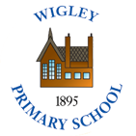  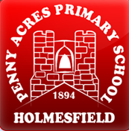 | Policy No: C3 | Revision No: | 6
 |  | Date Issued: | April 2012
 |  | Committee: | FGB
 | Geography Policy | Author: | Headteacher
 |  | Date Adopted: | June 2022
 |  | Minute No: | 5.7.22, min no 13.1
 |  | Review Date: | June 2024

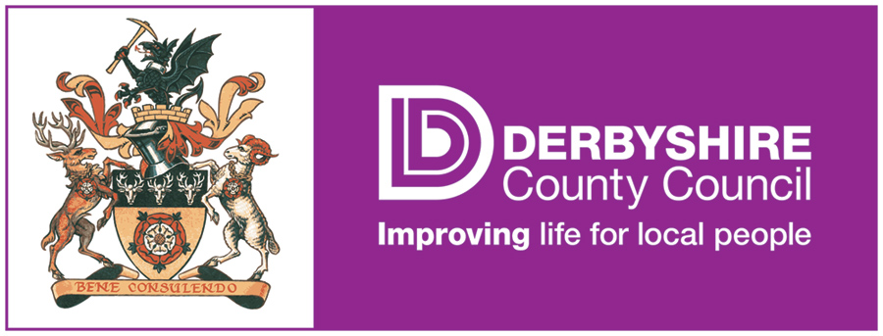

FEDERATION OF PENNY ACRES AND WIGLEY PRIMARY SCHOOL

GEOGRAPHY POLICY

Geography Policy

The shared Geography Policy of the Penny Acres and Wigley Federation reflects both school’s commitment to a broad, balanced and exciting topic based curriculum.

Aims and objectives
Geography teaches an understanding of places and environments.
The aims of geography are:
- to enable children to gain knowledge and understanding of places in the world;
- to increase children’s knowledge (and thus understanding and respect) of other cultures;
- to allow children to learn graphic sills, including how to use, draw and interpret maps;
- to enable children to know and understand environmental problems at a local, regional and global level;
- to have an appreciation of what being a ‘global citizen’ means;

Planning
At both schools pupils are taught in mixed-aged, mixed ability classes and the teaching of geography reflects this. Geography is taught through topic work and is carefully planned to ensure all pupils receive full curriculum coverage whether on a 3 year cycle (EYFS/KS1) or a 4 year cycle (KS2). EYFS/KS1 change topic half-termly, whilst KS2 change topic termly.

We follow the National Curriculum 2014 and ensure that topics consider the ‘Purpose of study’ and ‘Aims’.

Staff work together to produce long term, medium term and short term topic plans which include, when relevant to the topic, geographical subject content. Subject content is taken directly from the National Curriculum 2014.

Subject content - Key Stage 1

Pupils should develop knowledge about the world, the United Kingdom and their locality. They should understand basic subject-specific vocabulary relating to human and physical geography and begin to use geographical skills, including first-hand observation, to enhance their locational awareness.

Pupils should be taught to:

Locational knowledge
- name and locate the world’s seven continents and five oceans
- name, locate and identify characteristics of the four countries and capital cities of the United Kingdom and its surrounding seas

Place knowledge
- understand geographical similarities and differences through studying the human and physical geography of a small area of the United Kingdom and of a small area in a contrasting non-European country

Human and physical geography
- identify seasonal and daily weather patterns in the United Kingdom and the location of hot and cold area of the world in relation to the Equator and the North and South Poles.
- use basic geographical vocabulary to refer to:
- key physical features, including: beach, cliff, coast, forest, hill, mountain, sea, ocean, river, soil, valley, vegetation, season and weather
- key human features, including: city, town, village, factory, farm, house, office, port, harbour and shop

Geographical skills and fieldwork
- use world maps, atlases and globes to identify the United Kingdom and its countries, as well as the countries, continents and oceans studied at this key stage
- use simple compass directions (North, South, East and West) and locational and directional language (for example, near and far; left and right), to describe the location of features and routes on a map
- use aerial photographs and plan perspectives to recognise landmarks and basic human and physical features; devise a simple map; and use and construct basic symbols in a key
- use simple fieldwork and observational skills to study the geography of their school and its grounds and the key human and physical features of its surrounding environment

Subject content - Key Stage 2

Pupils should extend their knowledge and understanding beyond the local area to include the United Kingdom and Europe, North and South America. This will include the location and characteristics of a range of the world’s most significant human and physical features. They should develop their use of geographical knowledge, understanding and skills to enhance their locational and place knowledge.

Pupils should be taught to:

Locational knowledge
- locate the world’s countries, using maps to focus on Europe (including the location of Russia) and North and South America, concentrating on their environmental regions, key physical and human characteristics, countries and major cities
- name and locate counties and cities of the United Kingdom, geographical regions and their identifying human and physical characteristics, key topographical features (including hills, mountains, coasts and rivers), and land-use patterns; and understand how some of these aspects have changed over time
- identify the position and significance of latitude, longitude, Equator, Northern Hemisphere, Southern Hemisphere, the Tropics of Cancer and Capricorn, Arctic and Antarctic Circle, the Prime/Greenwich Meridian and time zones (including day and night)

Place knowledge
- understand geographical similarities and differences through the study of human and physical geography or a region of the United Kingdom, a region in a European country and a region within North or South America

Human and physical geography
- describe and understand key aspects of:
- physical geography, including: climate zones, biomes and vegetation belts, rivers, mountains, volcanoes and earthquakes and the water cycle
- human geography, including: types of settlement and land use, economic activity including trade links and the distribution of natural resources including energy, food, minerals and water

Geographical skills and fieldwork
- use maps, atlases, globes and digital/computer mapping to locate countries and describe features studied
- use the eight points of a compass, four and six-figure grid references, symbols and key (including the use of Ordnance Survey maps) to build their knowledge of the United Kingdom and the sider world
- use fieldwork to observe, measure, record and present the human and physical features in the local area using a range of methods, including sketch maps, plans and graphs and digital technologies.

Subject content - Early Years Foundation Stage

We teach geography in the EYFS as an integral part of the topic work covered during the year. We also relate the geographical aspects of the children’s work to the objectives set out in the Early Learning Goals. One of the Specific Areas of Learning, ‘Knowledge and Understanding of the World’ (ELG 14) states “children know about similarities and differences in relation to places, objects, materials and living things. They talk about the features of their own immediate environment and how environments might vary from one another”.

Assessment, Monitoring and Reporting
Both schools use Target Tracker (a commercial education software package supporting entry, analysis and sharing of pupil progress and attainment data through Early Years and Key Stages 1 and 2. It includes complete support for the National Curriculum). Target Tracker enables staff to track curriculum coverage and attainment by highlighting statements.

A member of staff has subject responsibility for Geography and is responsible for monitoring the subject by e.g. work scrutinies. The subject leader is also responsible for keeping colleagues informed about current developments in the subject and for providing a strategic lead and direction across the federation.
Parents’ Consultations are held twice yearly with annual reports sent home in the summer term.

Educational visits
Geography is taught within topic work across the federation, with the same topics being taught at the same time termly or half-termly across both schools.

To stimulate, enhance and inspire topic work, educational visits are booked for each topic. These may be local or further afield (including abroad). We believe that educational visits promote learning and understanding and prompt pupils to investigate and ask questions. Further, it develops knowledge of places and environments. We believe geographical education of this type enriches pupils’ lives.

