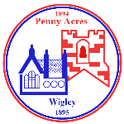
Federation of Penny Acres and Wigley Primary Schools – Topic Map
Life During the Wars 2022
Key Stage 2

Curriculum driver(s) -  - Local History information researched by the community and schools, collated by Mrs Whitfield.  Understanding what life was like locally and nationally during World War 2; and the impact of conflict across the world today. |  |  | Aims/Values drivers (taken from school’s key aims/values) –  - To develop and extend the children’s knowledge of their world and respect for moral values, tolerance of gender, sexual orientation and other cultures so that they are equipped for the opportunities, responsibilities and experiences of life.  To develop and encourage a pride and sense of belonging to our federation and establish our schools at the centre of the local community.
Key Question drivers  What was life like during World War 1 and 2? How are conditions then reflected in the war in Ukraine and in other parts of the world today?  How were the local communities affected during the war?  What was it like to be a child at Wigley/Penny Acres in the early 20th Century? |  |  | Authentic Outcome –  To create a ‘museum’ of artefacts through display from class work and home learning activities.
Visits/Visitors -  Eden Camp  Visit to a Mosque, Sikh Gurdwara and a Hindu Temple  Visitor for a Diwali workshop |  |  | Role play –  What was it/is it like during an air raid?
English

Reading (including key texts) | Writing |  |  | Spelling and Grammar
Y3/4  Apply their growing knowledge of root words, prefixes and suffixes (etymology and morphology) as listed in English Appendix 1, both to read aloud and to understand the meaning of new words they meet.  Reading books that are structured in different ways and reading for a range of purposes.  Predicting what might happen from details stated and implied.  Identifying how language, structure, and presentation contribute to meaning.  Retrieve and record information from non-fiction. | Y3/4  Pupils should be taught to: plan their writing by:  - discussing writing similar to that which they are planning to write in order to understand and learn from its structure, vocabulary and grammar  - discussing and recording ideas  Draft and write by:  - composing and rehearsing sentences orally (including dialogue), progressively building a varied and rich vocabulary and an increasing range of sentence structures (English Appendix 2)  - organising paragraphs around a theme  - in narratives, creating settings, characters and plot  - in non-narrative material, using simple organisational devices [for example, headings and sub-headings]  Evaluate and edit by:  - assessing the effectiveness of their own and others’ writing and suggesting improvements  - proposing changes to grammar and vocabulary to improve consistency, including the accurate use of pronouns in sentences  - proof-read for spelling and punctuation errors  - read aloud their own writing, to a group or the whole class, using appropriate intonation and controlling the tone and volume so that the meaning is clear. |  |  | Y3/4  choosing nouns or pronouns appropriately for clarity and cohesion and to avoid repetition (possessive pronouns)  Use of the forms a or an according to whether the next word begins  with a consonant or a vowel [for example, a rock, an open box] (determiner)
Y5/6  Apply their growing knowledge of root words, prefixes and suffixes (morphology and etymology), as listed in English Appendix 1, both to read aloud and to understand the meaning of new words that they meet.  Continuing to read and discuss an increasingly wide range of fiction, poetry, plays, non-fiction and reference books or textbooks.  Identifying and discussing themes and conventions in and across a wide range of writing.  Checking that the book makes sense to them, discussing their understanding and exploring the meaning of words in context.  Asking questions to improve their understanding.  Identifying how language, structure and presentation contribute to meaning.  Discuss and evaluate how authors use language, including figurative language, considering the impact on the reader.  Retrieve, record and present information from non-fiction.  Participate in discussions about books that are read to them and those they can read for themselves, building on their own and others’ ideas and challenging views courteously. | Y5/6  Pupils should be taught to:  plan their writing by:  - identifying the audience for and purpose of the writing, selecting the appropriate form and using other similar writing as models for their own  - noting and developing initial ideas, drawing on reading and research where necessary  - in writing narratives, considering how authors have developed characters and settings in what pupils have read, listened to or seen performed  Draft and write by:  - selecting appropriate grammar and vocabulary, understanding how such choices can change and enhance meaning  - in narratives, describing settings, characters and atmosphere and integrating dialogue to convey character and advance the action  - précising longer passages  - using a wide range of devices to build cohesion within and across paragraphs  - using further organisational and presentational devices to structure text and to guide the reader [for example, headings, bullet points, underlining]  Evaluate and edit by:  - assessing the effectiveness of their own and others’ writing  - proposing changes to vocabulary, grammar and punctuation to enhance effects and clarify meaning  - ensuring the consistent and correct use of tense throughout a piece of writing  - ensuring correct subject and verb agreement when using singular and plural, distinguishing between the language of speech and writing and choosing the appropriate register  - proof-read for spelling and punctuation errors |  |  | Y5/6  choosing nouns or pronouns appropriately for clarity and cohesion and to avoid repetition (possessive pronouns)  determiners
Tiered vocabulary | propaganda, armistice
 | Locality, rationing, shell-shocked, chronological, occupy, The Blitz, Churchill, spirit, bombs, Dig for Victory, Luftwaffe, refugee, declare, trenches, munitions, colonised, allied, evacuate
 | Invade, Remembrance, bunker, shelter, raid, sirens, frightened, hiding, remember, soldier, army, navy, changes
Numeracy
Topics this term include: Place value, addition and subtraction, multiplication and division, perimeter and area.
Place value
Y3/4  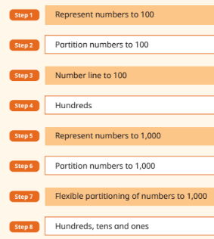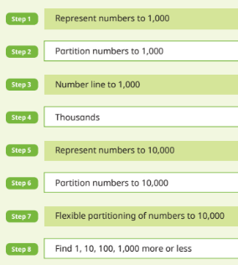  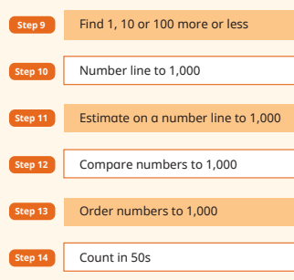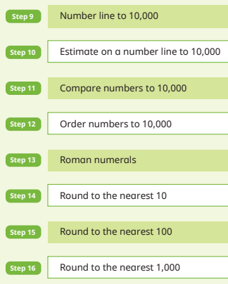 |  | Y5/6  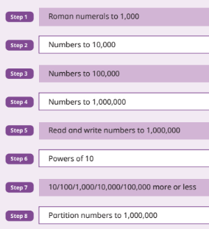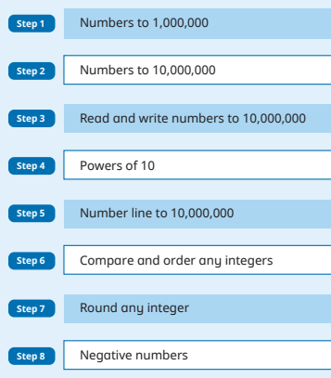  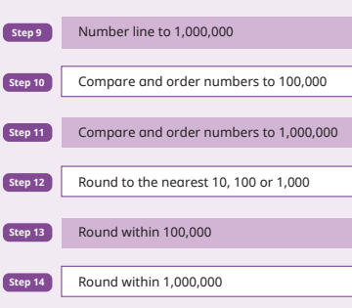
Y3 vocabulary:  ones, tens, hundreds, digit, one-, two-, three-digit number, place, place value, stands, represents, exchange, the same number as, as many as, more, larger, bigger, greater, fewer, smaller, less, fewest, smallest, least, most, biggest, largest, greatest, one more, ten more, one hundred more, one less, ten less, one hundred less, equal to, compare, order, size, first…twenty-first, twenty-second…, last, last but one, before, after, next, between, half way between, above, below, part, whole, part-whole, partition, |  | Y5 vocabulary:  powers of 10, numbers to a million, multiple of, factor of, factor pair, sequence, continue, predict, consecutive, greater than or equal to (≥), less than or equal to (≤), Roman Numerals to a thousand (I,V,X,L,C,D.M), integer, positive, negative, above/below zero, minus, negative numbers, formula, divisibility, square number, prime number, ascending/descending order, ordinal numbers,
Y4 Vocabulary:  Roman Numerals (I-C), decimal, decimal place, tenths, hundredths, round (to the nearest), thousand more/less, integers, negative integers, zero, |  | Y6 vocabulary:  numbers to ten million, multiple of, factor of, factor pair, sequence, predict, consecutive, greater than or equal to (≥), less than or equal to (≤), Roman Numerals to a thousand (I,V,X,L,C,D.M), integer, positive, negative, above/below zero, minus, negative numbers, formula, divisibility, square number, prime number, ascending/descending order, ordinal numbers
Addition and Subtraction
Y3/4  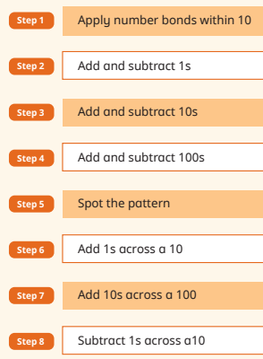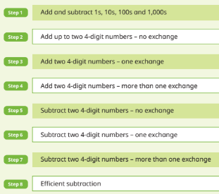  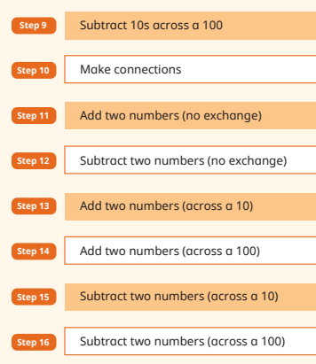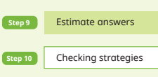 |  | Y5/6  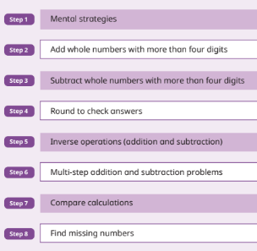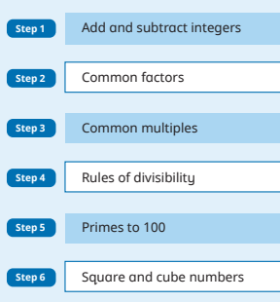
Y3 vocabulary:  Addition, add, more, and, make, sum, total, altogether, double, near double, half, halve, one more, two more, ten more, one hundred more…, subtract, take away, how many are left/left over? how many have gone? One less, two less, ten less, one hundred less, difference between, equals, is the same as, number bonds/pairs/facts, missing number, tens boundary, hundreds boundary, |  | Y5 vocabulary:  formal written method, number bonds/pairs/facts, missing number, tens boundary, hundreds boundary, inverse,
Y4 Vocabulary:  Difference between, equals, is the same as, number bonds/pairs/facts, missing number, inverse, partition, part-whole |  | Y6 vocabulary:  order of operation (BODMAS/BIDMAS), indices, inverse,
Multiplication and Division
Y3/4  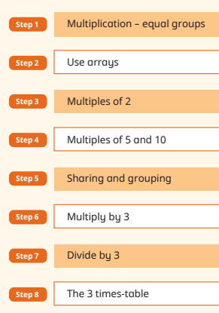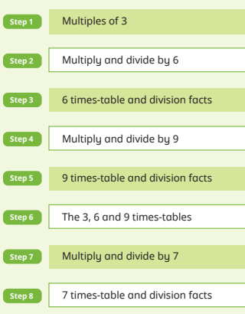  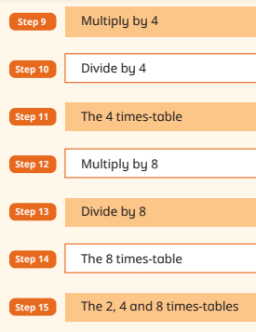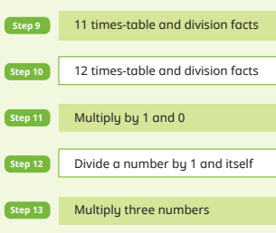 |  | Y5/6  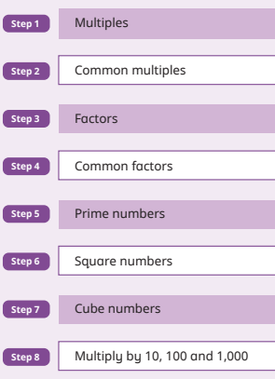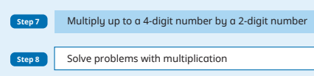  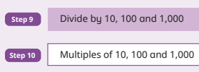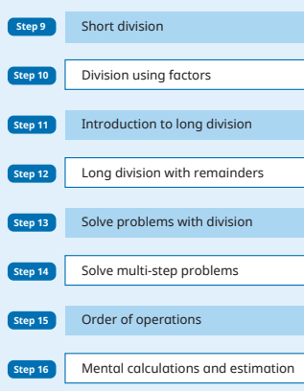  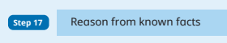
Y3 vocabulary:  multiplication, division, statement, number sentence, compare, more than , less than (<), greater than(>), equal (=), equally, least, most, remainder, share, partition, multi-step, product, scale up, multiply, multiply by, multiple, factor, groups of, times, product, repeated addition, grouping, sharing, share equally, doubling, halving, array, row, column, number patterns, multiplication table, multiplication fact, division fact, |  | Y5 vocabulary:  multiply, divide, add, subtract, place value, partition, equal, factor, multiple, remainder, sum, total, factor pairs, composite numbers, prime numbers, prime factors, square numbers, cubed numbers, multiplication fact, division fact, inverse, square/squared, cube/cubed,
Y4 Vocabulary:  multiply, divide, times-tables, partition, array, bar model, part-whole model, remainder, factor pairs, factors, commutative, multiplication facts, division facts, inverse, derive, |  | Y6 vocabulary:  order of operations, common factors, common multiples, square, squared, cube, cubed
Length, perimeter and area
Y3/4  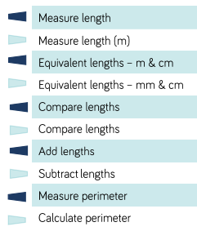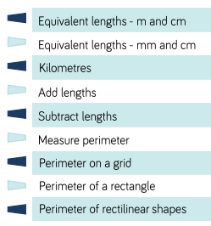 |  | Y5/6  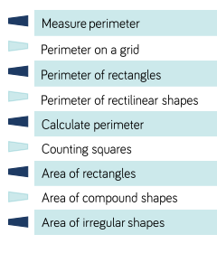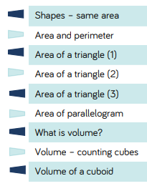
Y3 vocabulary:  length, height, width, perimeter, distance, centimetres (cm), millimetres (mm), metres (m), unit of measurement, measure, add, subtract, multiply, equivalent, convert, greater than (>), less than (<), ruler, metre stick, perimeter, metre stick, tape measure, |  | Y5 vocabulary:  area, volume, perimeter, parallelogram, height, enclosed, width, length, squared centimetres (cm²), squared metres (m²), base, estimate, formula, compound shape, cubic centimetres (cm³), cubic metres (cm³),
Y4 Vocabulary:  length, height, width, perimeter, distance, centimetres (cm), millimetres (mm), metres (m), unit of measurement, measure, add, subtract, multiply, equivalent, convert, greater than (>), less than (<), ruler, metre stick, perimeter, metre stick, tape measure, square centimetre (cm²) |  | Y6 vocabulary:  area, volume, perimeter, parallelogram, height, enclosed, width, length, squared centimetres (cm²), squared metres (m²), base, estimate, formula, compound shape, cubic centimetres (cm³), cubic metres (cm³),
Science
Vocabulary- absorb, bright, dim, emit, light beam, light source, spectrum, opaque, rays, reflect, sunlight, shadow, transparent, translucent
Echo, vibration, pitch, reflection, insulation, sound wave, frequency, volume

LKS2 – Light and sound
- Setting up simple practical enquiries, comparative and fair tests
- Making systematic and careful observations and taking measurements
- Gathering, recording, classifying and presenting data in a variety of ways to help in answering questions
- Recording findings using drawings, labels, charts and diagrams
- Reporting and presenting findings from enquiries
- Using evidence to answer questions and support findings
- Recognising that we need light in order to see things and dark is the absence of light
- Noticing that light is reflected from surfaces
- Recognising that light from the sun can be dangerous and how to protect our eyes
- Recognising that shadows are formed when the light from a light source is blocked by a solid object
- Finding patterns in the way that the size of shadows change

- Identifying how sounds are made
- Recognising that vibrations from sounds travel through a medium to the ear
- Finding patterns associated with pitch and volume
- Recognising that sound gets fainter as distance from the source increases

UKS2 – Light and Evolution and Inheritance
-Explaining how the eye works and how we see objects.
-Showing how light travels in straight lines and faster than sound.
-Seeing how light is reflected and how different colours of light are created.
-Making shadow puppets and find out about the ray model.
-Investigating how car mirrors help us see things and explore the relationship between light source, objects and shadows (size and distance)
-Explaining how periscopes work and researching telescopes, binoculars, magnifying glasses etc
-Finding out about Helen Keller/Braille

- Recording data and results of increasing complexity
- Reporting and presenting findings from enquiries
- Identifying scientific evidence that has been used to support or refute ideas and arguments
- Recognising that living things have changes over time and that fossils provide information about living things that inhabited the Earth millions of years ago
- Recognising that living things product offspring of the same kind, but normally offspring vary and are not identical to their parents
- Identifying how animals and plants are adapted to suit their environment and this sometimes leads to evolution

Vocabulary- absorption, lenses, optics, periscope, prism, rainbow, reflection, refraction, spectrum, adaptation, chromosomes, DNA, variation, evolution, features, fossil records, genes, genetic variation, inheritance, natural selection, palaeontologist, survival of the fittest

Computing
Select, use and combine a variety of software (including internet services) on a range of digital devices to design and create a range of programs, systems and content that accomplish given goals, including collecting, analysing, evaluating and presenting data and information.
Key vocabulary: pulse, pitch, tempo, rhythm, texture, metronome, melody, compose,
Y3/4
Music and Sound
- Exploring digital musical instruments and recording devices
- Learning how the instruments; sounds are stored and played back through different media
- Understanding that sound can be added to different software to create multimedia
- Learning to use different software to create, edit and manipulate sounds.
Busy Beats
Y5/6
Music and Sound
- Exploring digital musical instruments and recording devices
- Learning how the instruments; sounds are stored and played back through different media
- Understanding that sound can be added to different software to create multimedia
- Learning to use different software to create, edit and manipulate sounds.
Garage Band
Geography
(Key Vocabulary and links to programmes of study)
Interpret a range of sources of geographical information, including maps, diagrams, globes, aerial photographs and Geographical Information Systems.
Describe and understand key aspects of human geography, including: types of settlement and land use.
Key Vocabulary: human feature, physical feature, settlement, community, land use, urban, rural, farming, agriculture
Y3/4 Identify how the human features of a landscape have changed over time. Explore the physical features of a region in the UK. Identify how a place changes over time by using a range of historical maps and recent maps.
Y5/6 Identify key topological features of places in the UK. Identify key topological features of places in the UK and land-use patterns; and understand how some of these aspects have changed over time. Use a range of different maps to make inferences about natural resources and economic trade. Use scale to calculate distances on a map.
History
(Key Vocabulary and links to programmes of study)
Understand the methods of historical enquiry, including how evidence is used rigorously to make historical claims, and discern how and why contrasting arguments and interpretations of the past have been constructed.
Gain historical perspective by placing their growing knowledge into different contexts, understanding the connections between local, regional, national and international history; between cultural, economic, military, political, religious and social history; and between short- and long-term timescales.
Key Vocabulary: trench, frontline, support line, reserve line, The Allies, No Man's Land, soldier, alliance, rationing, poppy, assassination, Franz Ferdinand, Central Powers, Christmas truce, air raid, siren, gas mask, propaganda, tank, barbed wire, armistice, truce, airplane, artillery, barrage, bolt hole, battalions, empire, Home Front, gas, shrapnel, grenade, victory, mobilisation, infantry, mortar, revolution
Y3/4 Show knowledge and understanding of historical periods, events and people studied. Begin to identify significant features of the historical periods being studied. Recognise some of the similarities/differences between different periods of history. Make connections between historical periods and today. Understand and use historical vocabulary related to the historical periods, events and people being studied.
Ask and answer a range of questions about the historical periods being studied. Make suggestions as to which sources of evidence to use in order to answer questions about the past. Use sources of information that go beyond simple observations to answer questions about the past. Begin to make connections between information provided in more than one source. Know that the type of information available about the past depends on the period of time studied. Understand that what we know about the past is dependent on what has survived. Know that there are different opinions and interpretations about people and events from the past. Identify a range of ways in which the past is represented. Recognise that recounts are someone’s interpretation of past events. Differentiate between historical fact and fiction.
Y5/6 Show increasing factual knowledge and understanding of aspects of the history of Britain, local and world history. Identify and describe the significant features, events and figures of the historical periods being studied. Explain the causes/effects of important historical events/changes giving evidence to support answer. Appreciate/understand the significance within and between different periods in history. Identify changes within historical periods. Identify trends, links and connections within and across historical periods. Understand and use more complex historical terminology related to the historical periods, events and people being studied.
Know that different sources can provide different kinds of information and identify sources that are useful for finding out answers to specific questions. Ask questions about people, events, objects about the past and hypothesise about the possible answers.
Make confident uses of a variety of sources for independent historical research – draw conclusions and make personal interpretations. Use evidence from historical sources to support arguments. Select and combine information from different sources. Understand that sources can contradict each other. Compare and contract historical sources for the same period of history.
RE
Key Vocabulary: different names for God in religions studied, key vocabulary from the different parts of religious buildings, key vocabulary related to Diwali.
Key Question L2.1: What do different people believe about God?
Describe some of the ways in which Christians
Hindus and/or Muslims describe God.
• Ask questions and suggest some of their own
responses to ideas about God.
• Suggest why having a faith or belief in
something can be hard.
• Identify how and say why it makes a difference in people’s lives to believe in God.
Key Question L2.5: Why are festivals important to religious communities?
Make connections between stories, symbols and
beliefs with what happens in at least two festivals.
• Ask questions and give ideas about what matters most to believers in festivals (e.g. Easter, Eid).
• Identify similarities and differences in the way
festivals are celebrated within and between religions.
• Explore and suggest ideas about what is worth celebrating and remembering in religious
communities and in their own lives.
PSHE/Modern British Values
Exploring Emotions
LKS2
R1 – Recognising a wide range of emotions in themselves and others.
R1 – Responding appropriately to a range of emotions in themselves and others.
R7 – Understand their actions affect themselves and others.
R12 – Developing strategies to resolve results.
R12 – Identify strategies to manage emotions.
H1, H6 – Deepening their understanding of good and not so good feelings.
H6 – Extending vocabulary to help explain the range and intensity of feelings.
H7 – Recognising conflicting emotions.
UKS2
R1 – Recognising a wide range of feelings in others and how to respond appropriately.
R7 – Recognising that their actions can affect themselves and others.
R12 – Developing strategies to resolve results.
H6 – Extending emotional vocabulary.
H6 – Exploring the intensity and range of feelings.
H7 – Recognising when they experience conflicting emotions and how to manage these.
Bullying matters
R7 – Understanding that their actions affect themselves and others.
R11 – Identifying the importance of working towards shared goals.
R12- Developing strategies for getting support for themselves and others at risk.
R13 – Identifying that differences and similarities arise from a number of factors.
R14, L6 – Understanding the nature and consequences of discrimination, teasing, bullying and aggressive behaviour (including cyberbullying, prejudice-based language, ‘trolling’).
R18 – Knowing how to recognise bullying and abuse in all its forms.
UKS2
R7 – Understanding that their actions affect themselves and others.
R12 – Developing strategies for getting support for themselves or for others at risk.
R13 – Identifying that differences and similarities arise from a number of factors.
R14 – Understanding the nature of consequences of discrimination, teasing, bullying and aggressive behaviour (including cyberbullying, prejudice-based language, ‘trolling’).
R18 – Knowing how to recognise bullying and abuse in all its forms.
Art
(Key Vocabulary and links to programmes of study)
- to create sketch books to record their observations and use them to review and revisit ideas
- to improve their mastery of art and design techniques, including drawing, painting and sculpture with a range of materials [for example, pencil, charcoal, paint, clay]
- about great artists, architects and designers in history
Y3/4
Consider the formal elements within the art.
Children to generate ideas for their own poster considering shape and space.
Ch to create a simple image using each of the colour schemes and collage materials.
Ch to be able to create or replicate a propaganda poster using collage materials.
Ch to be able to discuss what they liked, disliked and could improve about their art.
Y5/6
Consider the cultural factors, process and mood of the art.
Children to generate ideas for their own poster including shape, space and texture, and colour.
Ch to annotate their collage with how to colour scheme alters the image.
Ch to be able to independently create a collage propaganda poster in their own style.
Ch to fairly appraise the work of their own and their peers and consider what they would need to do to improve next time.
DT
Key Vocabulary Y3/4: fabric, names of fabrics, fastenings, compartments, button, structure, finishing technique, strength, weakness, stiffening, templates, stitch, seam, user, purpose, design, model, evaluate, prototype, annotated sketch, functional, innovative, investigate, label, drawing, aesthetics, function, pattern, pieces
Key Vocabulary Y5/6: seam, seam allowance, wadding, reinforce, right side, wrong side, hem, template, pattern, pieces, name of textiles and fastenings used, pins, needles, thread, pinking shears, fastenings, iron transfer paper,
Y3/4
Designing
- Generate realistic ideas through discussion and design style for an appealing, functional product fit for purpose and specific users
- Produce annotated sketches, prototypes, final project sketches and pattern sequences.
Making
- Plan the main stages of making.
- Select and use a range of appropriate tools with some accuracy e.g., cutting, joining and finishing.
- Select fabrics and fastenings according to their functional characteristics e.g., strength and aesthetic qualities e.g., pattern.
Evaluating
- Investigate a range of 3D textile products relevant to the project.
- Test their product against the original design criteria and with the intended user.
- Take into account others’ views.
- Understand how a key event (Evacuation/worries over what is going on in the world) has influenced the development of the chosen product and/or fabric.
Technical knowledge and understanding
- Know how to strengthen, stiffen and reinforce existing fabrics.
- Understand how to securely join 2 pieces of fabric together.
- Understand the need for patterns and seam allowances.
- Know and use technical vocabulary relevant to the project.
Designing
- Generate innovative ideas by carrying out research including surveys, interviews and questionnaires.
- Develop model and communicate ideas through talking, drawing, templates, mock-ups and prototypes and, where appropriate, computer-aided design.
- Design purposeful, functional, appealing projects for the intended user that are fit for purpose based on a simple design specification.
Making
- Produce detailed lists of equipment and fabrics relevant to their tasks.
- Formulate step-by-step plans and, if appropriate, allocate tasks within a team.
- Select from a range of tools and equipment to make products that are accurately assembled and well finished. Work within the constraints of time, resource and cost.
Evaluating
- Investigate and analyse textile products linked to their final product.
- Compare the final product to the original design specification.
- Test products with intended user and critically evaluate the quality of the design, manufacture, function and fitness for purpose.
- Consider the views of others to improve their work.
Technical knowledge and understanding
- A 3-D textile product can be made from a combination of accurately made pattern pieces, fabric shapes and different fabrics.
Fabrics can be strengthened, stiffened and reinforced where appropriate.
Music

Play and perform in solo and ensemble contexts, using their voices and playing musical instruments with increasing accuracy, fluency, control and expression.
Improvise and compose music for a range of purposes using the inter-related dimensions of music ▪ listen with attention to detail and recall sounds with increasing aural memory.
Use and understand staff and other musical notations. A
Appreciate and understand a wide range of high-quality live and recorded music drawn from different traditions and from great composers and musicians.
Develop an understanding of the history of music.
These aims will be covered throughout the year by Wider Opportunities. Additional sessions related to news events and anniversaries will add to the understanding of the history of music e.g. Greek music will be covered during the Ancient Greek topic.
PE

- swim competently, confidently and proficiently over a distance of at least 25 metres
- use a range of strokes effectively [for example, front crawl, backstroke and breaststroke]
- perform safe self-rescue in different water-based situations.

Cricket
Use running, jumping, throwing and catching in isolation and in combination.
Play competitive games, modified where appropriate and apply basic principles suitable for attacking and defending.
Take part in outdoor and adventurous activity challenges both individually and within a team.
Vocabulary: accuracy batsman, boundary, bowl. bowler, fielder, fowl, over, pass, stamina, strikes, stumps, wicket keeper
Hockey
Play competitive games, modified where appropriate [for example, hockey], and apply basic principles suitable for attacking and defending.
Develop flexibility, strength, technique, control and balance.
Key Vocabulary: dribble, flick, obstruction, centre pass, clearing, cross

HOMEWORK OPPORTUNITIES

Make Do and Mend  During World War II, there were many shortages of food, clothing and materials. In 1941, clothes rationing began. This meant that people had to be very careful with the clothes they had to ensure that they lasted as long as possible. Hand-me-downs (clothes passed down from older family members) were common for most children.  As a result of these shortages, people got very creative with the items they had. They adapted or mended old and worn-out clothes and other materials (such as bed sheets) to make new items.  Research and explain one of the following:  - During World War II, how were clothes were adapted and given a new lease of life?  - How did fashions change as a result of the war? | During the second World War, shelters such as the Anderson and Morrison shelters were built to keep people safe in their homes.  Either:  Make an air raid shelter to protect you from the bombing.  Draw an annotate an air raid shelter to show how people thought it would protect them. | Compare the life of a child in war time with your own. Write a list of similarities and differences.  e.g food, games etc  This web link may help you if you are unsure where to start:  https://www.hope-education.co.uk/media/2036/now-and-during-the-war.pdf
It was a difficult time to live. As now, sacrifices had to be made and people missed family member, food, lifestyles etc.  Either:  Write a song to boost moral: You could either write the lyrics or compose the music (or both).  Or:  Make a drawing, collage or painting of a scene during WW1 or WW2.  Or:  Learn a wartime song to perform to friends or family members. | There are many fiction and non-fiction books about life during the wars.  Either:  from school or the local library, borrow a fiction or non-fiction book about life during either war. Write a book review for your classmates.  Or:  Make a persuasive poster of your own to encourage your classmates to do something good e.g. read a book, exercise, eat healthier, save energy. | During the early 20th Century, women campaigned for the right to vote.  Due to many men having to fight in the wars, women took on these roles of employment during the wars.  Either:  Find out who the suffragettes/suffragists were and what changes they implemented.  Or:  Research the role of women during WWII.
During the Christmas Truce, German soldiers reportedly sang Christmas Carols.  Either:  Find a German version of a favourite carol and see if you recognise any of the words.  Or:  Research popular styles of dance from a wartime period. | Alan Turing was a brilliant mathematician who reportedly broke the Enigma Code. Improve your maths skills by Either:  Design your own code and write a message.  Or:  Play a game of Battleships. | We are going to be looking at the changes in weaponry during the wars.  Either:  Draw and label a plane, tank or weapon used in war and identify which time period it would be used.  Or:  Make a model of an aeroplane from either World War 1 or 2.
Each November we commemorate those who have served and lost their lives in conflicts.  Either:  design/make a medal for a soldier in the war.  Or:  Write a poem about war and conflict. | During World War II, there were many shortages of food, clothing and materials. In 1941, clothes rationing began. This meant that people had to be very careful with the clothes they had to ensure that they lasted as long as possible. Hand-me-downs (clothes passed down from older family members) were common for most children.  As a result of these shortages, people got very creative with the items they had. They adapted or mended old and worn-out clothes and other materials (such as bed sheets) to make new items.  Research and explain one of the following:  - During World War II, how were clothes were adapted and given a new lease of life?  - How did fashions change as a result of the war? | Just as today, many families, including children, were persecuted and sent to safety.  Either:  Find out about who Anne Frank was, where she lived and about the diary she wrote.  Or:  Read an extract from Anne Frank’s diary and write a summary about what you have found out

