PSHE: Difference and Diversity
Recognise the factures that make people the same or different. Recognise the nature and consequences of discrimination.
Being Responsible
Identify why rules are needed in different situations. Understanding that there are human rights to protect everyone.

Maths: Fractions, decimals and percentages:
- recognise and use thousandths and relate them to tenths, hundredths and decimal equivalents
- read, write, order and compare numbers with up
to three decimal places
- add and subtract fractions with the same
denominator and multiples of the same number
Computing:
How a flat-file database can be used to organise data in records.
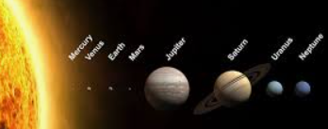
Out of this World Year 5 topic map
Links to Federation Aims and Values:
To provide them with a dynamic and relevant curriculum with new and exciting values providing positive challenge and experiences.
Art: 3D Design – Aliens 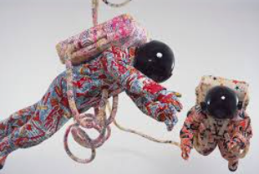
- Learn about great artists (Yinka Shonibare)
- Transferring 2D shape and texture to 3D form
- Creating Batik inspired patterns

RE: Key Question U2.6 What does it mean to be a Muslim in Britain today?
Key Question U2.7 What matters most to Christians and Humanists?
French:
Introducing the planets.
Design and Technology: Mechanical systems, pulleys and gears:
Design and make a toy space buggy.
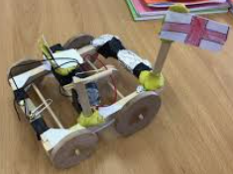

English: Book Study: Cosmic by Frank Cottrell Boyce
Insert dialogue into longer stories.
Use inference and deduction when studying texts. 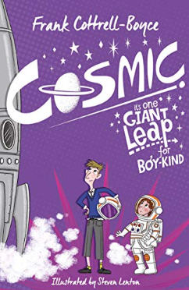

Geography: Land use and settlement
Explain about natural resources e.g. water in the locality. Ask and respond to geographical questions e.g. Describe the landscape. What would you need for a settlement on Mars? Where do we get energy? Water?
PE:
Gymnastics or dance
Hockey
Music:
Young Voices concert
The Pink Panther theme
Twinkle, twinkle little star
Science: Earth and Space
- Describing the movement of the Earth and other planets relative to the Sun and Earth;
- Using the idea of the Earth’s rotation to explain day and night
- Identifying the 8 planets in our solar system.

Key Vocabulary:
Hot: nebula, inertia, equinox, heliocentric, binary star, penumbra,
Medium: magnitude, meteoroid, meteorite, cosmonaut, cosmos, density, asteroid, elliptical orbit, comet, asteroid, astronomy, observatory, zodiac, crescent, waxing, constellation, solstice, waning, latitude, expanse, galaxy, gibbous,
Go: rocket, mass, dust, illuminate, astronaut, atmosphere, journey, gravity, movement, telescope

