Computing:
Introduction to a range of motion, sound and event blocks which will be used to create their own program using sequences.

RE: Key Question U2.5 Is it better to express your religion in arts and architecture or in charity and generosity?
Key Question L2.7 What does it mean to be a Christian in Britain today?
PE:
Net and wall games.
Striking and fielding games.

Music:
What shall we do with the drunken sailor?

French: 
The Enormous Turnip story.
School activities.

History: 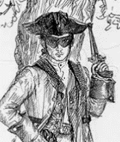
Changes in an aspect of social history, such as crime and punishment from the Anglo-Saxons to the present, to include outlaws and highwaymen.

PSHE:
Relationships: What do we mean by a relationship? What is a healthy relationship? What is a strong relationship?
Money matters: Explain the importance of money in people’s lives, money management, loans and debt. 

Maths:
Interpret and present data using bar charts, pictograms and
tables.
Measure and calculate the perimeter of a rectilinear figure.
Recall multiplication and division facts up to 12 x 12 in readiness for the Year 4 multiplication test.

Art and Design:
Drawing – printed buildings. Learn about perspectives and about great artists and architects.
English:
Debates connected to crime and punishment.
Collecting and recording key information from a range of texts.
Expressing time, place and cause using conjunctions [for example, when, before, after, while, so, because].
Indicating possession by using the possessive apostrophe with plural nouns.
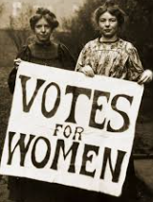

Links to Federation Aims and Values:
To develop our children’s self-confidence, self-awareness and self- belief by providing them with new and exciting experiences.
To develop and extend the children’s knowledge of their world and respect for moral values.

Design and Technology:

Mechanical systems – levers and linkages. Make a story book for a museum.
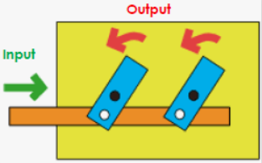

Science: 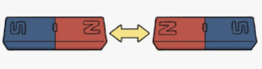
Electricity and forces: constructing simple circuits and Exploring forces between two objects and magnetic forces at a distance.


Key Vocabulary:
Go: labour arson exile theft murder outlaw highwayman smuggling
Medium: justice judge jury court trial law innocent guilty noble execute oath torture oath-keeper treason public humiliation poaching witchcraft black market cyber crime transportation forced labour forensic science pistol isolation separation
Hot: wergild tithing pillory vagrancy hue and cry capital punishment rapier Peelers
Crime and Punishment Year 4 topic map

