Crime and Punishment Year 5 topic map
RE: Key Question U2.5 Is it better to express your religion in arts and architecture or in charity and generosity?
Key Question L2.7 What does it mean to be a Christian in Britain today?
PE:
Net and wall games.
Striking and fielding games.

Music:
What shall we do with the drunken sailor?

Computing:
Use a Crumble controller and learn how to connect and program components.
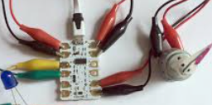
French: 
The Enormous Turnip story.
School activities.

History: 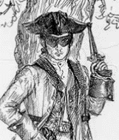
Changes in an aspect of social history, such as crime and punishment from the Anglo-Saxons to the present, to include outlaws and highwaymen.

PSHE:
Relationships: What do we mean by a relationship? What is a healthy relationship? What is a strong relationship?
Money matters: Explain the importance of money in people’s lives, money management, loans and debt. 

Maths:
Complete, read and interpret and information from tables, including timetables.
Calculate and compare the areas of squares and rectangles.
Solve problems which require a decimal and percentage equivalence.

Art and Design:
Drawing – printed buildings. Learn about perspectives and about great artists and architects.
English:
Debates connected to crime and punishment.
Collecting and recording key information from a range of texts.
Using relative clauses beginning with who, which, where, when, whose, that or with an implied relative pronoun.
Use a range of sentence openers to enhance description. Build tension and suspense in writing.
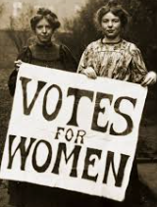

Links to Federation Aims and Values:
To develop our children’s self-confidence, self-awareness and self- belief by providing them with new and exciting experiences.
To develop and extend the children’s knowledge of their world and respect for moral values.

Design and Technology:

Mechanical Systems – Cams
Using cams to create movement, make cuts and combine materials, properties of materials.

Science: 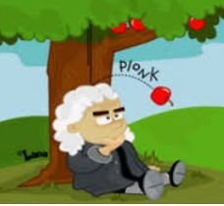
Electricity and forces: Using recognised symbols when representing a simple circuit in a diagram.
Explaining that unsupported objects fall towards the earth because of gravity.

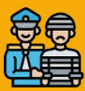
Key Vocabulary:
Go: labour arson exile theft murder outlaw highwayman smuggling
Medium: justice judge jury court trial law innocent guilty noble execute oath torture oath-keeper treason public humiliation poaching witchcraft black market cyber crime transportation forced labour forensic science pistol isolation separation
Hot: wergild tithing pillory vagrancy hue and cry capital punishment rapier Peelers

