Computing:
To develop their understanding of digital devices, with an initial focus on inputs, processes, and outputs.
Music:
Music this year is taught trough music partnership – learning to play an instrument.

Links to Federation Aims and Values:
To develop and extend the children’s knowledge of their world and respect for moral values, tolerance of gender, sexual orientation and other cultures so that they are equipped for the opportunities, responsibilities and experiences of life.

PE: Term 1: Netball
Term 2: Dance or gymnastics

Key Vocabulary:
Hot: Propaganda, armistice, conscription, outflank, battalions, entrenchment
Medium: locality, rationing, shell-shocked, chronological, occupy, Churchill, The Blitz, spirit, bombs, Dig for Victory, refugee, Luftwaffe, declare, trenches, evacuate
Go: invade, remembrance, bunker, shelter, raid, sirens, army, navy, soldier, frightened, raid.
PSHE:
Exploring emotions: How to identify, name and describe a wide range of emotions
Bullying Matter: Exploring the acronyms STOP and START to help understand the definitions of bullying.

Maths:
Place Value: count back through zero; count in multiples of 6,7, 9, 25 and 1000; find 1000 more or less than numbers; recognise the place value of each digit in a 4-digit number.
Addition and Subtraction: add and subtract numbers with up to 4 digits using the formal written methods of columnar addition and subtraction where appropriate.

French:
Greetings – Les petit oiseux (includes vocabulary for numbers and family)

Design and Technology:
Textiles:
To make a toy for an evacuee.
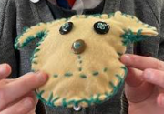

Back to the Wars Year 4 topic map
Art: 3D Design:
Looking at propaganda art work during the wars. Using the ideas of collage when creating a poster.
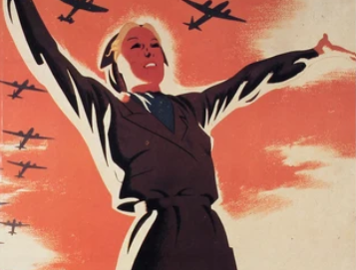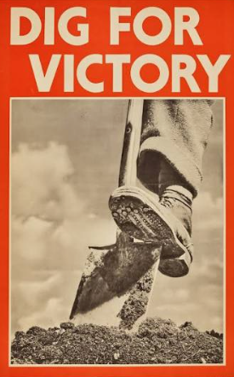
RE: Key Question U2.1 Why do some people believe God exists?
Key Question L2.4 Why do people pray?

Key Question U2.
English:
Book Study: Letters from the Lighthouse.

Word classes, co-ordinating conjunctions, Letter writing, non-chronological report writing. Comprehension skills.
Poetry.
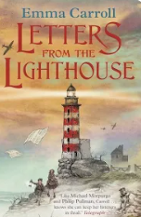
History and Geography:
What was life like during the wars including what was life like locally for children ad as an evacuee.
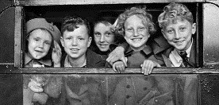
Science:
Sound and light: recognising that we need light to see things and that shadows are formed when the light from a light source is blocked by a solid object.


