Music:
Music this year is taught trough music partnership – learning to play an instrument.

PE: Term 1: Netball
Term 2: Dance or gymnastics

Computing:
Develop their understanding of computer systems and how information is transferred between systems and devices.
Key Vocabulary:
Hot: Propaganda, armistice, conscription, outflank, battalions, entrenchment
Medium: locality, rationing, shell-shocked, chronological, occupy, Churchill, The Blitz, spirit, bombs, Dig for Victory, refugee, Luftwaffe, declare, trenches, evacuate
Go: invade, remembrance, bunker, shelter, raid, sirens, army, navy, soldier, frightened, raid.
Maths:
Place Value: use negative numbers in context; read, write and order numbers up to 10 000 000; identify the value of each digit to 3 decimal places; round any whole number.
Addition and Subtraction: perform mental calculations, including with mixed operations and large numbers; use estimation to check answers to calculations; solve addition and subtraction calculations in context.
Back to the Wars Year 6 topic map
Science:
Light and Evolution and Inheritance: explain how the eye works and how we see objects; show how light travels in straight lines and faster than sound; see how light is reflected and how different colours of light are created.

Links to Federation Aims and Values:
To develop and extend the children’s knowledge of their world and respect for moral values, tolerance of gender, sexual orientation and other cultures so that they are equipped for the opportunities, responsibilities and experiences of life.

PSHE:
Exploring emotions: How to identify, name and describe a wide range of emotions
Bullying Matter: Exploring the acronyms STOP and START to help understand the definitions of bullying.

French:
Greetings – Les petit oiseux (includes vocabulary for numbers and family)

Design and Technology:
Textiles:
To make a bag for an evacuee.
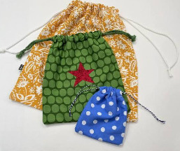

Art: 3D Design:
Looking at propaganda art work during the wars. Using the ideas of collage when creating a poster.
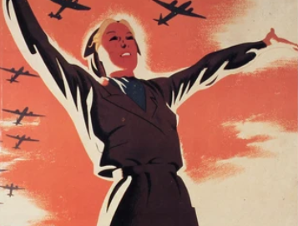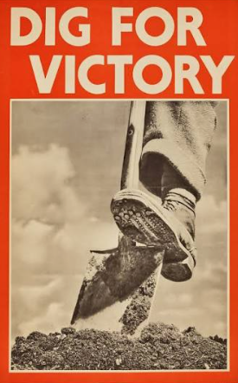
RE: Key Question U2.1 Why do some people believe God exists?
Key Question L2.4 Why do people pray?

Key Question U2.
English:
Book Study: Letters from the Lighthouse.

Word classes, co-ordinating conjunctions, Letter writing, non-chronological report writing. Comprehension skills.
Poetry.
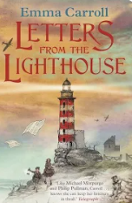
History and Geography:
What was life like during the wars including what was life like locally for children ad as an evacuee.
