L.O. I can use comparatives and superlatives
The White Seal was a big boat but the Katie Hinds was bigger. (Yes, I agree this isn’t fantastic language.)
Choose an activity:
The hard sheet:
Copy and complete these sentences:
- The ____ was fast.
- The ____ was faster.
- The ____was the fastest.
- The ____ was hot.
- The ____ was hotter.
- The ____was the hottest.
- The dog was quiet.
- The cat was ____.
- The mouse was the ____.
The harder sheet:
Fast is an adjective – it describes the speed at which something or someone is travelling.
Faster is a comparative adjective – it compares the speed of one thing with another.
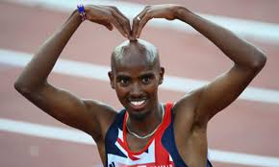
Fastest is a superlative adjective – nothing can be faster.
Copy and complete:
Mo Farah is faster than ______________________________________(comparative)
Mo Farah is faster than ______________________________________(comparative)
Mo Farah is the fastest ______________________________________(superlative)
Write one comparative and one superlative sentences for the following adjectives:
brave powerful fierce strange dangerous smart thoughtful cute colourful graceful daring loud wet hard hot

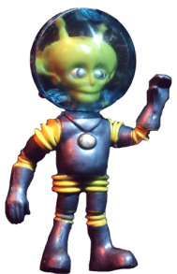
Some adjectives are stronger than others: eg. Fast, very fast, rapid, quick, supersonic
Can you think of any stronger adjectives for:
Hot - scorching cold -_____ tired-_____ bumpy - ____ good - _____
Use each of the adjectives you have found in your own sentences, eg:
The scorching sun was making us tired and thirsty.

The hardest sheet:
Fast is an adjective – it describes the speed at which something or someone is travelling.
Faster is a comparative adjective – it compares the speed of one thing with another.
Fastest is a superlative adjective – nothing can be faster.
Copy and complete:
Mo Farah is faster than ______________________________________(comparative)
Mo Farah is faster than ______________________________________(comparative)
Mo Farah is the fastest ______________________________________(superlative)
Write two comparative and one superlative sentences for the following adjectives:
brave powerful fierce strange dangerous smart thoughtful cute colourful graceful daring loud wet hard hot

Some adjectives are stronger than others: eg. Fast, very fast, rapid, quick, supersonic
Use a thesaurus to find adjectives which have a similar meaning to the following:
grim overweight cheeky slapdash hot brave cold cowardly
Write each as a list arranged according to strength, eg: fast, brisk, nippy, quick, smartly, speedy, swift, supersonic.
Use ten of the adjectives you have found in your own sentences.

