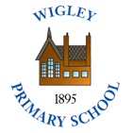  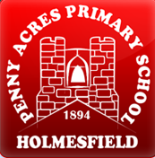 | Policy No:  C10 | Revision No: | 6
 | Policy No:  C10 | Date Issued: | April 2012
 | Policy No:  C10 | Committee: | Curriculum
 | Science Policy | Author: | Headteacher
 | Science Policy | Date Adopted: | October 2021
 | Science Policy | Minute No: | 5.10.21, min no 18.5
 | Science Policy | Review Date: | October 2023

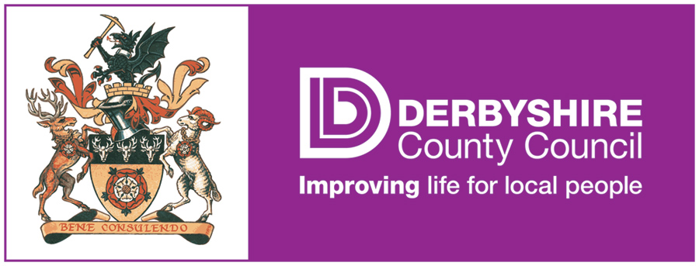

FEDERATION OF PENNY ACRES AND WIGLEY PRIMARY SCHOOL

SCIENCE POLICY

Science Policy

1. Aims and objectives (Purpose of study)

1.1 A high-quality science education provides the foundations for understanding the world through the specific disciplines of biology, chemistry and physics. Science has changed our lives and is vital to the world’s future prosperity, and all pupils should be taught essential aspects of the knowledge, methods, processes and uses of science. Through building up a body of key foundational knowledge and concepts, pupils should be encouraged to recognise the power of rational explanation and develop a sense of excitement and curiosity about natural phenomena. They should be encouraged to understand how science can be used to explain what is occurring, predict how things will behave, and analyse causes.

1.2 Aims

The national curriculum for science aims to ensure that all pupils:
- develop scientific knowledge and conceptual understanding through the specific disciplines of biology, chemistry and physics
- develop understanding of the nature, processes and methods of science through different types of science enquiries that help them to answer scientific questions about the world around them
- are equipped with the scientific knowledge required to understand the uses and implications of science, today and for the future.

Attainment targets By the end of each key stage, pupils are expected to know, apply and understand the matters, skills and processes specified in the relevant programme of study.

2. Teaching and learning style

  - We use a variety of teaching and learning styles in science lessons. Our principal aim is to develop children’s knowledge, skills, and understanding. Sometimes we do this through whole-class teaching, while at other times we engage the children in an enquiry based research activity. We encourage the children to ask, as well as answer, scientific questions. They have the opportunity to use a variety of data, such as statistics, graphs, pictures, and photographs. They use ICT in science lessons where it enhances their learning. They take part in role-play and discussions and they present reports to the rest of the class. They engage in a wide variety of problem-solving activities. Wherever possible, we involve the pupils in ‘real’ scientific activities, for example, researching a local environmental problem or carrying out a practical experiment and analysing the results. We also encourage S.A. to investigate scientific phenomena to promote independent learning.

2.2 We recognise that there are children of widely different scientific abilities in all year groups and we ensure that we provide suitable learning opportunities for all children by matching the challenge of the task to the ability of the child. We achieve this in a variety of ways by:
- Setting common tasks which are open-ended and can have a variety of responses;
- Setting tasks of increasing difficulty (we do not expect all children to complete all tasks);
- Grouping children by ability in the room and setting different tasks for each ability group;
- Providing resources of different complexity, matched to the ability of the child;
- Using classroom assistants to support the work of individual children or groups of children.

3. Science curriculum planning

3.1 The school uses the National Curriculum as the basis for science curriculum planning. The national curriculum has been adapted to the local circumstances of the school in that we make use of the local environment in our fieldwork.

3.2 We carry out our curriculum planning in science in three phases (long-term, medium-term and short term). The long-term plan is sometimes included within the topic studied in each term during key stage 2, usually the children study science as a discrete subject. The science co-ordinator works this out in conjunction with teaching colleagues. This is the same for key stage 1.

3.3 Our medium-term plans, also based on the national curriculum for science, give details of each unit of work for each term. The science co-ordinator keeps and reviews these plans. As we have some mixed-age classes, we do our medium-term planning on a two-year rotation cycle. In this way we ensure complete coverage of the National Curriculum.

3.4 The class teacher is responsible for writing the daily lesson plans for each lesson (short-term plans). These plans list the specific learning objectives of each lesson and the S.C. to achieve it. The class teacher keeps these individual plans, and she/he and the science co-ordinator often discuss them on an informal basis.

3.5 We have planned the topics in science so that they build upon prior learning. We ensure that there are opportunities for children of all abilities to develop their skills and knowledge in each unit and we also build progression into the science scheme of work, so that the children are increasingly challenged as they move up through the school.

4 Foundation Stage

4.1 We teach science in the EYFS class as an integral part of the topic work covered during the year. As the EYFS class is part of the Foundation Stage of the National Curriculum, we relate the scientific aspects of the children’s work to the objectives set out in the Early Learning Goals (ELGs) which underpin the curriculum planning for children aged three to five. Science makes a significant contribution to the objective in the ELGs of developing a child’s knowledge and understanding of the world, e.g. through investigating what floats and what sinks when placed in water.

5. The contribution of science to teaching in other curriculum areas

5.1 English
Science contributes significantly to the teaching of English in our school by actively promoting the skills of reading, writing, speaking and listening. Some if the texts that the children study in the Literacy are of a scientific nature. The children develop oral skills in science lessons through discussions and through recounting their observations of scientific experiments. They develop their writing skills through writing reports and projects and by recording information.

5.2 Mathematics
Science contributes to the teaching of mathematics in a number of ways. The children use weights and measures and learn to use and apply number. Through working on investigations they learn to estimate and predict. They develop the skills of accurate observation and recording of events. They use numbers in many of their answers and conclusions.

5.3 Information and communication technology
Children use ICT in science lessons where appropriate. They use it to support their work in science by learning how to find, select, and analyse information on the internet and on CD-ROMs. Children use ICT to record present and interpret data and to review, modify and evaluate their work and improve its presentation.

5.4 Personal, social and health education (PSHE) and citizenship
Science makes a significant contribution to the teaching of personal, social and health education. This is mainly in two areas. Firstly, the subject matter lends itself to raising matters of citizenship and social welfare. For example, children study the way people recycle material and how environments are changed for better or worse. Secondly, children benefit from the nature of the subject in that it gives them opportunities to take part in debates and discussions. They organise campaigns on matters of concern to them, such as helping the poor or homeless. Science promotes the concept of positive citizenship.

  - Spiritual, moral, social and cultural development
Science teaching offers children many opportunities to examine some of the fundamental questions in life, for example, the evolution of living things and how the world was created developing a sense of awe and wonder regarding the nature of our world. Science raises many social and moral questions. Through the teaching of science, children have the opportunity to discuss, for example, the effects of smoking and the moral questions involved in this issue. We give them the chance to reflect on the way people care for the planet and how science can contribute to the way we manage the earth’s resources. Science teaches children about the reasons why people are different and, by developing the children’s knowledge and understanding of physical and environmental factors, it promotes respect for other people.

- Teaching science to children with special needs

  - We teach science to all children, whatever their ability. Science forms part of the school curriculum policy to provide a broad and balanced education for all children. We provide learning opportunities that are matched to the needs of children with learning difficulties. Our work in science takes into account the targets set in the children’s Individual Education Plans (IEPs).

- Assessment and recording

  - We assess children’s work in science by making informal judgements as we observe them during lessons. On completion of a piece of work, the teacher marks the work and comments as necessary. At the end of a unit of work she/he makes a summary judgement about the work of each pupil in relation to the National Curriculum level of attainment. The teacher records the attainment electronically. We use this as the basis for assessing the progress of each child and we keep this information so as to inform the following years teaching.

  - Teachers will also use formal assessment to help inform judgements. Teachers make an assessment of the children’s work in science at the end of each Key Stage. We report the results of these tests to parents along with the teacher assessments.

7.3 Examples of children’s science work can be seen in the key stage 2 topic/science books. These demonstrate what this expected level of achievement is in science for each age group in the school.

- Resources

  - We have sufficient resources for all science teaching units in our schools.

- Monitoring and review

  - It is the responsibility of the science co-ordinator to monitor the standards of the children’s work and the quality of teaching in science. The science co-ordinator is also responsible for supporting colleagues in the teaching of science, for being informed about current developments in the subject and for providing a strategic lead and direction for the subject in the school. The science co-ordinator gives the Headteacher an annual summary report in which he/she evaluates strengths and weaknesses in the subject and indicates areas for further improvement. The science co-ordinator has specially allocated time for fulfilling the vital task of reviewing samples of children’s work and visiting classes to observe teaching in the subject.

