Working from home in science – Mrs Eyre
Autumn 1 - Thursday (2 hours)

Y3/4 How does food change when it is heated?
Some solids, like ice, change state when they are heated, forming a liquid. This is known as melting, and it is a reversible change. Liquids can be frozen, or solidified, by cooling them.
Heating some materials can cause a change that is not reversible, for example when you make toast, it is not possible to get the bread back.
Watch this video about how food changes when it is cooked.
https://www.bbc.co.uk/bitesize/topics/zcvv4wx/articles/z9brcwx

Do a survey of your family food. Look at food before it is cooked and compare to after it is cooked. Notice what it looks like, feels like, smells like, what colour it is etc. before and after. Use pictures and writing to explain how, and why, the food has changed.

Y5/6 Which inventions began as mistakes?
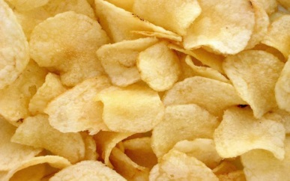
In 1853, in a New York restaurant, when a customer complained that the fried potatoes were too soggy and thick, and repeatedly sent them back to the waiter, the chef- George Crum- got so fed up, that he took the request for a thinner potato quite literally- he cut the potatoes into thin slices, fried them, and covered them in salt. And, Voila! The most favourite snack in the world was born! The potato crisp!
Watch this video and see some inventions that were made by mistake. https://www.youtube.com/watch?v=qO1brxn1rNs
https://www.labroots.com/trending/videos/10061/7-inventions-that-changed-our-lives-but-were-made-accident
Research more inventions that were made by mistake, such as the ‘post it’ note, blutac and Coca-cola. Include detail about the invention itself, how it was invented and the scientist who invented it.

