   | Policy No:  C5 | Revision No: | 5
 | Policy No:  C5 | Date Issued: | October 2016
 | Policy No:  C5 | Committee: | Curriculum
 | Music Policy | Author: | Headteacher
 | Music Policy | Date Adopted: | October 2022
 | Music Policy | Minute No: | 4.10.22, min no 19.3
 | Music Policy | Review Date: | October 2024

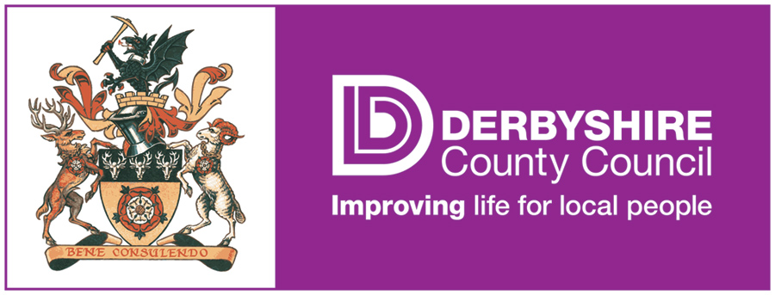

FEDERATION OF PENNY ACRES AND WIGLEY PRIMARY SCHOOL

MUSIC POLICY

Music Policy

This policy is a statement of the aims, objectives, principles and strategies for the teaching and learning of Music for the Federation of Penny Acres and Wigley Primary Schools.

Aims and objectives

Music is a unique way of communicating that can inspire and motivate children. It gives an opportunity for personal expression and it can play an important part in the personal development of an individual. Music reflects our culture and society and so the teaching and learning of music enables children to better understand the world they live in. Besides being a creative and enjoyable activity, music can be a highly academic and demanding subject. It is also important in helping children feel part of a community. We provide opportunities for all children to create, play, perform and enjoy music.

The aims of music teaching are to enable children to:
- know and understand how sounds are made and then organised into musical structures;
- know how music is made through a variety of instruments;
- know how music is composed and written down;
- know how music is influenced by the time, place and purpose for which it was written;
- develop the interrelated skills of performing, composing and appreciating music;
- enjoy and appreciate a wide variety of musical styles;
- make and quantify judgements about the quality of music;
- understand and explore how music is created, produced and communicated, including through the inter-related dimension: pitch, duration, dynamics, tempo, timbre, texture, structure and appropriate musical notations.

Teaching and learning style

In our Federation, we make music an enjoyable learning experience. We encourage children to participate in a variety of musical experiences through which we aim to build up the confidence of all children. Our teaching focuses on developing
- an ability to sing in tune and with other people.
- the skills of recognising pulse and pitch.
- an ability to play instruments with control and sensitivity
- working with others to make music, recognising how individuals combine together to make sounds.
- knowledge of musical notation and how to compose music.

Differentiation

We recognise that there are children of widely different musical abilities in all classes, so we provide suitable learning opportunities for all children by matching the challenge of the task to the ability of the child. We achieve this in a variety of ways by:
- setting common tasks, which are open-ended and can have a variety of responses;
- setting tasks of increasing difficulty for more able children;
- differentiation in planning for children who have been identified as “gifted” and “talented” through enrichment and extension activities. (Those children who are very able, or have a range of musical experiences to draw upon are encouraged to use and develop their talents both within the curriculum, and through extra-curricular performances e.g. music assembly).

Equal Opportunities

All pupils will have equal access to the Music Curriculum. Staff will be encouraged to ensure no gender bias by providing equal access for boys and girls, also for pupils of different social backgrounds and ethnic groups.

Pupils are encouraged to share their experiences and culture with others in order to enhance the quality of learning. This will be achieved by pupils experiencing music from
- different times and cultures
- different composers past and present
- different performers past and present.

Derbyshire Wider Opportunities Scheme delivers instrument lessons to all Key Stage 2 pupils.

Our Y1 and Y2 pupils are taught how to play the recorder.

Foundation Stage

We teach music in our reception class as an integral part of the topic work covered during the year. As the reception class is part of the Foundation Stage, we relate the musical aspects of the children’s work to the objectives set out in the Early Learning Goals (ELGs), which underpin the curriculum planning for children aged three to five. Music contributes to a child’s personal and social development. Counting songs foster a child’s mathematical ability and songs from different cultures increase a child’s knowledge and understanding of the world.

Opportunities for live music

- Singing practice — once a week school meets to learns hymns and songs for parents’ assembly and special occasions linked to R.E. and P.S.H.E
- At Christmas time, all pupils take part in a musical production. At other times throughout the year e.g. Harvest, Easter and special events such as well-dressing, the whole school gets together to provide appropriate musical entertainment. Both Schools participate in carol singing at the local old people’s homes and hospices.
- Children from both of our schools will continue to participate in national events such as “The Big Sing, Young Voices”.

Assessment and recording

- Teachers assess children’s work in music by making informal judgements about achievement of Teaching and Learning objectives as they observe them during lessons. At the end of each key stage the teacher makes a summary judgement about the work of each pupil in relation to the National Curriculum programme of study. We use this as the basis for assessing the progress of the child and for completing reports to parents.

- Recordings, use of a digital camera or iPad may also be used to record work.

Additional music teaching

Additional flute and guitar lessons are offered individually to pupils from a music teacher weekly.

In service

Appropriate opportunities for in-service training are found, whenever possible, for the music co-ordinator and members of staff and then shared at staff meetings.

Resources

There are sufficient resources for all music-teaching units in the school. Each classroom has a portable CD player and we have a comprehensive collection of CDs.

Health and Safety

Children are always encouraged to use instruments carefully and safely. An instrument, which is blown, should have the mouthpiece cleaned after each child has used it.

Monitoring and review

The music subject leader is responsible for the standard of children’s work and for the quality of teaching in music. The work of the subject leader also involves supporting colleagues in the teaching of music, being informed about current developments in the subject and providing a strategic lead and direction of the subject in school. The music subject leader is responsible for giving the Headteacher an annual summary report in which s/he evaluates the strengths and weaknesses in the subject and indicates areas for further improvement.

National Curriculum for Music

Key Stage 1
- use their voices expressively and creatively by singing songs and speaking chants and rhymes
- play tuned and untuned instruments musically
- listen with concentration and understanding to a range of high-quality live and recorded music
- experiment with, create, select and combine sounds using the inter-related dimensions of music.

Key Stage 2

Pupils should be taught to sing and play musically with increasing confidence and control. They should develop an understanding of musical composition, organising and manipulating ideas within musical structures and reproducing sounds from aural memory.

Pupils should be taught to:
- play and perform in solo and ensemble contexts, using their voices and playing musical instruments with increasing accuracy, fluency, control and expression
- improvise and compose music for a range of purposes using the inter-related dimensions of music
- listen with attention to detail and recall sounds with increasing aural memory
- use and understand staff and other musical notations
- appreciate and understand a wide range of high-quality live and recorded music drawn from different traditions and from great composers and musicians
- develop an understanding of the history of music.

