**Working from home in science – Mrs Eyre**

**Thursday 4th June**

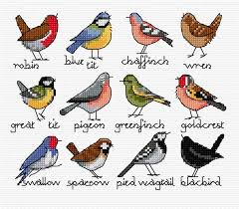Hello everyone, I hope you have had a good half term! This week’s science is all about birds and bird watching. Time for science ambassadors at home to get out the binoculars and spread your wings into the wonderful world of birds. Use your eagle eyes and get spotting!

**Y3/4 What different birds visit your garden?**

Gather as much information as possible about the birds that visit your garden and that you see in your local environment. Record what you see.

Identify them if you can, <https://www.rspb.org.uk/birds-and-wildlife/wildlife-guides/identify-a-bird/> draw them, photograph and make notes about them.

Where did you see them? How many were there? What were they doing? Were they nesting, eating, swimming? Did you hear them?

Research ‘What food can you put out in the summer for garden birds?’ and ‘Where is the best place to put it?’ Try to encourage more birds to your garden/local environment.

Perhaps present your bird spotting information as a short diary of notes and pictures to show what birds you see over a period of time and what you have learned about them.

**Y5/6 What are the world’s most incredible exotic birds?**

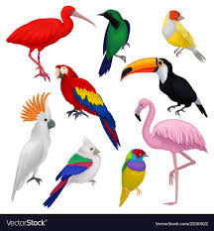Watch this video ‘the top ten most beautiful exotic birds in the world.’

<https://www.youtube.com/watch?v=jZ9kP_ksnG0>

Research an exotic bird from a different region.

What is the bird’s natural habitat?

Why do these birds have such an amazing plumage?

What special adaptations do they have to help them survive?

What is their life cycle and what threatens their existence?

Is it endangered, and if so, why?

Present as a power point and show it to an audience.

Enjoy your exotic explorations!