Working from home in science – Mrs Eyre
Thursday 11th June
Hello again everyone! Today is all about plants again, from those delicious edible ones, to the dangerous poisonous ones!

Y3/4 What different parts of different plants can you eat?
Plants form a large part of a healthy balanced diet. Gather evidence about what different plant food your family eats in a typical week. Perhaps do a survey of what different fruit, salad and vegetables you use in your house. Maybe do a questionnaire to find what plant foods your family like to eat most.
Use your findings to classify (group) the plant foods into the different parts of the plant that is eaten, such as
LEAVES, ROOT, STEM, FLOWER, FRUIT, BUD, SEED
(eg lettuce would be in the leaves group and celery would be in the stem group)
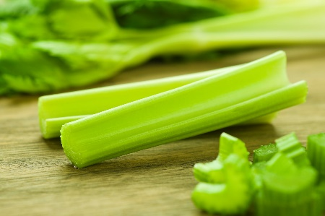
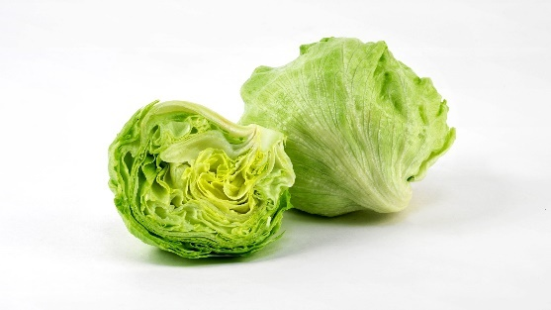

Some might be in more than one group! Think how you can show that!
Record your findings in a variety of ways ….. try a table/graph/list/notes/drawings/Venn diagram etc.
It’s all part of your 5 a day!

Y5/6 What are the most dangerous plants in the world?

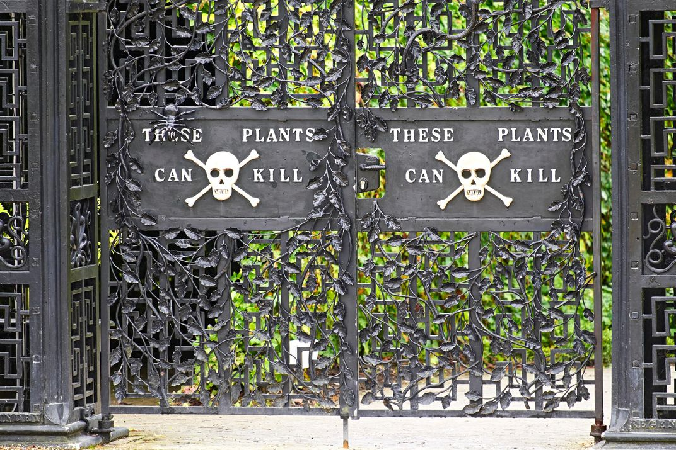

Did you know that many plants are poisonous and some can be deadly? Find out which are the most dangerous plants in the world. Some plants have both physical and chemical types of defence mechanism to defend against herbivorous animals and humans. Explore how they are adapted for survival, and how they attack their victims!!!
Watch this video about Alnwick poison garden
https://www.youtube.com/watch?v=jGo9gYypQc8
Draw/design a dangerous garden that is behind these gates! Include as many deadly plants as you can. Label each plant and briefly annotate to explain how the plant operates.
Stay alert! Plants can kill!

