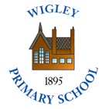  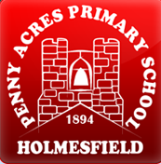 | Policy No:  C7 | Revision No: | 5
 | Policy No:  C7 | Date Issued: | October 2016
 | Policy No:  C7 | Committee: | Curriculum
 | English Policy | Author: | Headteacher
 | English Policy | Date Adopted: | October 2021
 | English Policy | Minute No: | 5.10.21, min no 18.2
 | English Policy | Review Date: | October 2023

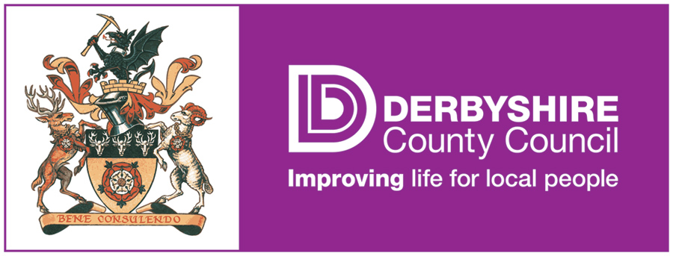

FEDERATION OF PENNY ACRES AND WIGLEY PRIMARY SCHOOL

ENGLISH POLICY

ENGLISH POLICY

1. Aims and objectives

The study of English develops children’s abilities to listen, speak, read and write for a wide range of purposes, so using language to learn and communicate ideas, views and feelings. It enables children to express themselves creatively and imaginatively, as they become enthusiastic and critical readers of stories, poetry and drama, as well as non-fiction and media texts. Children gain an understanding of how language works by looking at its patterns, structures and origins. Children use their knowledge, skills and understanding in speaking and writing across a range of different situations.

  - The aims of English are:
- To enable children to speak clearly and audibly in ways which take account of their listeners;
- To encourage children to listen with concentration in order to be able to identify the main points of what they have heard;
- To enable children to adapt their speech to a wide range of circumstances and demands;
- To develop children’s abilities to reflect on their own and others’ contributions and the language used;
- To enable children to evaluate their own and others’ contributions through a range of drama activities;
- To develop confident, independent readers through an appropriate focus on word, sentence and text-level knowledge;
- To encourage children to become enthusiastic and reflective readers through contact with challenging and lengthy texts;
- To help children enjoy writing and recognise its value;
- To help children to write with accuracy and meaning in narrative and non-fiction;
- To increase the children’s ability to use planning, drafting and editing to improve their work;

- Teaching and learning style

2.1 In the Federation of Penny Acres and Wigley Primary Schools, we use a variety of teaching and learning styles in English lessons. Our principal aim is to develop children’s knowledge, skills, and understanding in English. We do this through a daily lesson that has a high proportion of whole-class and group teaching. During these lessons children may experience a whole-class shared reading or writing activity, a whole-class focused word or sentence activity, a guided group or independent activity and a whole-class session to review progress and learning. They have the opportunity to experience a wide range of texts and use a range of resources such as dictionaries and thesauruses to support their work. Children may use ICT in English lessons where it enhances their learning, as in drafting their work and using multimedia to study how words and images are combined to convey meaning. Wherever possible we encourage children to use and apply their learning in other areas of the curriculum.

  - There are children of differing ability in both the KS1 and KS2 classes. We recognise this fact and provide suitable learning opportunities for all children by matching the challenge of the task to the ability of the child. We achieve this through a range of strategies. In some lessons we do it through differentiated group work, while in other lessons we ask children to work from the same starting point before moving on to develop their own ideas. We use classroom assistants to support some children. We also use classroom assistants, in conjunction with the teacher, to enable work to be matched to the needs of individuals.

- English curriculum planning

  - English is a core subject in the National Curriculum. We use the National Curriculum as the basis for implementing the statutory requirements of the programme of study for English.

  - We carry out the curriculum planning in English in three phases (long-term, medium term and short-term). The National Curriculum details what we teach in the long-term. Our yearly teaching programme identifies the key objectives in literacy that we teach to each year. As our schools have mixed-age classes, we rotate on a four-year cycle (KS2) and two-year cycle (KS1).

  - Our medium-term plans, which we also base on the Framework, give details of the main teaching objectives for each term. These plans define what we teach and ensure an appropriate balance and distribution of work across each term. The English subject leader is responsible for keeping and reviewing these plans.

  - Class teachers complete a weekly (short-term) plan for the teaching of English. This lists the specific learning objectives for each lesson and gives details of how the lessons are to be taught. It also includes details of what each group of children will be learning. The class teacher keeps these individual plans, and the class teacher and subject leader often discuss them on an informal basis.

- The Foundation Stage

  - We teach English in EYFS as an integral part of the school’s work. The format for the daily lesson is similar to that used in the rest of the school. As the EYFS is part of the Foundation Stage of the National Curriculum, we relate the English aspects of the children’s work to the objectives set out in the Early Learning Goals which underpin the curriculum planning for children aged three to five. We give all children the opportunity to talk and communicate in a widening range of situations, to respond to adults and to each other, to listen carefully, and to practise and extend their range of vocabulary and communication skills. They have the opportunity to explore, enjoy, learn about, and use words and text in a range of situations.

- Contribution of English to teaching in other curriculum areas

  - The skills that children develop in English are linked to, and applied in every subject of our curriculum. The children’s skills in reading, writing, speaking and listening enable them to communicate and express themselves in all areas of their work in school

  - Mathematics
English contributes significantly to the teaching of mathematics in our school. Children in EYFS develop their understanding of number, pattern, shape and space by talking about these areas with adults and other children. Children in Key Stage 1 meet stories and rhymes that rely on counting and sequencing. Children in Key Stage 2 are encouraged to read and interpret problems in order to identify the mathematics involved. They explain and present their work to others during plenary sessions and they communicate mathematically through the developing use of precise mathematical language.

  - Information and communication technology (ICT
The use of ICT enables children to use and apply their developing skills in English in a variety of ways. Younger children use ICT as a source of information and as a way of enabling them to present their completed work effectively. Older children use the internet when searching for information about a different part of the world, or when using desktop publishing to design a class newspaper. Children use the planning and proofing tools in a word processor when checking their draft work. We encourage all children to use ICT as a resource for learning, whenever they feel it is appropriate.

  - Personal, social and health education (PSHE) and citizenship
English contributes to the teaching of personal, social and health education and citizenship. We encourage younger children to take part in class and group discussions on topical issues. In their science work they talk about things that improve their health and about rules for keeping them safe around the school. Older children research and debate topical problems and events. They discuss lifestyle choices and meet and talk with many visitors who work within the school community. Planned activities within the classroom encourage children to work together and respect each other’s views.

  - Spiritual, moral, social and cultural development
The teaching of English develops skills through which our children can give critical responses to the moral questions they meet in their work. Their understanding and appreciation of a range of texts brings them into contact with their own literary heritage and texts from other cultures. The organisation of lessons allows children to work together and gives them the chance to discuss their ideas and results.

- Teaching English to children with special needs

  - We teach English to all children, whatever their ability. English forms part of the school curriculum policy to provide a broad and balanced education to all children. Teachers provide learning opportunities matched to the needs of children with learning difficulties. Work in English takes into account the targets set for individual children in their individual Education Plans (IEPs). Teachers provide help with communication and literacy through:
- using texts that children can read and understand;
- using visual and written materials in different formats;
- using ICT, other technological aids and taped materials;
- using alternative communication such as signs and symbols;
- using translators and amanuenses.

- Assessment and recording

  - Teachers assess children’s work in English in three phases. The short-term assessment that teachers make as part of every lesson, help teachers to adjust their daily plans. Teachers match these short-term assessments closely to the teaching objectives. They use medium-term assessments to measure progress against the key objectives, and to help them plan for the next unit of work. Teachers make long-term assessments towards the end of the school year, the results of test materials (e.g. end of Year 2 and Year 6 SATs) to assess progress against school and national targets. Teachers also make annual assessments of children’s progress using the level descriptions of the National Curriculum. With the help of these long-term assessments, teachers are able to set targets for the next school year and summarize the progress of each child before discussing it with the child’s parents. These long-term assessments act as the basis for planning work for the new school year.

  - The subject leader attends regular cluster moderation meetings to keep informed of the national levels, where necessary keeping samples of children’s work. This demonstrates what the expected level of achievement is in English at each level. Staff meet regularly to review individual examples of work against the national exemplification material produced by the QCA and the DfE.

- Resources

  - There are a range of resources to support the teaching of English across the school. All classrooms have dictionaries and a range of age-appropriate small apparatus e.g. phonics materials. All classrooms have a selection of fiction and non-fiction texts. Children have access to the internet through classroom computers. Headphones are available to children who wish to listen to books or poetry on the computer (CD, DVD, internet). The library contains a range of books to support children’s individual research.

- Monitoring and review

  - Monitoring of the standards of the children’s work and of the quality of teaching in English is the responsibility of the Headteacher. The work of the subject leader involves supporting colleagues in the teaching of English, being informed about current developments in the subject, and providing a strategic lead and direction for the subject in the school. The subject leader gives the Headteacher an annual summary report in which he/she evaluates the strengths and weaknesses in the subject, and indicates areas for further improvement. The leader has specially-allocated regular management time in order to enable him/her to review samples of the children’s work and undertake lesson observations of English teaching across the school. The named governor responsible for literacy meets regularly with the subject leader in order to review progress.

