Working at home in RE, PSHE and art – Mrs Eyre
Friday 12th June
Do actions speak louder than words?
Today our story is about a group of birds and the relationship they have with each other. Watch the video and see how the birds’ actions affect themselves and others. Really notice their body language and facial expressions.
https://www.youtube.com/watch?v=BPopaJsNWd4
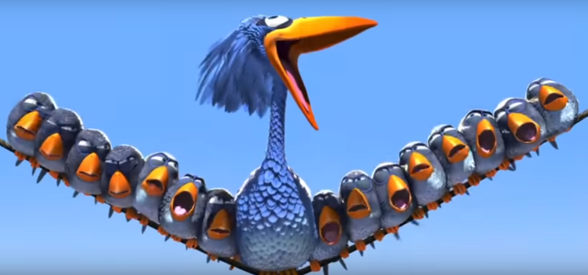
Why is the way we respond important in a relationship?
How could the birds have behaved differently towards big bird and each other?
Watch the video a second time and note the negative things the little birds do (eg whispering, laughing at, chanting)
List 10 ways the birds could have behaved better.

