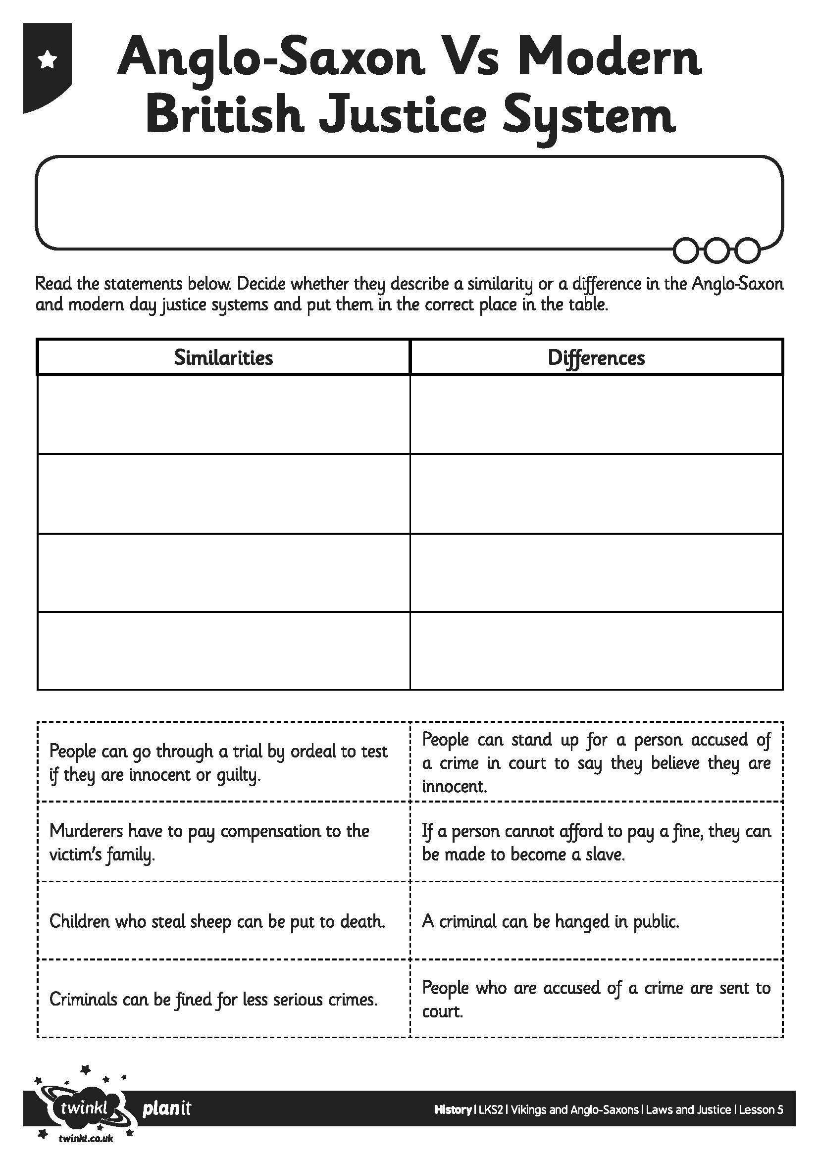
I can explain how the legal system worked in Anglo-Saxon Britain.
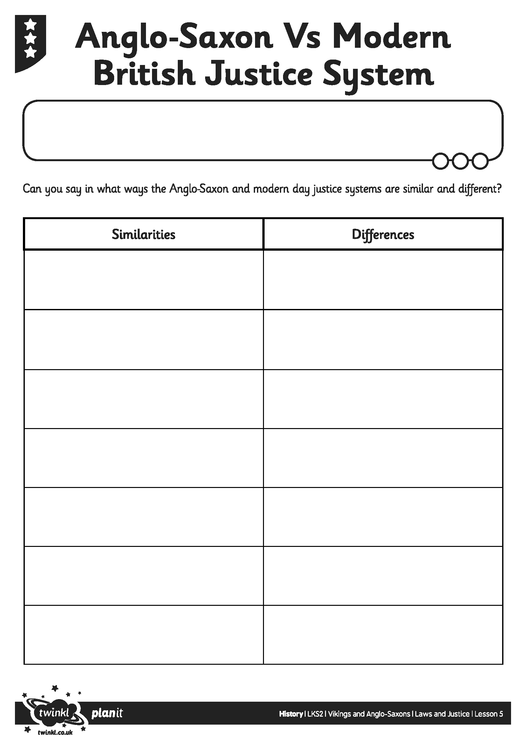
I can explain how the legal system worked in Anglo-Saxon Britain.

