The Atlantic slave trade by Aiden Bradley
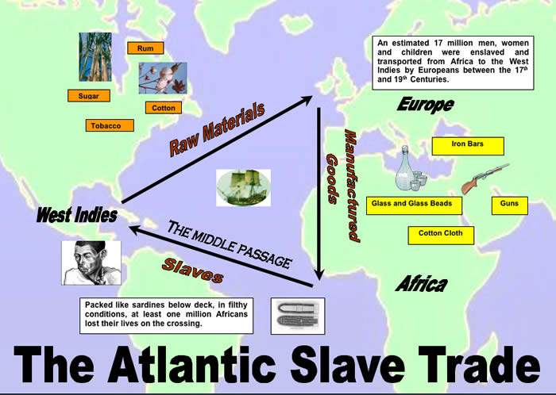
This Photo by Unknown Author is licensed under CC BY-SA-NC
The Atlantic slave trade was where European people took African people and sold them as slaves.
The Atlantic slave trade is called that because it happened in and around the Atlantic Ocean.
It went on for 400 years.
Sara Forbes Bonetta was a princess from Nigeria who was sold to King Ghezo of Dahomey. He then gave her as a gift to queen Victoria because he didn’t want to stop buying slaves.
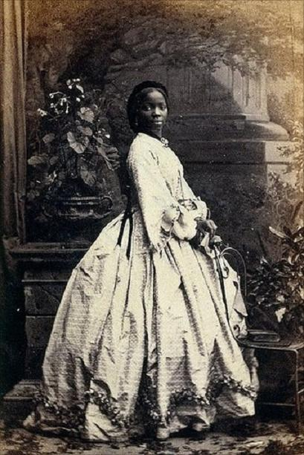
This Photo by Unknown Author is licensed under CC BY-NC-ND
The slaves were taken on slave ships.
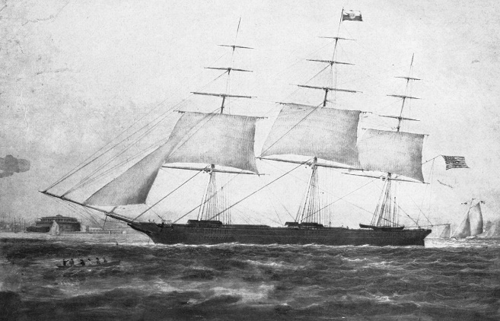
This Photo by Unknown Author is licensed under CC BY-SA
Lots of slaves died because the conditions of the ship were bad.
The slave trade was banned in 1807 in Britain.
This Photo by Unknown Author is licensed under CC BY-SA-NC

