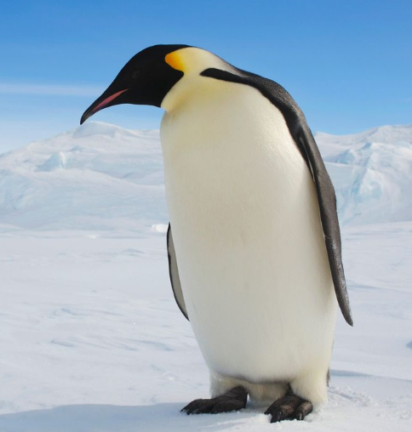
P4C
Hello, I would like to focus on the penguin this week. My question is:
Is a penguin a bird?
I don’t want to go down the biology line. I want you to talk about a penguin in comparison to other birds, then compare it to animals which walk on two feet, also a penguin swims – compare it to other animals which swim. Decide, in conversation with another family member if you would consider a penguin to be a bird, or is it closer to another animal? What do you think?

