 | Policy No:  S1 | Revision No: | 8
 |  | Date Issued: | January 2013
 |  | Committee: | FGB
 | Anti-Bullying Policy | Author: | Headteacher
 |  | Date Adopted: | October 2022
 |  | Minute No: | 4.10.22, min no 19.9
 |  | Review Date: | October 2023

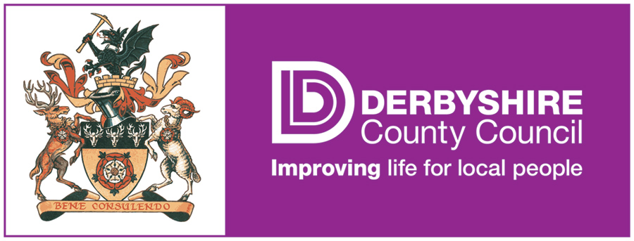

FEDERATION OF PENNY ACRES AND WIGLEY PRIMARY SCHOOL

ANTI-BULLYING POLICY

Anti-bullying Policy
Introduction

In the Federation of Penny Acres and Wigley Primary Schools we aim to provide a safe, caring and friendly environment for all our pupils to allow them to learn effectively, improve their life chances and help them maximise their potential.
We would expect pupils to feel safe in and out of school, including an understanding of the issues relating to safety, such as bullying. We also want them to feel confident to seek support from school should they feel unsafe.

Policy Development

This policy was formulated in consultation with the whole school community with input from members of staff, governors, parents/carers, children and young people.

Pupils contribute to the development of the policy through the school council, circle time discussions, etc. The school council will develop a Student friendly version to be displayed in both schools.

Parents/Carers will be encouraged to contribute by: taking part in written consultations, parent meetings, parent focus groups producing a shorter parent’s guide.

Roles and Responsibilities

The Executive Headteacher has overall responsibility for the policy and its implementation and liaising with the governing body, parents/carers, LA and outside agencies and appointing an Anti-bullying coordinator who will have general responsibility for handling the implementation of this policy.

The Anti-bullying Coordinator in our schools is: Mr D Ratcliffe (Executive Headteacher)

Their responsibilities are:
- Policy development and review involving pupils, staff, governors, parents/carers and relevant local agencies
- Implementing the policy and monitoring and assessing its effectiveness in practice
- Ensuring evaluation takes place and that this informs policy review
- Managing bullying incidents
- Managing the reporting and recording of bullying incidents
- Assessing and coordinating training and support for staff and parents/carers where appropriate
- Coordinating strategies for preventing bullying behaviour

The nominated Governor with the responsibility for Anti-bullying (Behaviour) is:
Mr P Dorward

Definition of Bullying
‘Behaviour by an individual or group usually repeated over time, that intentionally hurts another individual or group either physically or emotionally’.
Safe to Learn: embedding anti bullying work in schools (2007).

How does bullying differ from teasing/falling out between friends or other types of aggressive behaviour?

- There is a deliberate intention to hurt or humiliate.
- There is a power imbalance that makes it hard for the victim to defend themselves.
- It is usually persistent.

Occasionally an incident may be deemed to be bullying even if the behaviour has not been repeated or persistent - if it fulfils all other descriptions of bullying. This possibility should be considered, particularly in cases of sexual, sexist, racist or homophobic bullying and when children with disabilities are involved. If the victim might be in danger then intervention is urgently required.

What does bullying look like?

Bullying can include:

- name calling
- taunting
- mocking
- making offensive comments
- physical assault
- taking or damaging belongings
- cyber bullying - inappropriate text messaging and e mailing; sending offensive or degrading images by phone or via the internet
- producing offensive graffiti
- gossiping and spreading hurtful and untruthful rumours
- excluding people from groups.

Although bullying can occur between individuals it can often take place in the presence (virtually or physically) of others who become the ‘bystanders’ or ‘accessories’.

Why are children and young people bullied?

Specific types of bullying include:

- bullying related to race, religion or culture
- bullying related to special educational needs or disabilities
- bullying related to appearance or health
- bullying relating to sexual orientation – homophobia/not fitting in with gender stereotypes
- bullying of young carers or looked after children or otherwise related to home circumstances
- sexist or sexual bullying.

There is no hierarchy of bullying - all forms should be taken equally seriously and dealt with appropriately.

Bullying can take place between:

- young people
- young people and staff
- between staff
- individuals or groups
- Certain groups of pupils are known to be particularly vulnerable to bullying by others: these may include pupils with special educational needs such as learning or physical disabilities; young carers, Looked After children, those from ethnic and racial minority groups and those young people who may be perceived as lesbian, gay, bi-sexual, transgender or questioning their gender role.

Reporting and Responding to Bullying

Our school has clear and well-publicised systems to report bullying for the whole school community (including staff, parents/carers, children and young people) this includes those who are the victims of bullying or have witnessed bullying behaviour (bystanders).

Procedures

All reported incidents will be taken seriously and investigated involving all parties.
We will:

- Interview all parties
- Inform parents
- Implement a range of responses appropriate to the situation: - solution focused, restorative approach, circle of friends, individual work with victim, perpetrator, referral to outside agencies if appropriate
- Refer to the Behaviour policy and school sanctions and how these may be applied including what actions may be taken if bullying persists
- Follow up especially keeping in touch with the person who reported the situation and parents/carers
- Initiate support for the victim and the bully
- Police involvement when necessary (e.g. if a crime has been committed).

Recording Bullying and Evaluating the Policy

Bullying incidents will be recorded by the member of staff who deals with the incident and this will be notified to and held by the Anti-bullying coordinator.

The information we hold will be used to ensure individual incidents are followed up. It will also be used to identify trends and inform preventative work in school and development of the policy.

This information will be presented to the governors in an anonymous format as part of the annual report.

The policy will be reviewed and updated annually.

The policy review will be linked to the School Improvement Plan, working towards a more inclusive and harmonious ethos across the school community.

Strategies for Preventing Bullying

As part of our on-going commitment to the safety and welfare of our pupils we at the Federation of Penny Acres and Wigley Primary Schools have developed the following strategies to promote positive behaviour and discourage bullying behaviour.

- Restorative Approaches
- Involvement in Healthy Schools
- Anti-Bullying week annually
- PSHE/citizenship
- Specific curriculum input on areas of concern such as Cyberbullying and internet safety
- Student voice
- Parent groups/extended schools
- Parent information events/information
- Staff training and development for all staff
- Counselling and/or Mediation schemes

Links with other policies

Behaviour Policy
Safeguarding Policy
Acceptable Use Policy - Cyberbullying and internet safety
Equalities Policy - Race, Sexist, Sexual, Transphobic, Homophobia, SEN and Disability PSHE and Citizenship Policy
Complaints policy
Confidentiality Policy.

