Working at home in RE, PSHE and art – Mrs Eyre
Friday 3rd July
It’s RE/PSHE and ART time again!
Last week in science our scientist of the week was an artist also! You may have done this activity…..
‘Be a ‘Maria Sibylla Merian style’ science ambassador and take a sketch pad and pencil outside. Find some interesting natural science to sketch. Try to observe objects very closely and include minute detail in your drawings.’
For art today, research Maria’s artwork and choose some that inspires you. Combine this with your science sketches to produce a piece of artwork in the style of Maria Sibylla Merian.

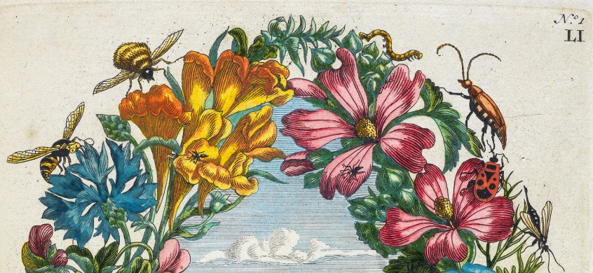
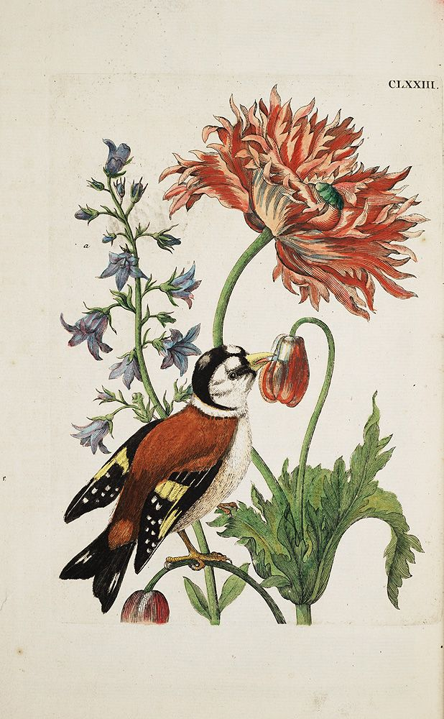
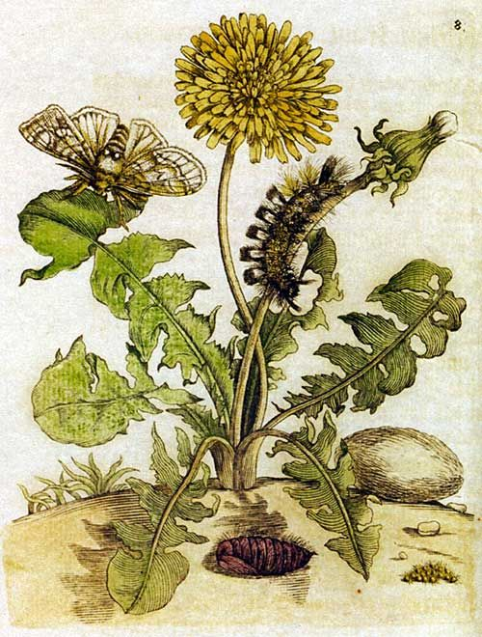
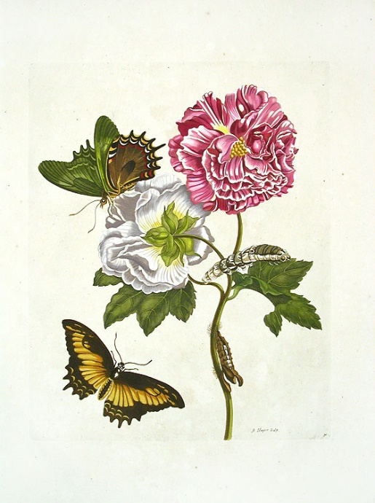
Happy drawing!

