**Materials**

* Empty Plastic Two Litre Bottle
* Drinking Straw
* Small Paper Clip
* Play-dough or Reusable Adhesive Putty
* Thick Tin Foil (I used a Tin Foil Pan)
* Scissors
* Water

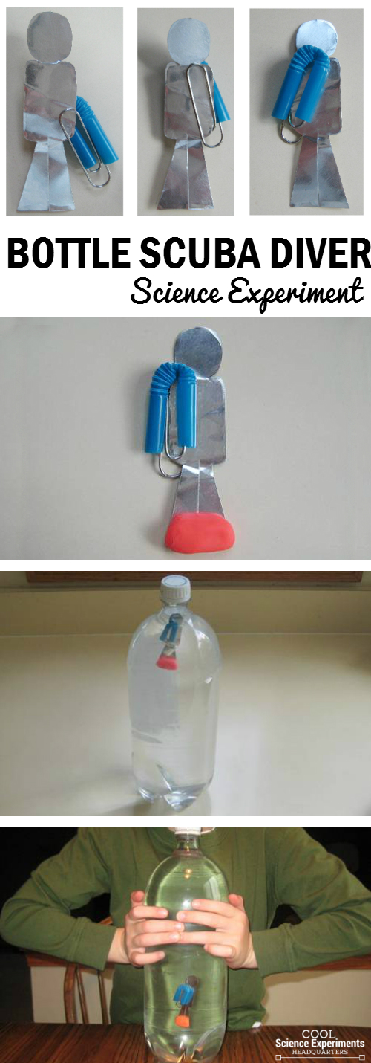**Instructions**

1. Cut out your diver using the same shape and size indicated above. I lightly sketched my diver on my foil before I cut him out. Note: That is a small paper clip. The diver should be approximated an inch and a half tall.
2. Cut the straw and position it on the paper-clip as show above. Each end should be secured by the ends of the paper clip.
3. Slowly slide the straw onto the diver as show above. The diver should look like he’s wearing a scuba tank.
4. Place a small piece of play-dough or putty on the diver’s feet.
5. Fill a glass with water and put the diver in. This is to test to make sure it floats. It should float as shown above. If it doesn’t float, you’re straw may have a hole in it. Try again with a new straw.
6. Fill the two liter bottle with water. Make sure to fill it to the top, otherwise the experiment won’t work. Carefully place the diver into the bottle and screw on the lid
7. Squeeze the bottle and watch as the diver sinks to the bottle. Stop squeezing and he will float back to the top.