Working from home in science – Mrs Eyre
Thursday 2nd July - How are seeds dispersed?
This week in science we are all looking at how seeds are dispersed. Watch this video and see how many different ways seeds can be spread.
https://www.bbc.co.uk/bitesize/clips/znvfb9q
https://www.youtube.com/watch?v=xY4JFOSuqvY&safe=active
Research the main methods of seed dispersal and present as a power point, or word document. Include lots of detail, different examples of each and pictures. eg
- Wind (wings/parachute eg dandelion)
- Water (floating eg water lily)
- Explosion (bursting pods eg gorse)
- Animals (fur/burying eg sticky burrs/acorns)
- Birds (eating eg blackberries)
- Gravity (drop and roll eg coconut)
- Fire (eg pine cones)
- Self dispersal (pepperpots eg poppies)
Can you find any examples in your garden or locality?
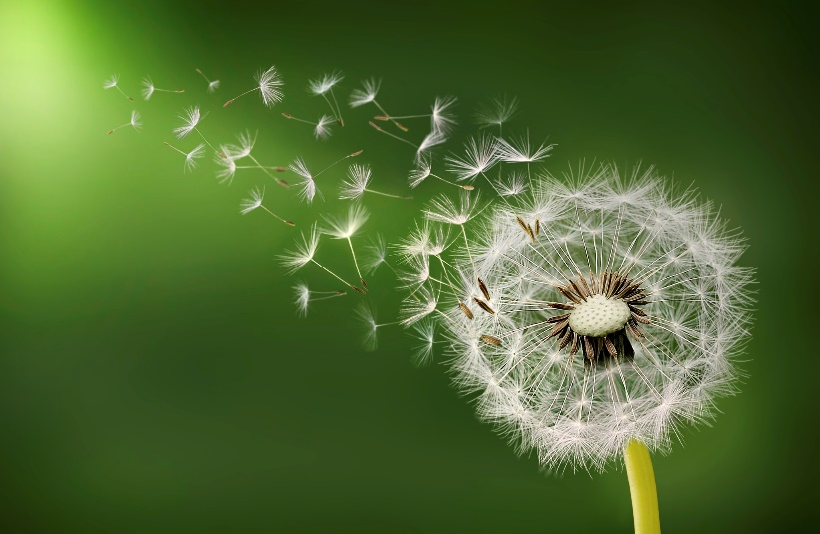
Can you find any unusual examples from other countries/habitats?
