L.O. I can extract information from a Biography – Usain Bolt
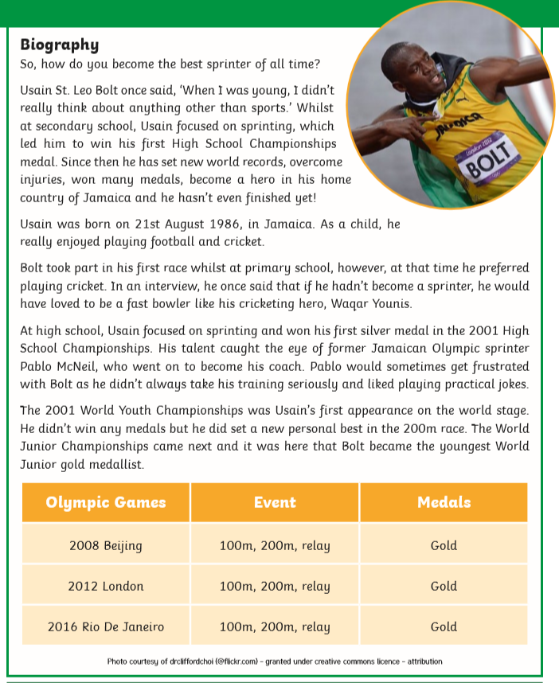
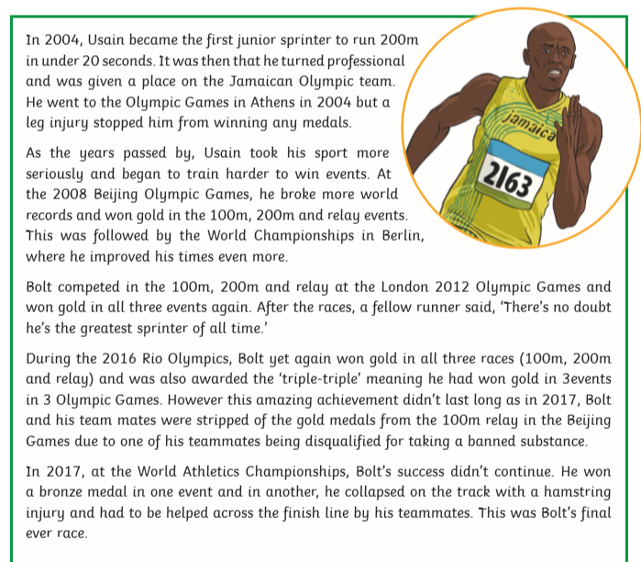
Y5/6
- When and where was Usain Bolt born?
Usain Bolt was born in Jamaica on the 21st August, 1986.
- What did Usain become the first sprinter to do in 2004?
In 2004, Usain became the first junior sprinter to run 200m in under 20 seconds.
- How do you think Bolt felt when he was chosen to represent his country in the Olympic Games?
Either:
I think he may have been disappointed because he preferred football and cricket and he would have much preferred to play cricket. He wanted to be a fast bowler like his cricketing hero, Waqar Younis.
I think he would have felt really proud to represent his country. He had been winning competitions in running since High School. In 2001, he won his first silver medal. He eventually started to take his running seriously and turned professional in 2004.
- How many gold medals did he win in the 2008, 2012 and 2016 Olympic Games?
Usain won 3 gold medals in the 100m, 200m and relay event at each of the 2008, 2012 and 2016 Olympic Games, which makes nine gold medals in total. However, his gold medal in the relay in 2008 was taken off him meaning he now has eight gold medals.
- How do you think Usain felt after the 2017 World Championships? Explain your answer with reasoning from the text.
Suggested answer: Usain might have felt disappointed that he didn’t win yet another gold medal. He might have been worried about his injury and devastated that he finished his career in this way.
Y3/4 (Answers on Page 1 of the text only. Please write in full sentences.)
- What is Usain’s full name?
His full name was Usain St. Leo Bolt.
- What was the first medal he won?
Usain won his first medal at Secondary School, competing in the High School Championships. He won a silver medal.
- What country was he born in? (Extension – look up the flag for this country and draw it.)
Usain Bolt was born in Jamaica.
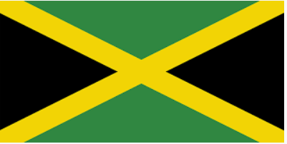
- At Primary School, did he prefer running? Explain your answer.
No, at Primary School he much preferred cricket; he wanted to be a fast bowler like his cricketing hero, Waqar Younis.
- Who was his coach? Where did he first meet him?
His coach was called Pablo McNeil. He first met him at the 2001 High School Championships.
- Which Olympic Games did he win his first gold medal? What races were these for?
He won his first gold medals in the 2008 Beijing Olympic games for the 100m, 200m and the relay.

