 | Policy No: C18 | Revision No: | 4
 |  | Date Issued: | October 2016
 |  | Committee: | Full Governors
 | Written Calculations Policy | Author: | Headteacher
 |  | Date Adopted: | October 2021
 |  | Minute No: | 5.10.21, min no 18.7
 |  | Review Date: | October 2023

FEDERATION OF PENNY ACRES AND WIGLEY PRIMARY SCHOOL

WRITTEN CALCULATIONS POLICY

Background to the policy

This policy represents the changes in the Primary Mathematics curriculum. Children are encouraged to reach Mastery in mathematics for their Year group, by using a range of concrete, pictorial and abstract approaches, before understanding a formal written approach. The approaches in this policy are a collective approach – a teacher will decide which approach(es) to use for their pupils each year to gain mastery.

This calculations policy uses the themes and ideas from the White Rose Maths Hub, adapted to suit the learning needs to the children at Penny Acres and Wigley Federation.

We also believe that it is essential to use the correct terminology and language to gain Mastery and Greater Depth in mathematics.

It also can be used to provide a rationale to parents on the how we teach mathematics.

Year 1 Addition
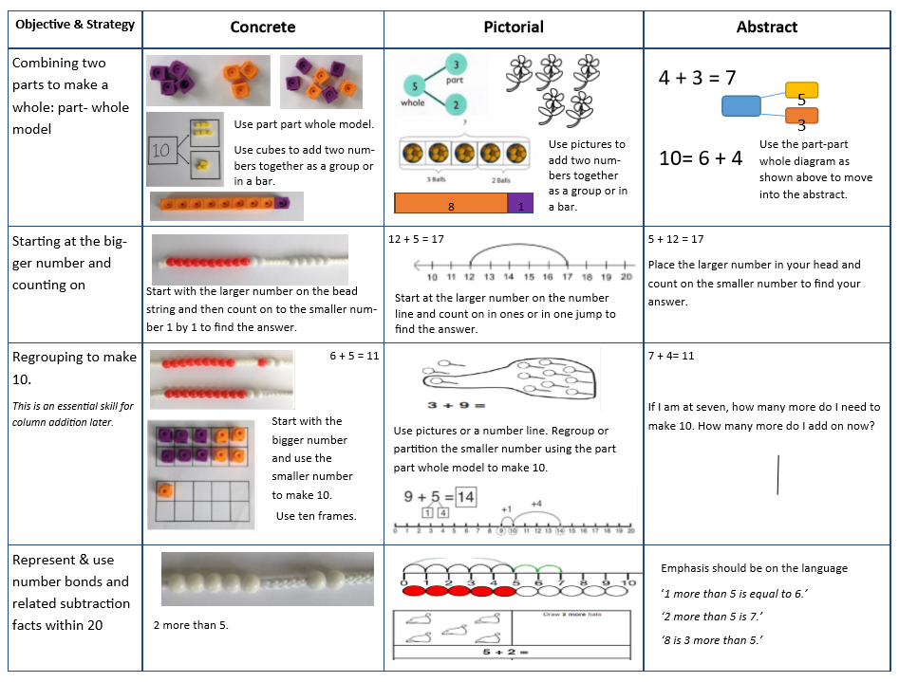

Year 2 – Addition
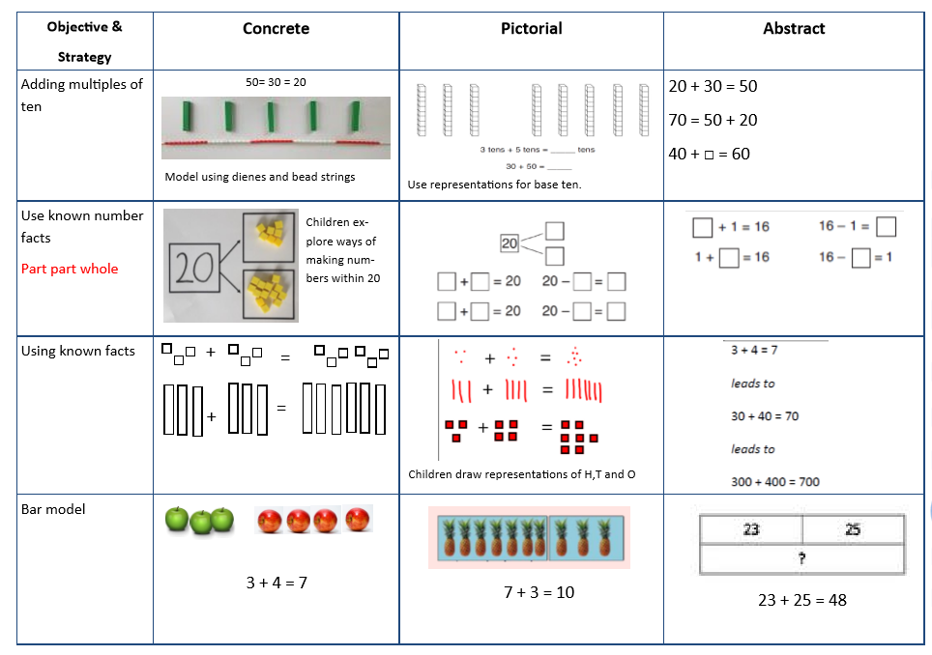

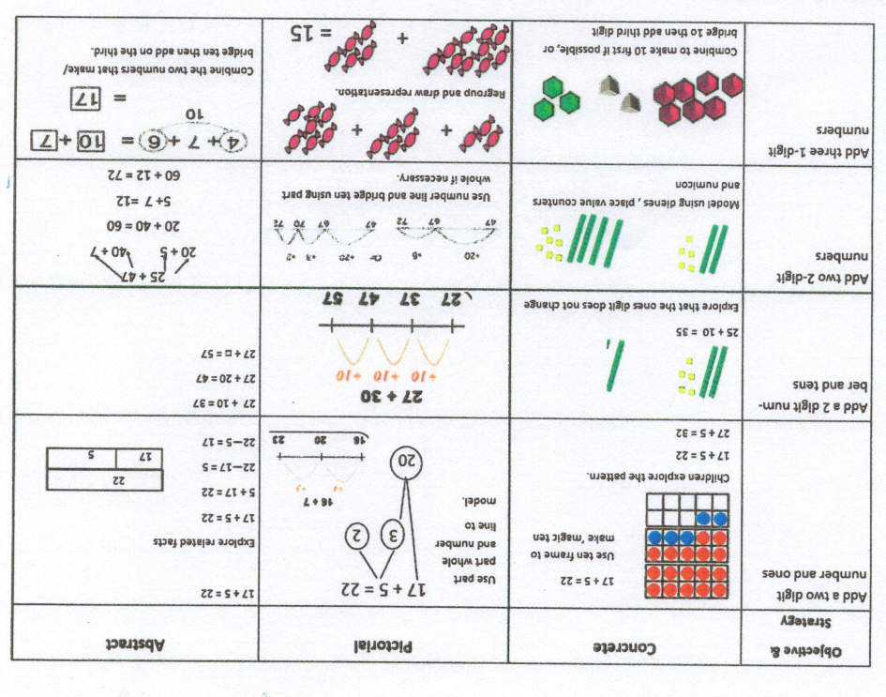

Year 3 – Addition
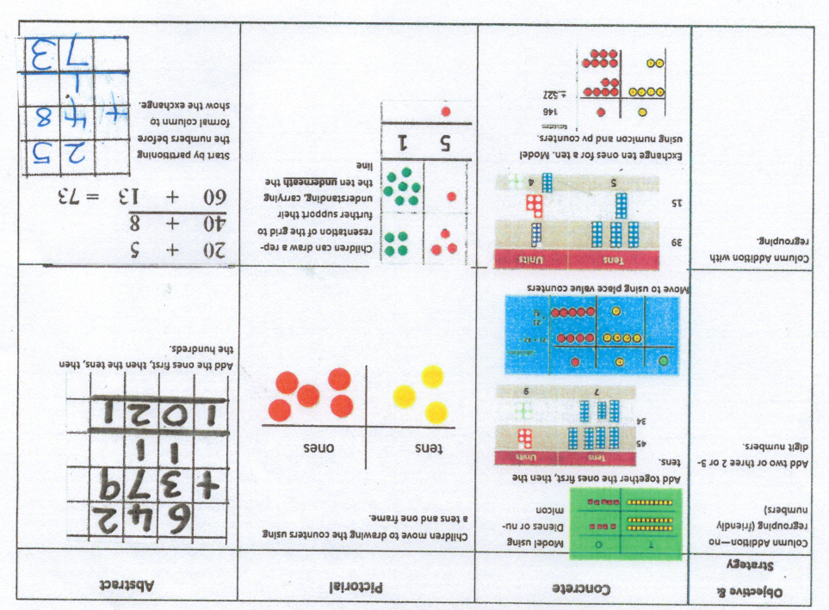

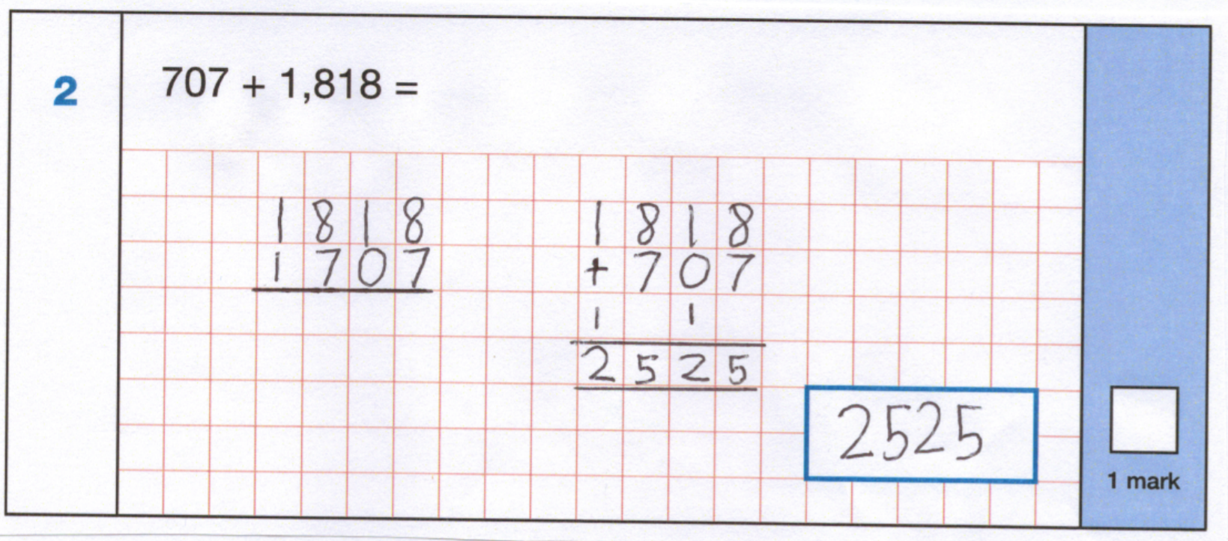

Years 4-6 – Addition

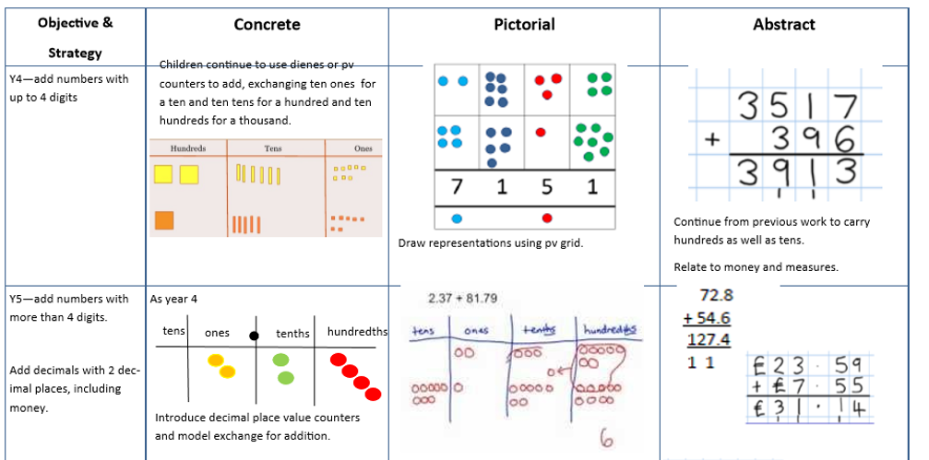
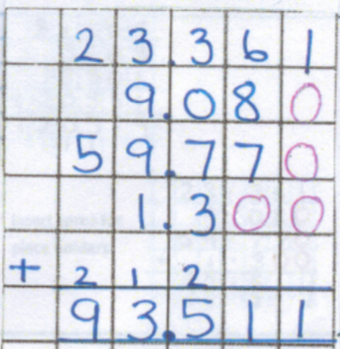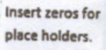

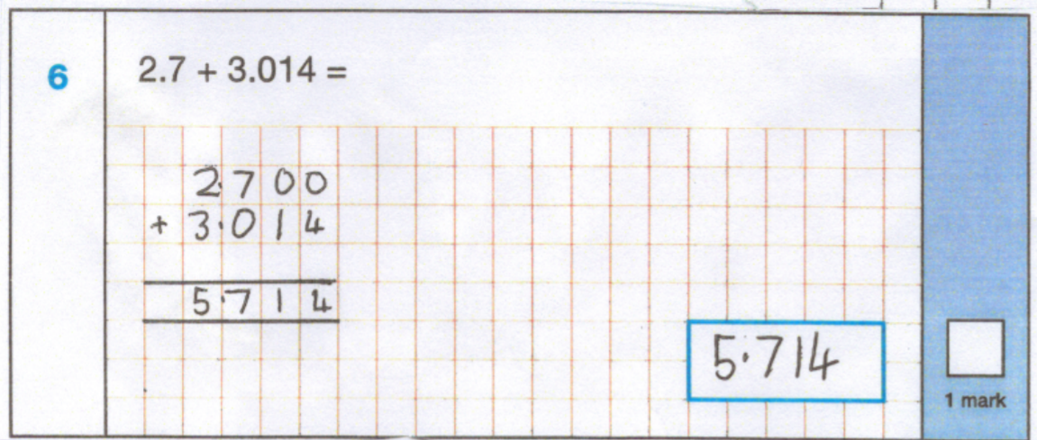

Year 1 – Subtraction

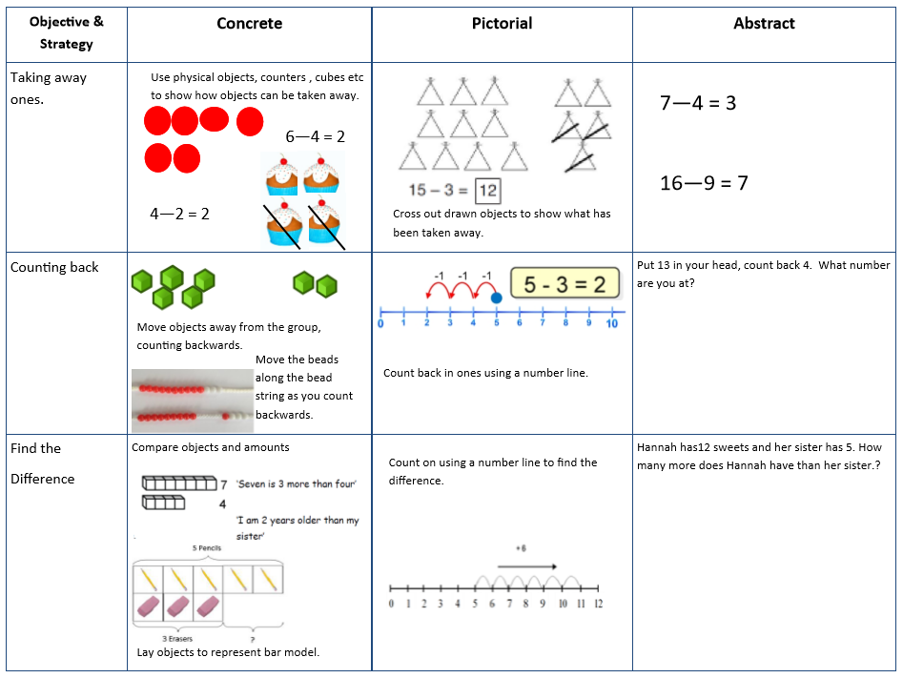
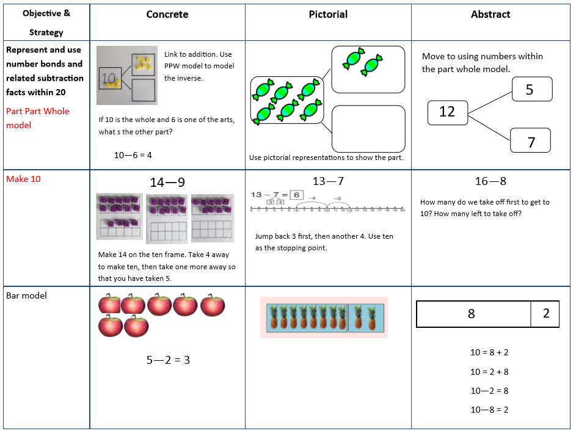

Year 2- Subtraction
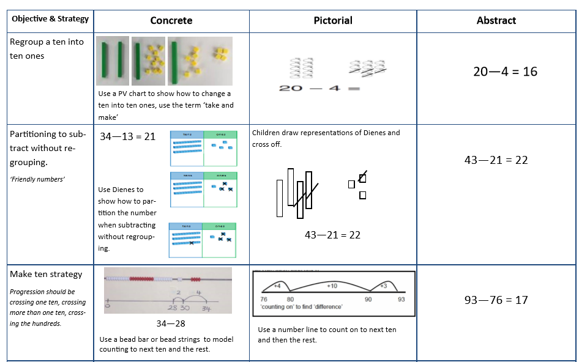
Year 3 Subtraction

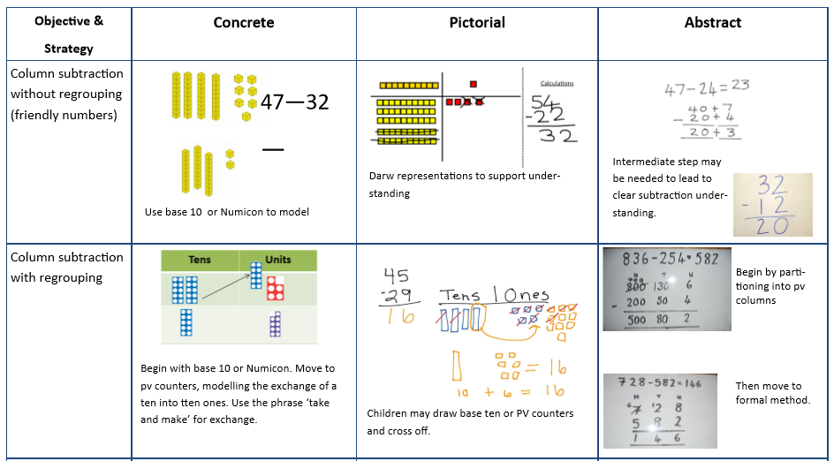

Year 4-6 – Subtraction
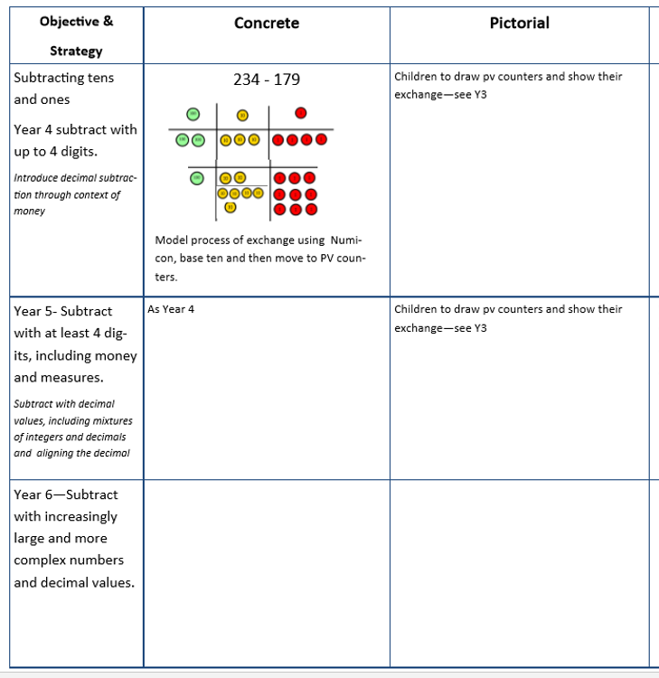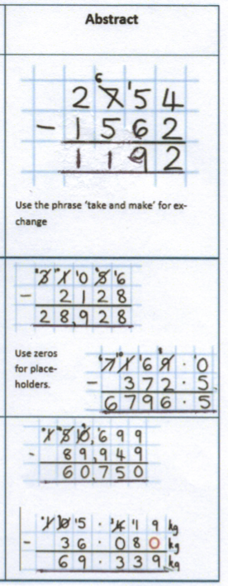

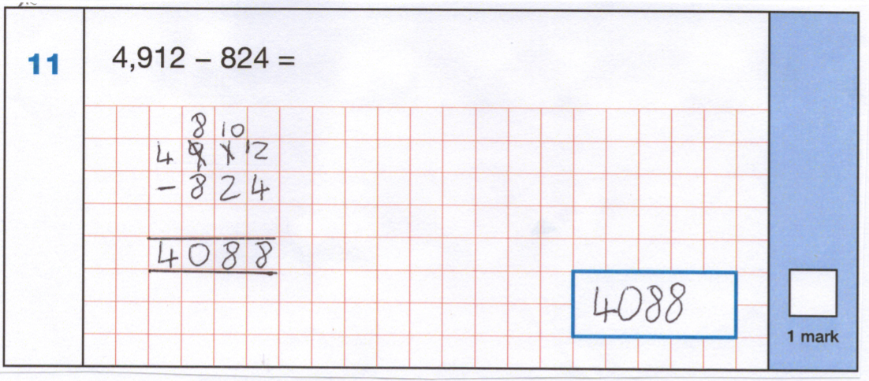

Year 1 – Multiplication

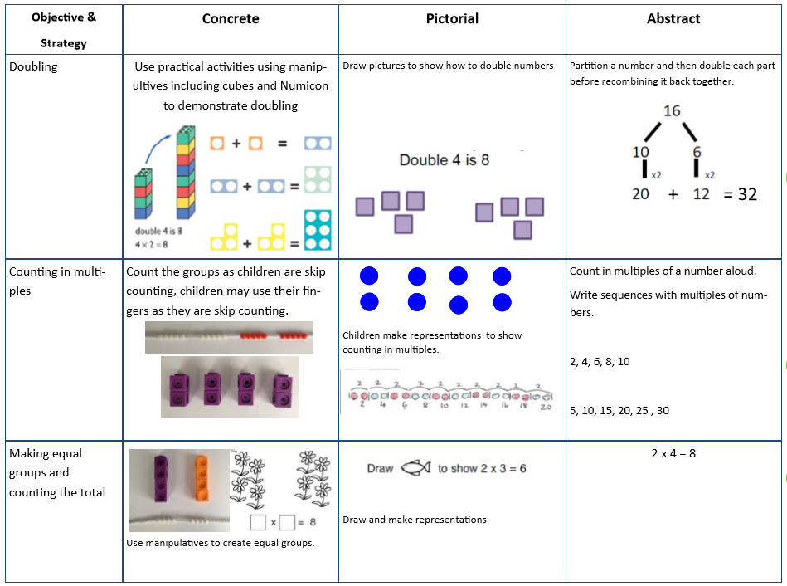
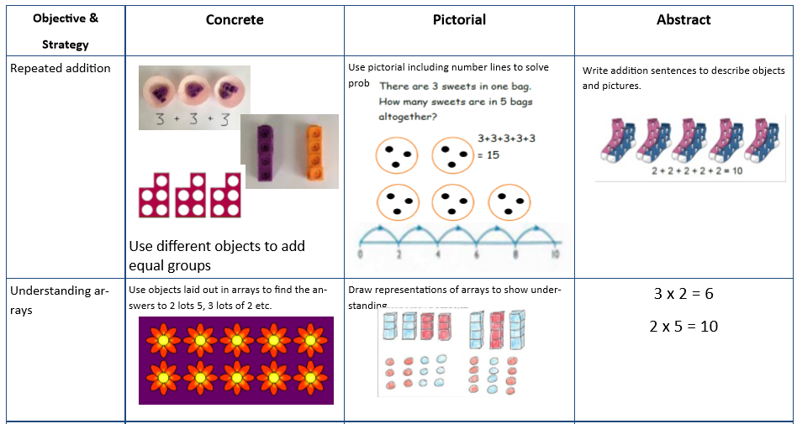

Year 2 – Multiplication 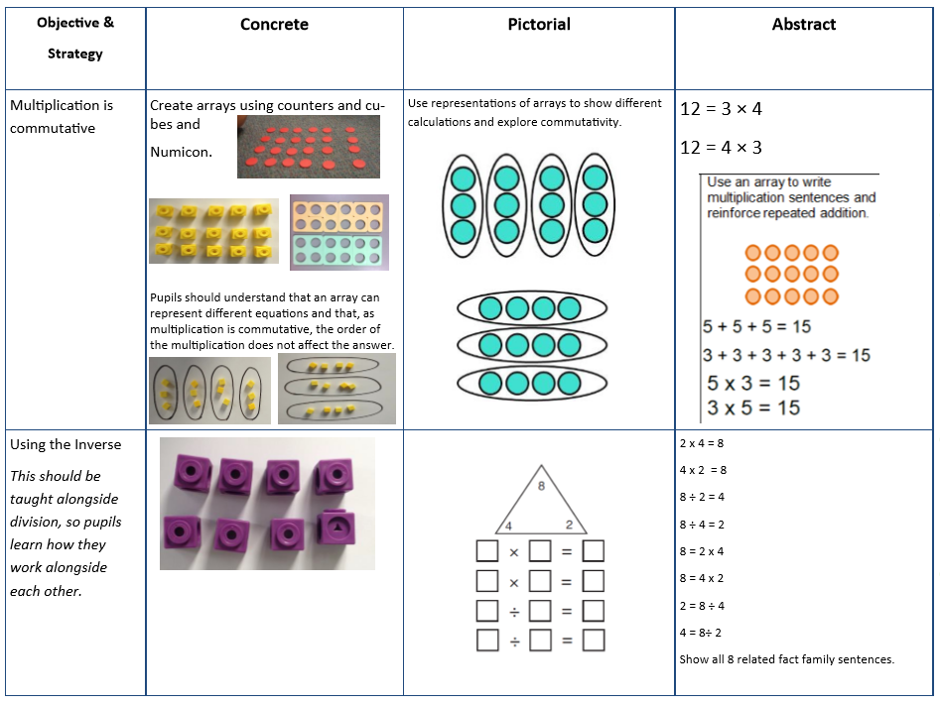
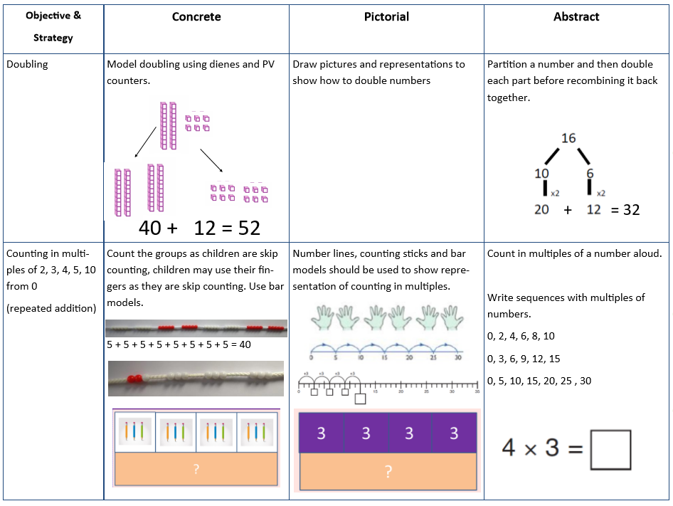

Year 3 – Multiplication

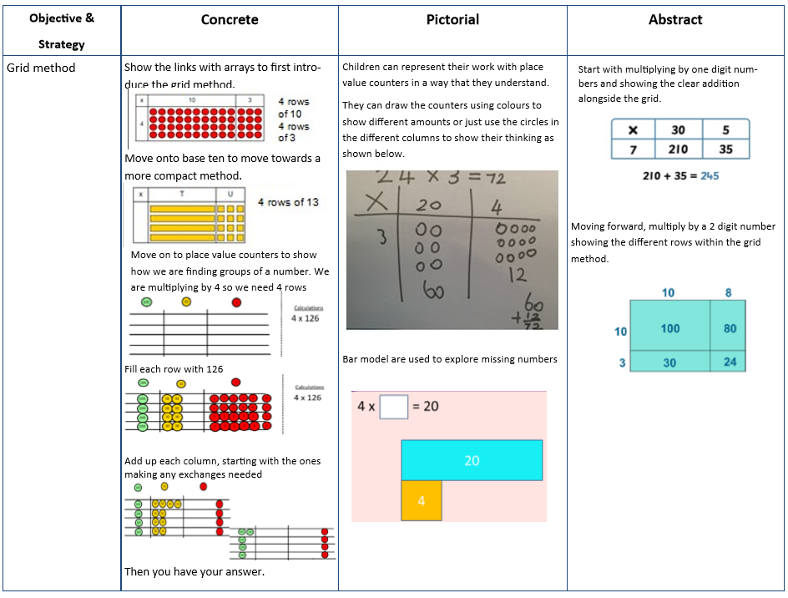

Year 4 – Multiplication

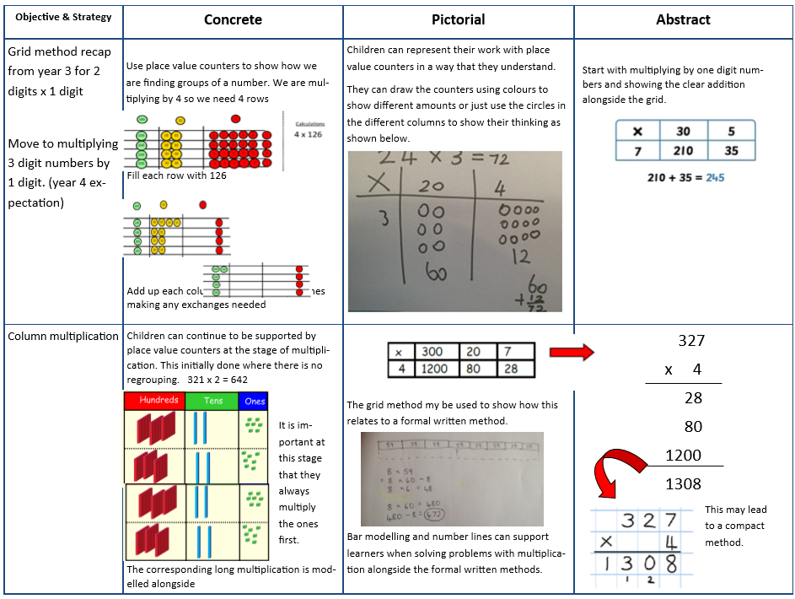

Years 5 and 6 Multiplication

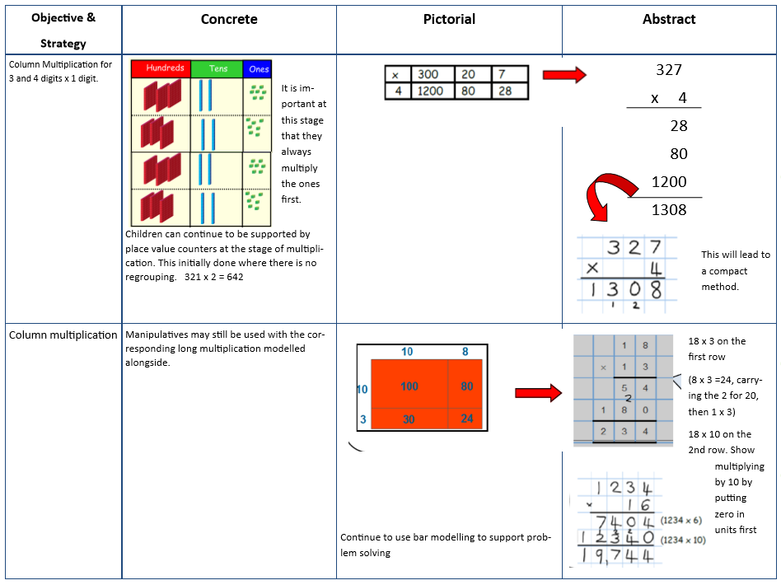

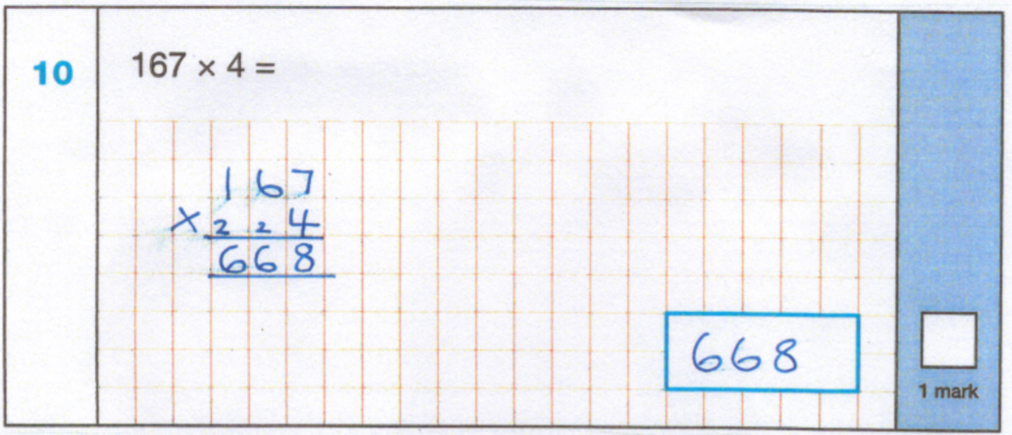

Year 6 Multiplication

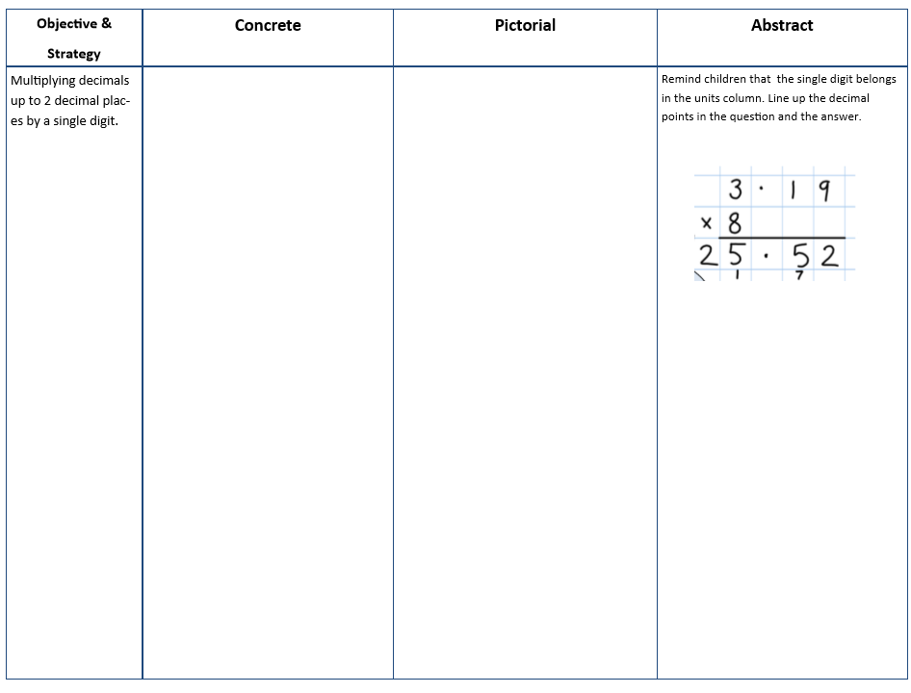

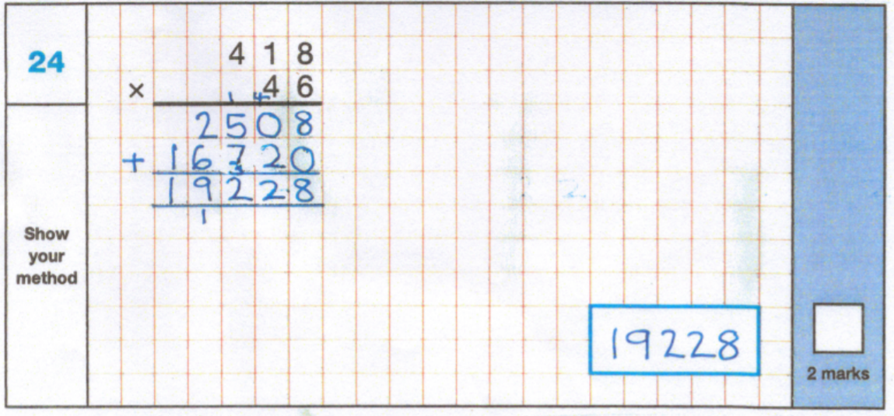

Year 1 – Division

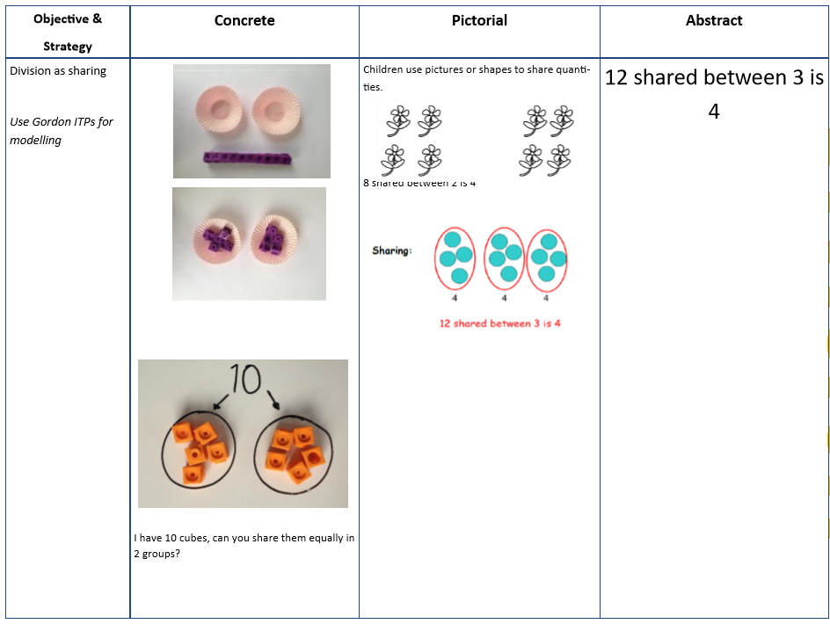

Year 2 – Division

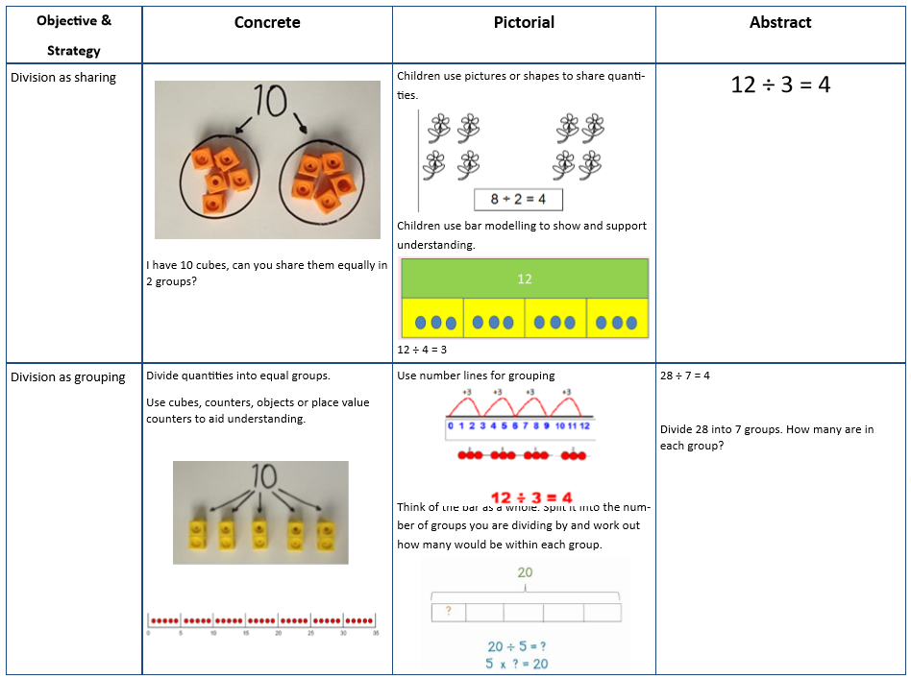

Year 3 – Division

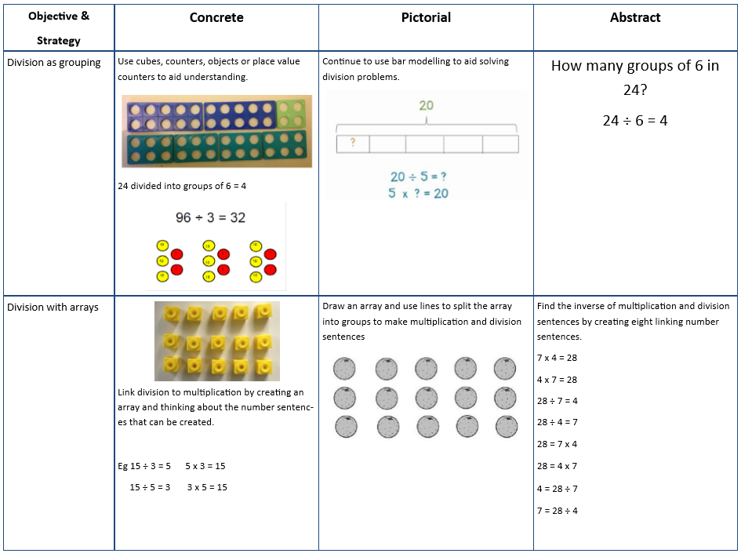
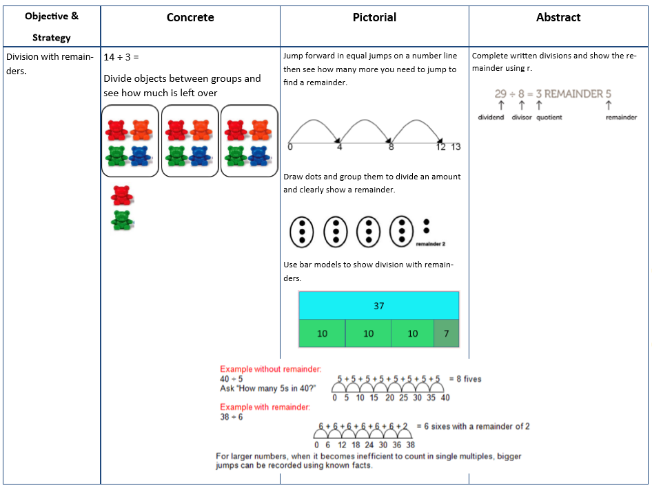

Years 4-6 Division

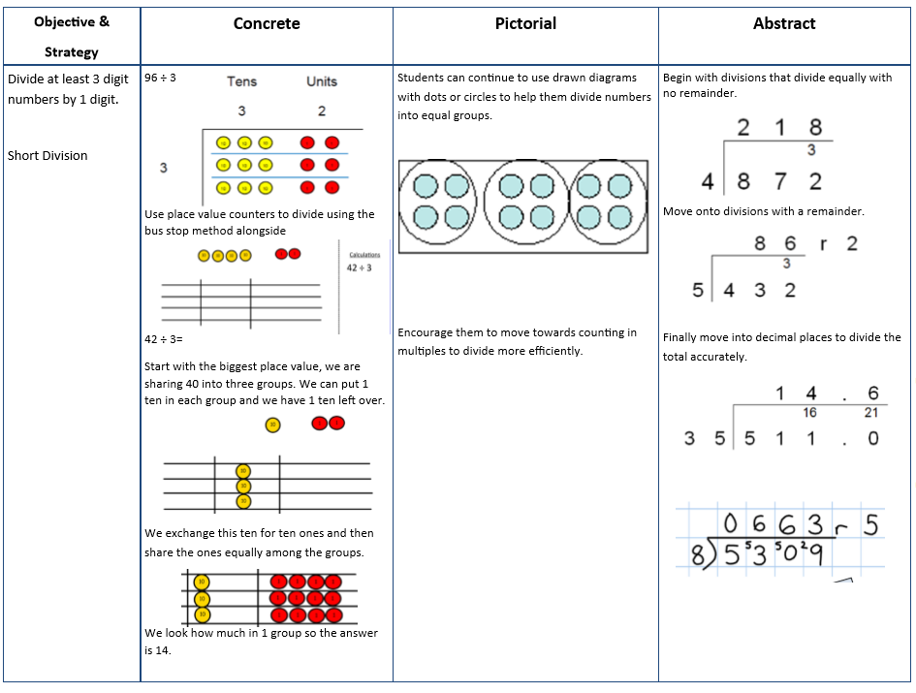
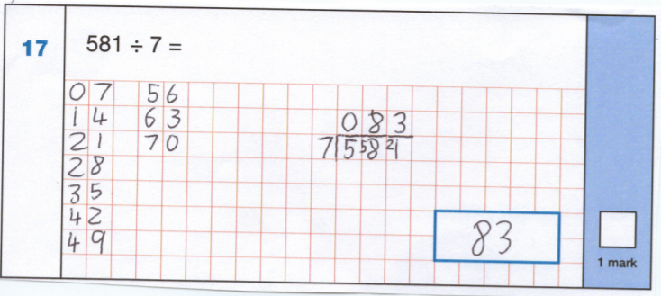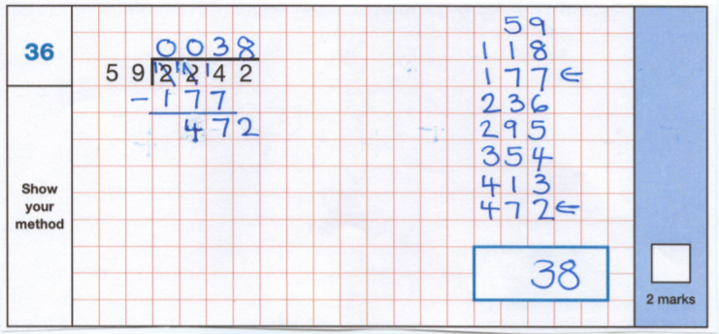

Year 6 – Division

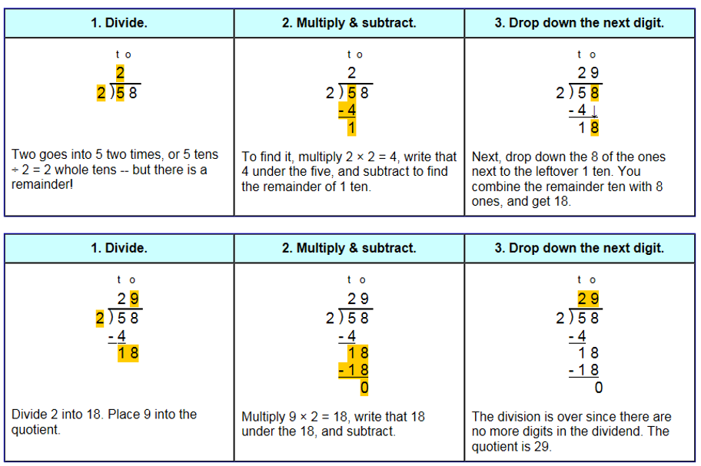
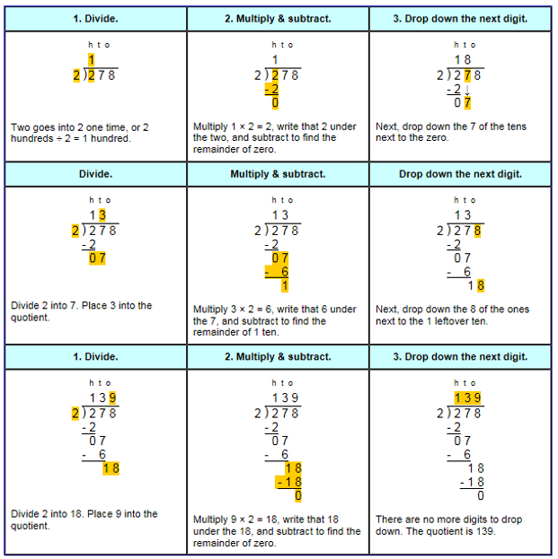

Adding fractions
Year 3 and 4
Objective and strategy | Concrete | Pictorial | Abstract
Add fractions with the same denominator within one whole | 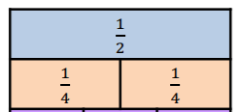 | 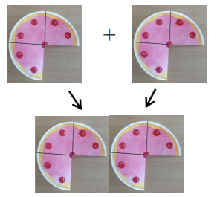 | $\frac{3}{4}$+$\frac{3}{4}$=$\frac{6}{4}$

Year 5
Objective and strategy | Concrete | Pictorial | Abstract
Recognise mixed numbers and improper fractions and convert from one form to another |  | +  = | 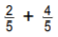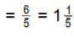
Add fractions with the same denominator and denominators which are multiples of the same number. | whole  half  quarter | 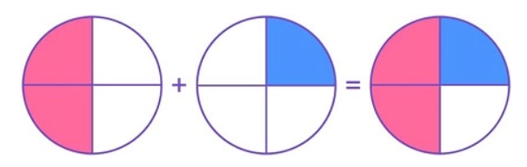 | $\frac{1}{2}$ + $\frac{1}{4}$ = $\frac{3}{4}$

Year 6
Objective and strategy | Concrete | Pictorial | Abstract
Add fractions with different denominators and mixed numbers, using the concept of equivalent fractions. | 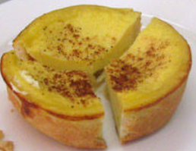  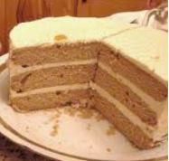 | $\frac{1}{4}$ + $\frac{1}{3}$ =  $$\frac{1}{4}$$  $$\frac{1}{12}$$ $$\frac{1}{12}$$ $$\frac{1}{12}$$ $$\frac{1}{12}$$  $$\frac{1}{3}$$  $$\frac{1}{12}$$ $$\frac{1}{12}$$ $$\frac{1}{12}$$ | $\frac{1}{4}$ + $\frac{1}{3}$ =  Find the common denominator –  4x3 = 12. Both are factors of 12.  $\frac{1}{4 }$ = $\frac{3}{12}$  $\frac{1}{3}$ = $\frac{4}{12 }$ so  $\frac{3}{12}$ + $\frac{4}{12}$ = $\frac{7}{12}$

Subtracting fractions
Year 4
Objective and strategy | Concrete | Pictorial | Abstract
Add and subtract fractions with the same denominator. | 1 whole  x x | x x | $\frac{6}{9}$-$\frac{2}{9}$= $\frac{4}{9}$

Year 5
Objective and strategy | Concrete | Pictorial | Abstract
Subtract fractions with the same denominator and denominators which are multiples of the same number. | 1 whole  x x x x  1 whole | x x x x | 2 - $\frac{4}{5} =$  $\frac{10}{5}$ - $\frac{4}{5} =$ $\frac{6}{5}$  $\frac{6}{5}$ = 1 $\frac{1}{5}$
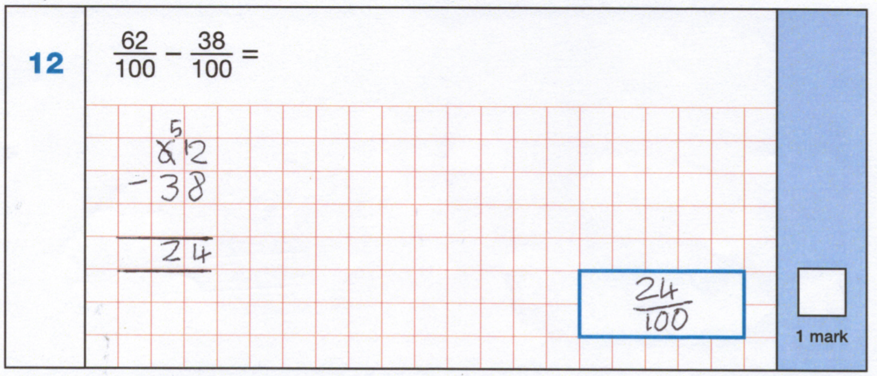
Year 6
Objective and strategy | Concrete | Pictorial | Abstract
Subtract fractions with different denominators and mixed numbers, using the concept of equivalent fractions. | 1 whole  $$\frac{1}{2}$$ $$\frac{1}{2}$$  $$\frac{1}{6}$$ $$\frac{1}{6}$$ $$\frac{1}{6}$$ $$\frac{1}{6}$$ $$\frac{1}{6}$$ $$\frac{1}{6}$$  1 whole  $$\frac{1}{3}$$ $$\frac{1}{3}$$ $$\frac{1}{3}$$  $$\frac{1}{6}$$ $$\frac{1}{6}$$ $$\frac{1}{6}$$ $$\frac{1}{6}$$ $$\frac{1}{6}$$ $$\frac{1}{6}$$ | 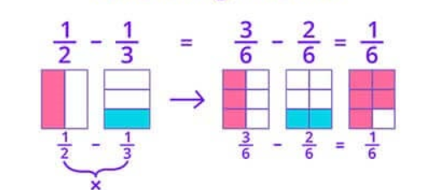 | $\frac{1}{2}$ - $\frac{1}{3}$ =  X3 x2  $\frac{3}{6}$ - $\frac{2}{6}$  = $\frac{1}{6}$

Multiplying fractions
Year 5
Objective and strategy | Concrete | Pictorial | Abstract
Multiply proper fractions and mixed numbers by whole numbers, supported by materials and diagrams | 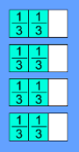 = $\frac{8}{3}$ | $\frac{2}{3}$ x 4 =  or  $\frac{8}{3}$ = 2 $\frac{2}{3}$ | 2 x 4  $\frac{2}{3}$ x $\frac{4}{1}$  3 x 1  $\frac{8}{3}$ or 2$\frac{2}{3}$

Year 6
Objective and strategy | Concrete | Pictorial | Abstract
multiply simple pairs of proper fractions, writing the answer in its simplest form | $\frac{2}{3}$ x$\frac{3}{4}$ =  Take $\frac{2}{3}$ of a shape:  Divide each third into quarters:  Shade $\frac{3}{4}$ of the $\frac{2}{3}$ : | 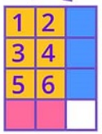  Combine both together = $\frac{6}{12}$= $\frac{1}{2}$ | $\frac{2}{3}$ x$\frac{3}{4}$ =  Multiply the numerators – 2x3=6  Multiply the denominators – 3 x 4 =12  = $\frac{6}{12}$ = $\frac{1}{2}$
Dividing fractions
Year 6
Objective and strategy | Concrete | Pictorial | Abstract
divide proper fractions by whole numbers | How many groups of $\frac{1}{2}$  are there in 8 wholes?  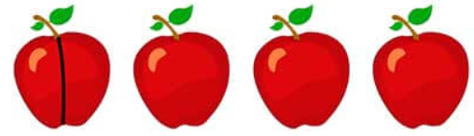 | What would be the size of each part if ½ is divided into 4? | $\frac{1}{2}$ ÷ 4 =  multiplication and division are the inverse so inverse the fraction and inverse the division symbol to multiplication  $\frac{2}{1}$ x $\frac{4}{1}$ = $\frac{8}{1}$  or  8 whole ones

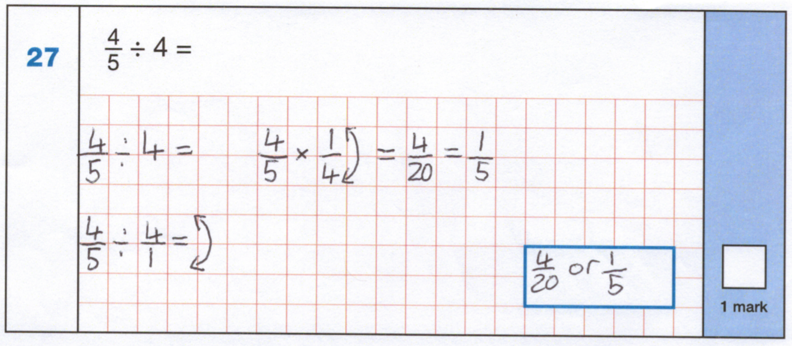

Penny Acres and Wigley Federation
Mathematical Language
Reception
Place Value/Number
zero, ones, tens, digit, the same number as, as many as, more, larger, bigger, greater, fewer, smaller, less, fewest, smallest, least, most, biggest, largest, greatest, one more, ten more, one less, ten less, compare, order, size, first, second, third, fourth, fifth, sixth, seventh, eighth, ninth, tenth, last, last but one, before, after, next, between, count up to, count on from, count in ones, twos, fives, tens, few pattern, pair,
Estimating
guess, how many, estimate, nearly, close to, about the same as, just over, just under, too many, too few, enough, not enough
Addition and Subtraction
add, more, and, make, sum, total, altogether, double, one more, two more …ten more, how many more to make...? how many more is… than …? how much more is…? take away, how many are left/left over? how many have gone? One less, two less…ten less, how many fewer is… than…? How many less is…? difference between
Multiplication and Division
sharing, doubling, halving, number patterns,
Fractions
parts of a whole, half, quarter,
Measurement
measure, size, compare, guess, estimate, enough, not enough, too much, too little, too many, too few, nearly, close to, about the same as, just over, just under,
Length
metre, length, height, width, long, short, tall, high, low, wide, narrow, thick, thin, longer, shorter, taller, higher, far, near, close
Weight
weigh, weighs, balances, heavy, light, heavier than, lighter than, heaviest, lightest, scales
Money
money, coin, penny, pence, pound, price, cost, buy, sell, spend, spent, pay

Time
Time, Monday…Sunday, day, week, birthday, holiday, morning, afternoon, evening, night, bedtime, dinnertime, playtime, today, yesterday, tomorrow, before, after, next, last, now, soon, early, late, takes longer, takes less time, hour, clock
Properties of shapes
shape, pattern, flat, curved, straight, round, hollow, solid, sort, make, build, draw, size
2D shape – corner, side, rectangle, square, circle, triangle
3D shape – face, edge, cube, cone
Position and direction
over, under, above, below, top, bottom, side, on, in, outside, inside, around, in front, behind, front, back, beside, next to, opposite, apart, between, middle, edge, corner, direction, left, right, up, down, forwards, backwards, sideways, across, next to, close, near, far, along, through, to, from, towards, away from, movement, slide, roll, turn, stretch, bend, whole turn, half turn
Statistics
count, sort, group, set, list

Year 1
Place Value
number, none, zero one, two, three, four, five, six, seven, eight, nine, ten, eleven, twelve, thirteen, fourteen, fifteen, sixteen, seventeen, eighteen, nineteen, twenty, count, one more, one less, many, few, fewer, fewest, least, smallest, greatest, lesser, equal to, the same as, odd even, part-whole, ones, tens, digit, number, compare, in order, a different order, figure, size, value, between, half way between, above, below, pair, ten more, ten less,
Addition within 20
add (+), altogether, ones, tens, number bonds, part-whole, equals (=)
Subtraction within 20
subtract (-), take away, find the difference, how many are left? tens, ones, number bonds, part-whole
Numbers to 50
tens, ones, compare, order, less than (<), greater than (>),

Fractions
whole, equal parts, four equal parts, one half, two halves, a quarter, four quarters, fraction, equal part,
Length and height
long, longer, longest, tall, taller, tallest, short, shorter, shortest, length, height, compare, measure, centimetre, metre, ruler, far, near, close, metre stick
Weight, Capacity and Volume
heavy, heavier, heaviest, light, lighter, lightest, capacity, balance scales, full, empty, compare, weight, weigh, balanced, measure, estimate, kilogram, litre, capacity, volume, more than, less than, holds, container
Multiplication
equal groups, array, row, column, double, twice
Division
equal, groups, share
Position and direction
turn, half turn, quarter turn, three-quarter turn, whole turn, position, left, right, forwards, backwards, above, below, above, below, top, middle, bottom, up, down, in between, left, right, forwards, backwards, sideways, across, close, far, near, along, through
Numbers to 100
100 square, number square, place value, grid
Time
before, after, yesterday, today, tomorrow, day, week, slower, faster, month, year, calendar, date, minute hand, hour hand, o’clock, half past, second, minute, hour, Monday, Tuesday, Wednesday, Thursday, Friday, Saturday, Sunday, Spring, Summer, Autumn, Winter, day, week, month, year, weekend, birthday, holiday, morning, afternoon, weekend, night, midnight, first, second, third
Money
pounds, pence, penny, coins, notes, p, price, cost, buy, sell, spent, spend, pay, change, how much? how many? total,
Geometry (properties of shape)
group, sort, cube, cuboid, pyramid, sphere, cone, cylinder, circle, triangle, square, shape, flat, curved, straight, round, hollow, solid, corner, face, side, edge, make, build, draw, cube, cuboid, pyramid, sphere, cone, cylinder,
Geometry (position and direction)
position, over, under, underneath, above, below, top, bottom, side, on, in, outside, inside, around, in front, behind, back, front, before, after, beside, next to, opposite, apart, between, middle, edge, centre, corner, whole turn, half turn, quarter turn, three-quarter turn,
Statistics
count, sort, vote, group, set, list, table

Year 2
Place Value
Numbers to 100, partition, hundred more, hundred less, numeral, zero, none, how many? forwards, backwards, ones, tens, hundreds, digit, one-, two-, three-digit number, place, place value, stands for, represents, exchange, the same number as, as many as, equal to, compare, order, size, first, second…twentieth, last, last but one, between, halfway between,
Addition and Subtraction
addition, add, more, and, make, sum, total, altogether, double, near double, half, halve, one more, two more, ten more, a hundred more. Subtract, take away, how many are left/left over? difference between, equals, number bonds/pairs/facts, tens, boundary
Multiplication and Division
divide, ÷, division, share, group, odd, even, times table, grouping part-whole, how many parts? bar model, sharing, multiplication, multiply, multiplied by, multiple, groups of, times, repeated addition, once, twice, three times…ten times,
Fractions
fraction, equal part, equal grouping, equal sharing, parts of a whole, half, two halves, three quarters, one third, a third, equivalent, equivalence,
Measurement
measure, measurement, size, compare, measuring scale, guess, estimate, enough, not enough, too much, too little, too many, too few, nearly, close to, about the same as, roughly, just over, just under,
Length
centimetre, metre, length, height, width, depth, long, short, tall, high, low, wide, narrow, thick, thin, longer, shorter, taller, higher, far, further, furthest, near, close, ruler, metre stick, tape measure,

Data/Statistics
count, tally, tally chart, pictogram, key, sort, vote, graph, block graph, pictogram, represent, group, set, list, table, label, title, most popular, most common, least popular, least common,
Position and Direction
clockwise, anticlockwise, forwards, backwards, left, right, middle, turn, half turn, quarter turn, three-quarter turn, right angle,
Geometry – Properties of Shape
size, bigger, larger, smaller, symmetrical, line of symmetry, fold, match, mirror line, reflection, pattern, repeating pattern,
Problem Solving
number facts, calculate mentally, bar model, number line, part-whole model, number square, predict, describe the pattern, describe the rule, find, investigate,
Time
o’clock, half past, quarter past, quarter to, minute hand, hour hand, duration, departure, counting backwards, counting forwards, morning, afternoon, evening, night, 5, 10, 15…minutes past, clock, clock face, watch, hands, digital/analogue, clock/watch, timer, hours, minutes, seconds
Weight, volume and temperature
mass, balance, weighing scales, grams, g, kilograms, kg, litres, l, millilitres, ml, volume, capacity, temperature, thermometer. degrees Celsius, °C, estimate, approximation, heaviest, lightest, scales,

Year 3
Place Value
ones, tens, hundreds, digit, one-, two-, three-digit number, place, place value, stands, represents, exchange, the same number as, as many as, more, larger, bigger, greater, fewer, smaller, less, fewest, smallest, least, most, biggest, largest, greatest, one more, ten more, one hundred more, one less, ten less, one hundred less, equal to, compare, order, size, first…twenty-first, twenty-second…, last, last but one, before, after, next, between, half way between, above, below, part, whole, part-whole, partition,
Addition and Subtraction
Addition, add, more, and, make, sum, total, altogether, double, near double, half, halve, one more, two more, ten more, one hundred more…, subtract, take away, how many are left/left over? how many have gone? One less, two less, ten less, one hundred less, difference between, equals, is the same as, number bonds/pairs/facts, missing number, tens boundary, hundreds boundary,
Multiplication and Division
multiplication, division, statement, number sentence, compare, more than , less than (<), greater than(>), equal (=), equally, least, most, remainder, share, partition, multi-step, product, scale up, multiply, multiply by, multiple, factor, groups of, times, product, repeated addition, grouping, sharing, share equally, doubling, halving, array, row, column, number patterns, multiplication table, multiplication fact, division fact,
Fractions
equal, equivalent, parts, whole, unit, fraction, equation, integer, non-unit fraction, numerator, denominator, represent, share, group, mixed number, whole number, divide, set of objects, multiply, tenth, interval, inequality statement,
Money
pounds (£), pence (p), convert, total, difference, change, price, cost, buy, bought, sell, sold, spend, spent, pay, change, dear, cost more, total
Statistics
pictogram, key, bar chart, table, scale, row, column, vertical axis, frequency table, diagram, Carroll diagram, Venn diagram, frequency, axis, axes, count, tally, sort, represent,
Length
length, height, width, perimeter, distance, centimetres (cm), millimetres (mm), metres (m), unit of measurement, measure, add, subtract, multiply, equivalent, convert, greater than (>), less than (<), ruler, metre stick, perimeter, metre stick, tape measure,
Time
month, year, midnight, midday, am, pm, duration, estimate, consecutive, hour, minute, second, past, to, start, end, duration, digital clock, analogue clock, Roman Numerals I-XII, leap year, twelve hour/twenty-four hour clock
Angles and Properties of Shape, Position and Direction
right angle, acute, obtuse, parallel, perpendicular, vertical, horizontal, triangle, quadrilateral, kite, trapezium, rhombus, parallelogram, cuboid, triangular prism, square-based pyramid, cone, cylinder, sphere, edges, spaces, vertices, clockwise, anticlockwise, orientation, north (N), south (S), east (E), west (W), horizontal, vertical, diagonal, right angle, straight line, acute angle, obtuse angle,

Mass and temperature
mass, weight, measure, scale, interval grams (g), kilograms (kg), balances, scales, temperature, thermometer. degrees Celsius, °C, estimate, approximation, heaviest, lightest, scales,
Capacity
capacity, millilitre (ml), litre (l), scale, interval, convert, volume, holds, contains, container,

Year 4
Place Value
Roman Numerals (I-C),decimal, decimal place, tenths, hundredths, round (to the nearest), thousand more/less, integers, negative integers, zero,
Addition and Subtraction
Difference between, equals, is the same as, number bonds/pairs/facts, missing number, inverse, partition, part-whole
Multiplication and Division
multiply, divide, times-tables, partition, array, bar model, part-whole model, remainder, factor pairs, factors, commutative, multiplication facts, division facts, inverse, derive,
Measure – area
length, width, area, space, rectangle, square, rectilinear shape, unit, least, greatest, triangle, quadrilateral, reflection, rotation,
Measure – weight
Mass, weight, kilogram, half-kilogram, gram, weigh, balances, scales
Measure – length
length, height, width, perimeter, distance, centimetres (cm), millimetres (mm), metres (m), unit of measurement, measure, add, subtract, multiply, equivalent, convert, greater than (>), less than (<), ruler, metre stick, perimeter, metre stick, tape measure, square centimetre (cm²)
Fractions
tenths, hundredths, equivalent, simplify, numerator, denominator, fraction, mixed number, improper fraction, simplest fraction, add, subtract, fraction of an amount,

Decimals
tens, ones, decimal point, tenths, hundredths, greater than, equivalent, less than, decimal, centimetre, millimetre, decimal point, 0.1, 0.01, whole number, greater than (>), less than (<), equal to (=), order, compare, convert, ascending, descending,
Money
notes, coins, pounds (£), pence(p), add, subtract, change, round to the nearest, order, greater than (>), less than (<), cheaper, more expensive, estimate, over estimate, under estimate, total, notation,
Time
convert, compare, units of time, seconds, minutes, hours, days, weeks, months, years, 12 hours, 24 hours, analogue, digital, am/pm,
Statistics
data, line graph, pictogram, bar chart, table, altogether, more than, greatest, smallest, continuous data, compare, x-axis, y-axis, coordinates, translation, quadrant
Geometry – Angles and 2D Shapes
Quadrilateral, triangle, regular, irregular, interior angle, angle, acute, obtuse, reflect, right angle, symmetrical, isosceles, scalene, equilateral, line of symmetry, reflective symmetry, equilateral triangle, isosceles, triangle, scalene triangle, pentagon, pentagonal, hexagon, hexagonal, heptagon, octagon, octagonal, quadrilateral, parallelogram, rhombus, trapezium, polygon, parallel, perpendicular,
Geometry – position and direction
position, horizontal, vertical, up, down, left, right, coordinate, square, rectangle, plot, vertex, vertices, point, grid, north (N), south (S), east (E), west (W), north-east (NE), north-west (NW), south-east (SE), south-west (SW), horizontal, vertical, diagonal, translate, translation, angle measurer, protractor, compass, degree, right angle, straight line, acute, obtuse, reflex, reflection, set square,

Year 5
Number and Place Value
powers of 10, numbers to a million, multiple of, factor of, factor pair, sequence, continue, predict, consecutive, greater than or equal to (≥), less than or equal to (≤), Roman Numerals to a thousand (I,V,X,L,C,D.M), integer, positive, negative, above/below zero, minus, negative numbers, formula, divisibility, square number, prime number, ascending/descending order, ordinal numbers,

Addition and Subtraction
formal written method, number bonds/pairs/facts, missing number, tens boundary, hundreds boundary, inverse,
Multiplication and Division
multiply, divide, add, subtract, place value, partition, equal, factor, multiple, remainder, sum, total, factor pairs, composite numbers, prime numbers, prime factors, square numbers, cubed numbers, multiplication fact, division fact, inverse, square/squared, cube/cubed,
Fractions
equivalent, numerator, denominator, home, fraction, simplify, expand, division, improper, mixed number, convert, sequence, order, greater than (>), less than (<), equal to (=), whole, efficient, common denominator, operator, whole(s), proper fraction, improper fraction, fraction of amount, ratio, proportion, halves, quarters, fifths,
Decimals and Percentages
decimal, decimal place, tenths, hundredths, thousandths, decimal point, place value, digit, fractions, percent (%), percentages, exchange, column,
Geometry – properties of shapes
angle, whole turn, right angle, acute angle, obtuse angle, reflex angle, interior angle, degrees ( °), clockwise, anticlockwise, orientation, parallel, perpendicular, quadrilateral, view, regular, irregular, 3D shape, pyramid, sphere, cone, hexagon, pentagon, triangle, top view, plan view, side view, regular and irregular polygons,
Geometry – position and direction
reflection, translation, vertex, vertices, coordinates, mirror line, horizontal axis, vertical axis,
Measure – converting units
convert, metric units, imperial units, kilo, kilogram, metre, millimetre, centimetre, metre, kilometre, metre, kilometre, pound (lb), ounce (oz), inch (in), foot (ft), yard (yd), pint, gallon, stone (st), approximately, timetable,
Measure – Volume and Capacity
volume, cube, cuboid, 3D shape, solid, capacity, calculate, estimate, unit cubes, least, greatest,
Time
timetable, arrive, depart, Roman Numerals to a thousand (I,V,X,L,C,D.M),12-hour clock, 24-hour clock, a.m. p.m., digital, analogue,

Money
discount, currency

Year 6
Place Value
numbers to ten million, multiple of, factor of, factor pair, sequence, predict, consecutive, greater than or equal to (≥), less than or equal to (≤), Roman Numerals to a thousand (I,V,X,L,C,D.M), integer, positive, negative, above/below zero, minus, negative numbers, formula, divisibility, square number, prime number, ascending/descending order, ordinal numbers
Addition and subtraction
order of operation (BODMAS/BIDMAS), indices, inverse,
Multiplication and Division
order of operations, common factors, common multiples, square, squared, cube, cubed
Decimals
multiply, divide, decimal, decimal place (dp), reoccurring decimal, decimal place, place value, tenths, hundredths, thousandths, products, fraction,
Percentages
percent (%), percentage, parts, whole, decimal, fraction, divide, share, multiply, convert, compare, order, equivalent fraction, simplify, less than (>), greater than (>),
Algebra
sequence, rule, term, algebra, expression, calculation, formula, substitute, generalise, operation, calculate, equation, inverse, solution, variables, symbol, known values,
Measure – Imperial and Metric Measurements
metrical, imperial, units of measurement (or measure), grams (gm), kilograms (kg), pounds (lbs), ounces (oz), mass, millilitres (ml), litres (l), pints, capacity, millimetres (mm), centimetres (cm), metres (m), kilometres (km), inches (in), feet (ft), yards, miles, length, convert, conversion table, conversion graph,
Measure – Perimeter, Area and Volume
area, volume, perimeter, parallelogram, height, enclosed, width, length, squared centimetres (cm²), squared metres (m²), base, estimate, formula, compound shape, cubic centimetres (cm³), cubic metres (cm³),

Ratio and Proportion
ratio, proportion, part, whole, scale, scale factor, similar, notation,
Geometry – Properties of Shapes
degree, angle, acute, obtuse, reflex, protractor, triangle, right angle, isosceles, equilateral, scalene, regular, polygon, quadrilateral, kite, parallelogram, rhombus, trapezium, diameter, radius, circumference, concentric, perimeter, net, pyramid, tetrahedron, cylinder, prism, vertically opposite angles, cuboid, cube,
Problem Solving
partition, estimate, round, compare, equivalent, percentage, ratio, proportion, convert, common denominator, coordinates, translation, reflection, vertex, scaling, isosceles triangle,
Statistics
mean, average, pie chart, segment, line graph, bar chart, percentage, fraction, data,

