Jessica Ennis: My story from beating the school bullies to becoming a golden girl | 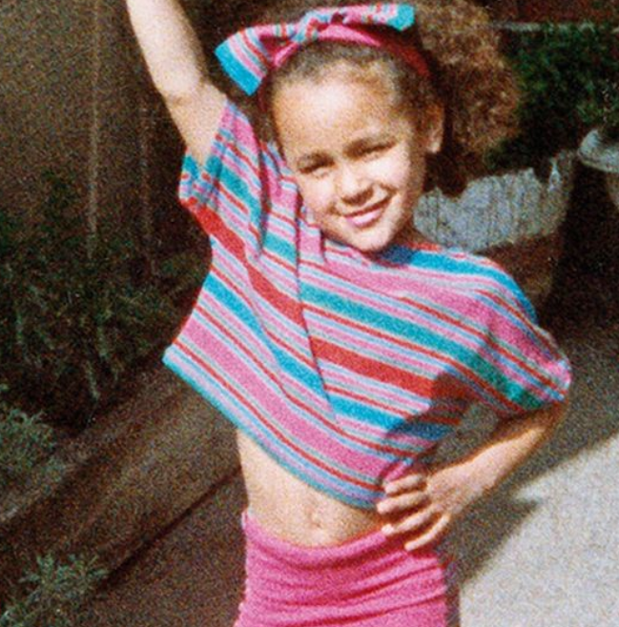

I am crying. I am a Sheffield schoolgirl writing in her diary about the bullies awaiting me tomorrow. They stand menacingly at the gates and lurk unseen by my head, mocking my size and status. They make a small girl shrink, and I feel insecure and frightened. I pour my feelings out into words on the page, as if exposing them in some way will help, but nobody sees my diary. It is kept in my room as a hidden tale of hurt. Fast forward two decades and I am crying again. I am standing in a cavernous arena in London. Suddenly, the pain and suffering and frustration give way to a flood of overwhelming emotion. In the middle of this enormous arena I feel smaller than ever, but I puff out my chest, look to the flag and stand tall. It has been a long and winding road from the streets of Sheffield to the tunnels that feeds the Olympic Stadium like an artery.
I am Jessica Ennis. I have been called many things, from tadpole to poster girl, but I have to fight to make that progression. I smile and am polite so people think it comes easily, but it doesn’t. I am not one of those athletes who slap their thighs and snarl before a competition, but there is a competitive animal inside, waiting to get out and fight for survival and recognition. Cover shoots and billboards are nice, but they are nothing without the work and I have left blood, sweat and tears on tracks all around the world. It is an age where young people are fed ideas of quick-fix fame and instant celebrity, but tears mean more if the journey is hard. So I don’t cry crocodile tears; I cry the real stuff.
In 1993 my parents sent me to Sharrow Junior School. In terms of academic results it was not the best, but Mum was keen for me to go somewhere that had a rich mix of races and cultures. I was the smallest in the class and I became more self-conscious about it as the years went by. Swimming was a particular ordeal, and in my mind now, I can still see this young, timid wisp standing by the side of the pool in her red swimming costume quaking with anxiety. I was small and scraggy and that was when the bullying started.
There were two girls who were really nasty to me. They did not hit me, but bullying can take on many forms and the abuse and name-calling hurt. The saying about sticks and stones breaking bones but words never hurting falls on deaf ears when you are a schoolkid in the throes of a verbal beating. At that age, girls can be almost paralysed by their self-consciousness, so each nasty words cut deep wounds.
I went home, cried and wrote my diary. Perhaps it would be nice to say that one day I fought back and beat the bullies, but I didn’t. It festered away and became a big thing in my life, leaving me wracked with fear about what they would say or do next. It got to the point where I dreaded seeing them at school. And then we moved on to secondary school and I found out that they were going there too.
The dread got deeper.
L.O. I understand what an autobiography is
- Highlight and write down the key facts about Jessica-Ennis Hill.
- Highlight or underline the personal pronoun I – this shows she is writing it – it is written in the first person.
- Write down the chronology – what happened in order of her life. Include any dates.
- Does this make you empathise or feel for her? Which parts of her life story make you feel like this?
- Is it interesting to read? Why?
- Scan the text for these words and underline/highlight them: suddenly, so. These help move the life story forward. Y5/6 This autobiography doesn’t have many. Could you write a list of any other connectives she could have used? Can you edit the text to place these in it?

