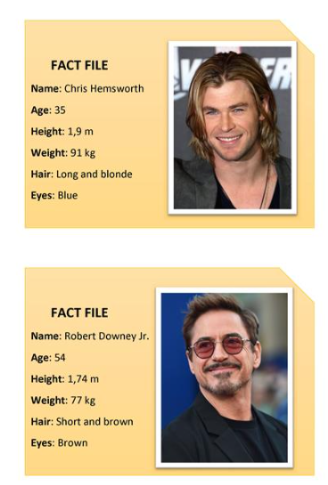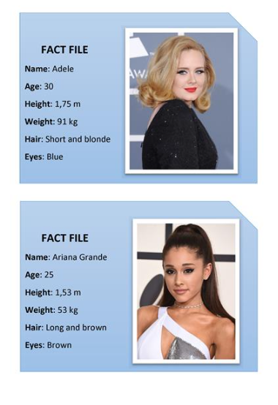
Day 3: L.O. I can write a fact file

Use the fact file above to write key information about yourself.
Extension: Use a computer to organise the layout and add a picture.

