L.O. I can match the pictures of fruits to their names
Cut out the cards. Look for clues in the French to match to the pictures. Check with the answers at the bottom of the sheet. Learn the French words.
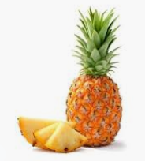  pineapple | l’orange
la goyave | 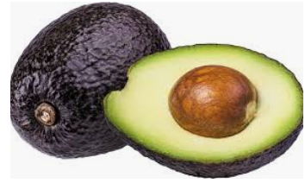  avocado
la mangue | 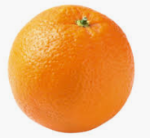  orange
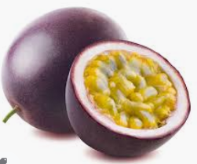  passion fruit | le fruit de la passion
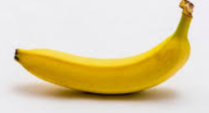  banana | l’avocat
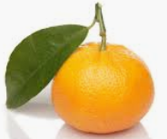  mandarin | l’ananas
le mandarin | 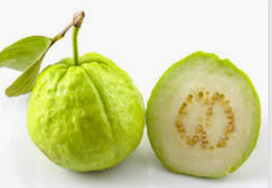  guava
la banane | 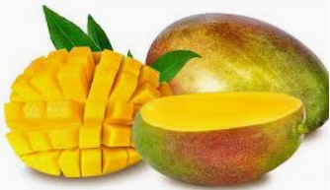  mango

Answers:
banana | la banane
pineapple | l’ananas
avocado | l’avocat
passion fruit | le fruit de la passion
mango | la mangue
guava | la goyave
orange | l’orange
mandarin | le mandarin

