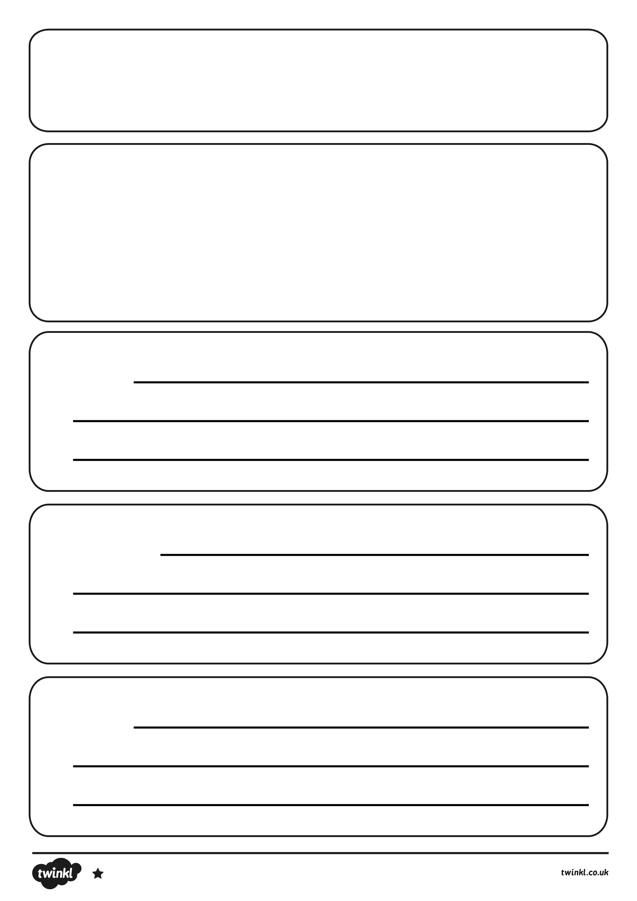
How to look after a baby dinosaur.
You will need:
Firstly
Secondly
Lastly
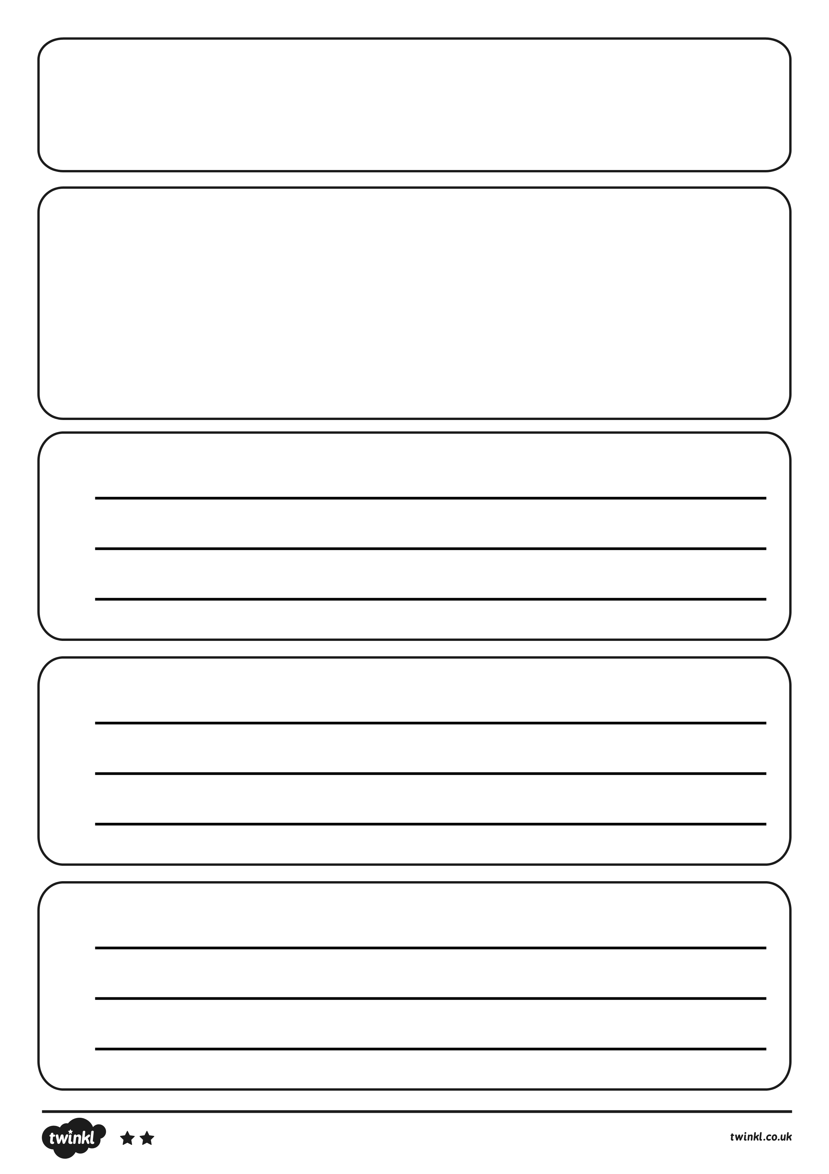
Title
You will need:
1.
2.
3.
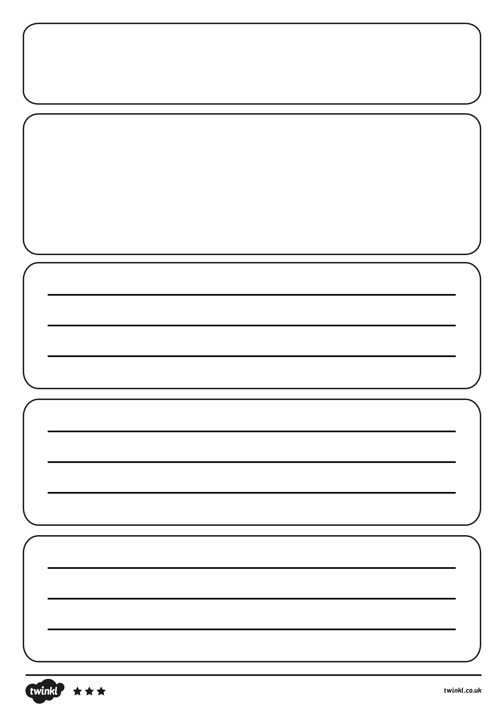
Title
text

