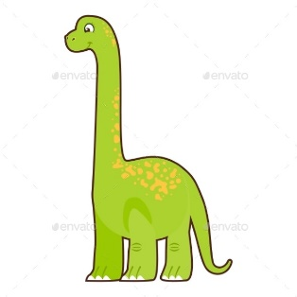
Take care of your baby dinosaur at home and do the activities below:

- Write instructions for how to look after your dinosaur.
- Keep a little diary of your adventures at home. Include drawings and write sentences. Use capital letters, finger spaces and full stops. Use the correct letter formation.
- Read to your dinosaur every day.
- Hide your dinosaur somewhere in your home or garden. Write clues to help a family member find it. Use capital letters, finger spaces and full stops. Use the correct letter formation.
- What sort of dinosaur do you think your baby is? Find out some facts and create a fact file.

