Working at home in RE, PSHE and art – Mrs Eyre
Friday 5th June
Hello everyone! Welcome back to RE/PSHE and ART!
This week we are focusing on art, and linking it to our science work about birds.
Use google to search images of beautiful birds and colourful bird art to inspire your artwork.
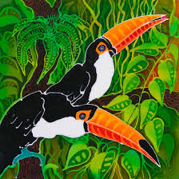
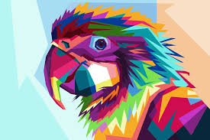

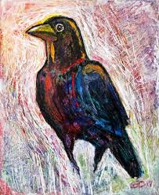
Think about the use of colour. Think about what techniques and styles of artwork would suit your choice. Practise parts of the design before you start.
Remember you don’t have to do the whole bird. (you may just focus on the eye, or the claws!) Just let your imagination flow.
I look forward to seeing your beautiful exotic works of art completed.

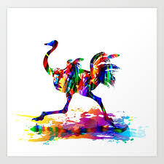
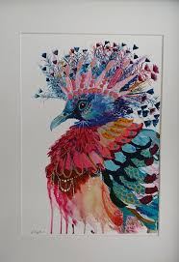
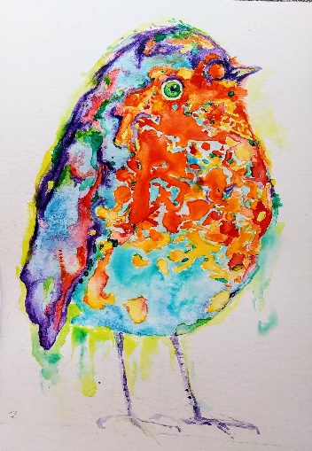
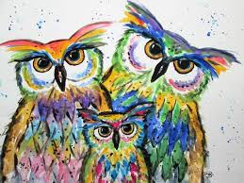
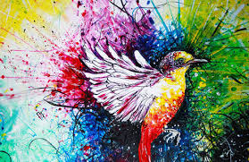
Have Fun!

