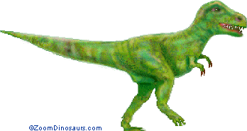 | 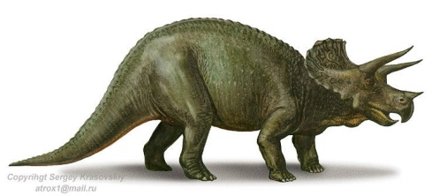
Tyrannosaurus rex  South Dakota, North America | Triceratops  Alberta, Canada, North America
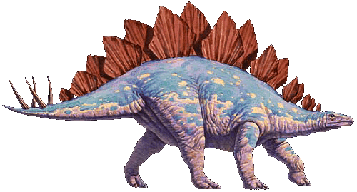 | 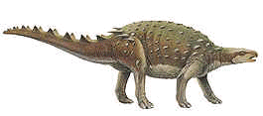
Stegosaurus  Colorado, North America | Dracopelta  Portugal, Europe
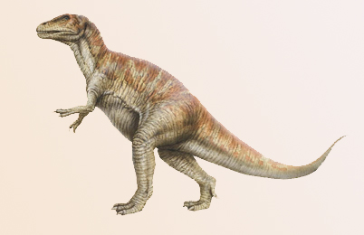 | 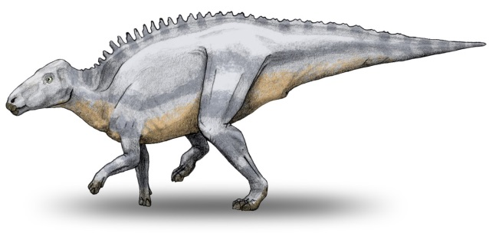
Megalosaurus  England, Europe | Telmatosaurus  Romania, Europe
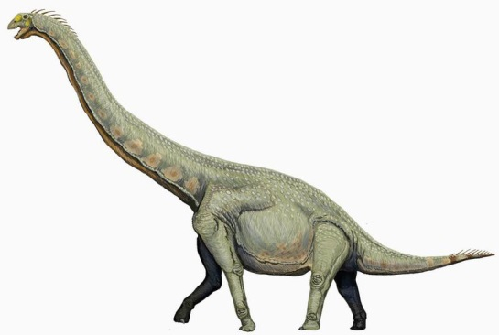 | 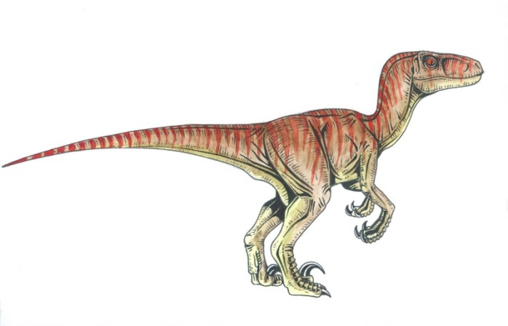
Barosaurus  India, Asia | Velociraptor  China, Asia
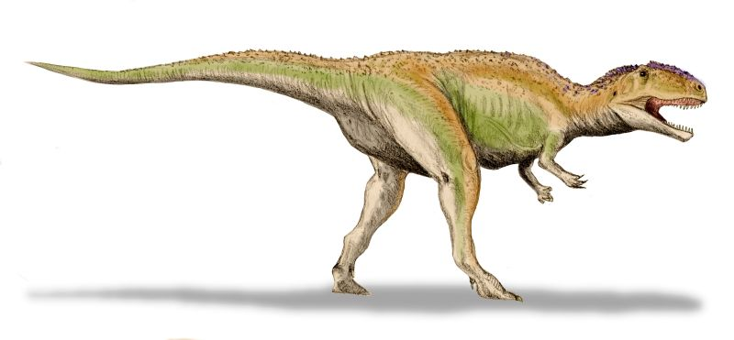 | 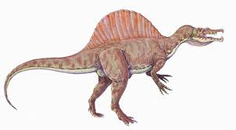
Giganotosaurus  Argentina, South America | Spinosaurus  Morocco, Africa
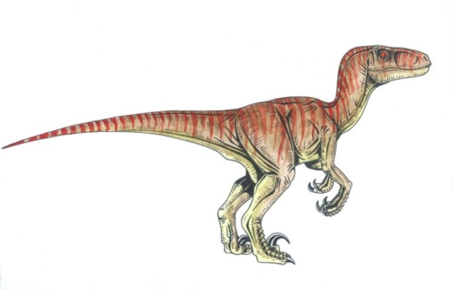 | 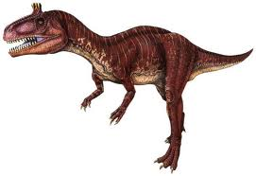
Velociraptor  Mongolia, Asia | Cryolophosaurus  Antartica

