Where is the South Pole?
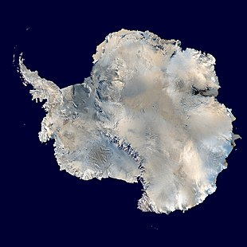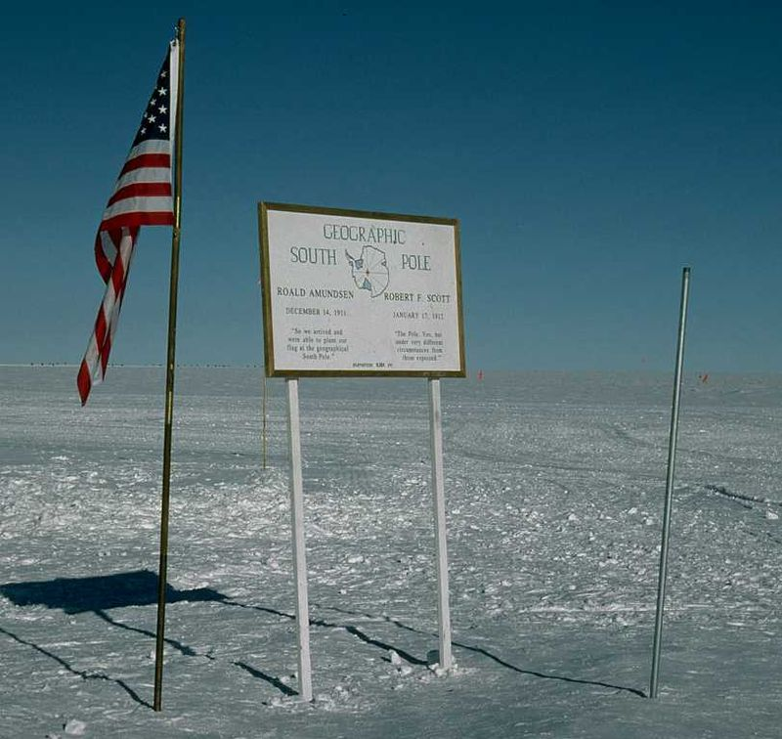
These pictures show a satellite view of the South Pole and the South Geographic Pole.
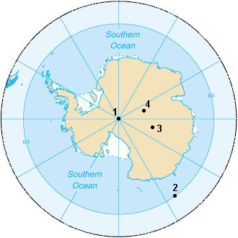 | Can you research to label the numbers 1-4?  South Pole of Inaccessibility  South Geomagnetic Pole  South Magnetic Pole  South Geographic Pole.

Use this website link to answer the following questions:
https://kids.kiddle.co/South_Pole
- What continent is the South Pole in?
- What is the Amundsen-Scott South Pole Station?
- What is the coordinate of the South Pole?
- Is there land underneath the ice? Yes/No? Y5/6 explain.
- Is the Geographic Pole in the same place every year?

