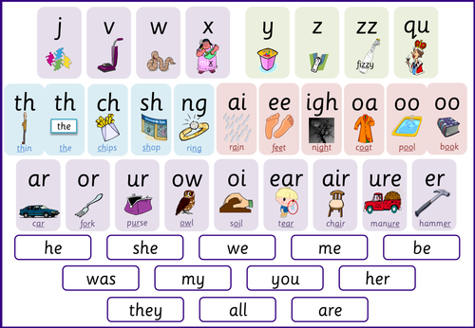
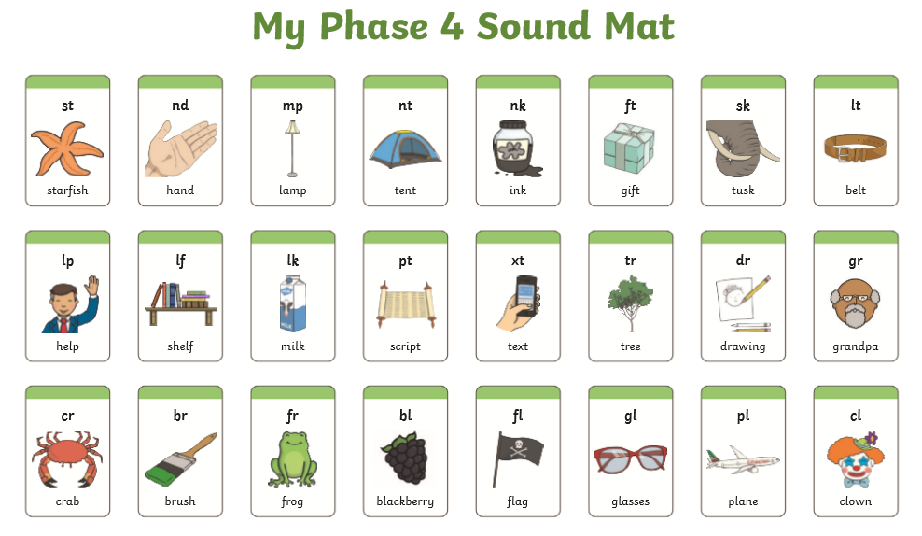
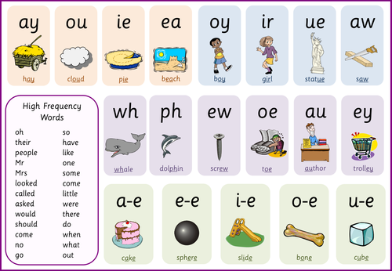

Key Questions about Phonics

What is a phoneme?
A phoneme is the smallest unit of sound in speech. When we teach reading we teach children which letters represent those sounds. For example – the word ‘hat’ has 3 phonemes – ‘h’ ‘a’ and ‘t’. We use sound buttons when teaching segmenting and blending.
What is a grapheme?
A grapheme is a letter or a number of letters that represent the sounds in our speech. So a grapheme will be the letter/ letters that represent a phoneme.
For example:
1 letter grapheme – m a t (m)
2 letter grapheme – sh i p (sh)
3 letter grapheme – n igh t (igh)

What is a digraph and a trigraph?

A digraph is a 2 letter grapheme e.g. ‘ch’ in ‘chip’
A trigraph is a 3 letter grapheme e.g. ‘igh’ in ‘high’ ‘air’ in hair.
What are adjacent consonants?
Adjacent consonants are 2 or more consonants that are next to each other in a word. For example in the word ‘lost’ the ‘s’ and ‘t’ are adjacent consonants. Or in the word ‘clip’ the ‘c’ and ‘l’ are adjacent consonants. It important to remember that each consonant is a separate sound so ‘cl’ for example is 2 sounds ‘c’ and ‘l’.
Why is it important to teach adjacent consonants?
Many children can find it difficult to blend 2 or 3 consonants when they appear next to each other in a word. This is a skill that can be mastered and children may need lots of practice to achieve this.
What are consonant and vowel digraphs?
Consonant digraphs are 2 letters that are consonants that spell 1 sound e.g.: ‘s’ and ‘h’ together spell ‘sh’. As this is 1 sound, it cannot be called 2 adjacent consonants.
Vowel digraphs or trigraphs are vowel sounds spelled by more than 1 letter e.g: ‘oo’ or ‘ai’ or ‘igh’
What is ‘blending’?
Blending is the process of pushing sounds together in a word. Children are taught to sound out words and then push the sounds together into a recognisable word e.g. sh i p – ship, f ar m- farm. We use sound buttons to help with blending.
What is segmenting?
Segmenting is the process of separating sounds in words. Children a taught to listen and isolate sounds in words. Then they are taught to represent those sounds in letters. This is the process of spelling.
Useful Links:
Youtube: Geraldine the Giraffe
Youtube: Nessy (for Phonics and Literacy resources)
Phonics Play-
Username: march20
Password: home
Monster Phonics-
Username: login
Password: homelearning

What are high-frequency words?
High frequency words are common words that children will come across very early in his/her reading experience. They will appear in many texts.
The list of the first 100 high-frequency words (HFWs) includes words which are decodable e.g. ‘dad’ and some words which are not initially decodable such as ‘the’ and ‘where’.
There is a list of the 100 HFWs below:

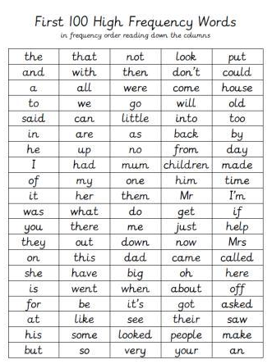

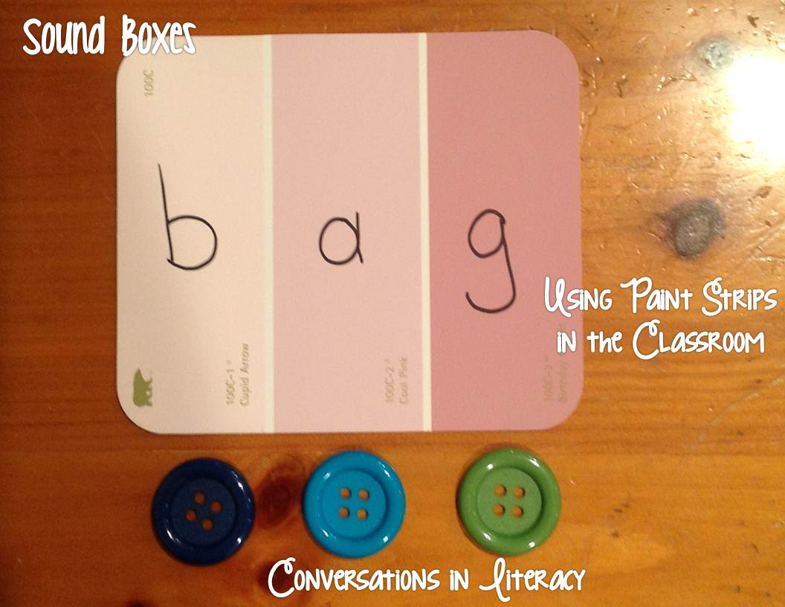
An interesting idea for learning to blend, using buttons:

