L.O. I can decide which foods are healthy
Look at the pictures below, cut them out and group them into (bon pour la santé ) healthy and unhealthy (mauvais pour la santé).
le gâteau | les bonbons
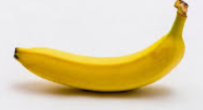  la banane | 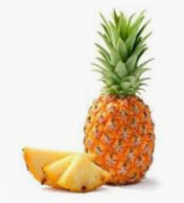  l’ananas
le Croissant | 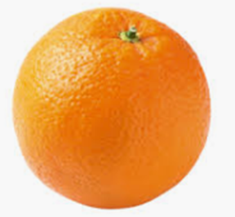  l’orange
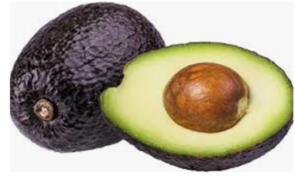  l’avocat | 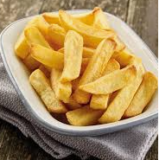  les frites

Extension:
- Learn the vocabulary.
- Can you write some sentences about what you like (j’aime) and is good for you (bon pour la santé ) and what you like and is not good for you (mauvais pour la santé).
- Can you add details such as colours? Is there anything you don’t like (je n’aime pas)?

