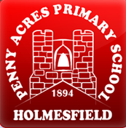 | Policy No:  C15 | Revision No: | 6
 |  | Date Issued: | February 2017
 |  | Committee: | Curriculum
 | Early Years Foundation Stage Policy | Author: | Headteacher
 |  | Date Adopted: | October 2021
 |  | Minute No: | 5.10.21, min no 18.6
 |  | Review Date: | October 2023

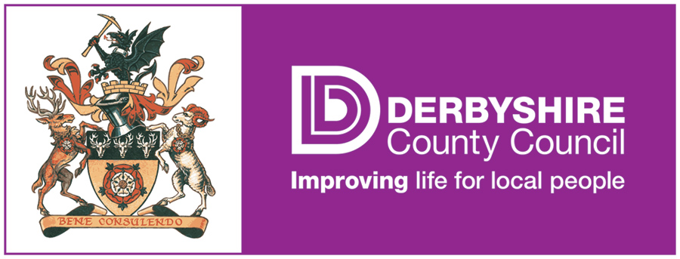

FEDERATION OF PENNY ACRES AND WIGLEY PRIMARY SCHOOL

EARLY YEARS FOUNDATION STAGE POLICY

Early Years Foundation Stage Policy
1 Introduction

1.1 The Early Years Foundation Stage (EYFS) extends from the age of three to the end of the reception year. Entry into our primary school is at the beginning of the school year in which the children are five (although compulsory schooling does not begin until the start of the term after a child's fifth birthday).

1.2 The Early Years Foundation Stage is important in its own right, and also in preparing children for later schooling. The Early Learning Goals set out what is expected from most children by the end of the Early Years Foundation Stage.

1.3 The early-years education we offer our children is based on the following principles:
• it builds on what our children already know and can do;
- It ensures that no child is excluded or disadvantaged; theme – ‘A unique child’.
- It offers a structure for learning that has a range of starting points, content that matches the needs of young children, and activities that provide opportunities for learning both indoors and outdoors; This is so they can learn in different styles and at different rates.
- It provides a rich and stimulating environment.
- Positive relationships – Children learn to be strong and independent from a base of loving and secure relationships with parents and/or a key person.

2 Aims and objectives

2.1 The curriculum of the Early Years Foundation Stage underpins all future learning by promoting and developing the Early Learning Goals in the seven areas of learning:

1. Communication and Language
• Listening and attention
• Understanding
• Speaking

2. Physical Development
• Moving and handling
• Health and self-care

3. Personal, Social and Emotional Development
• Self-confidence and self-awareness
• Managing feelings and behaviour
• Making relationships

4. Literacy
• Reading
• Writing
5. Mathematics
• Numbers
• Shape, space and measure

6. Understanding the World
• People and communities
• The world
• Technology

7. Expressive Arts and Design
• Exploring and using media and materials
• Being imaginative

Each child will be assessed to whether they are emerging (not yet reached the Early Learning Goal), expected (reached the Early Learning Goal) or exceeding (exceeded the Early Learning Goal).

3 Teaching and learning style

3.1 The features of effective teaching and learning in our school are defined in our Teaching and Learning Policy. They apply to teaching and learning in the Foundation Stage just as much as they do to the teaching and learning in Key Stage 1 or 2.

3.2 The more general features of good practice in our school that relate to the Early Years Foundation Stage are:
• The partnership between teachers and parents/carers that helps our children to feel secure at school, and to develop a sense of well-being and achievement;
- The understanding that teachers have of how children develop and learn, and how this must be reflected in their teaching;
- The range of approaches that provide first-hand experiences, give clear explanations, make appropriate interventions, and extend and develop the children's play, talk or other means of communication;
- The carefully planned curriculum that helps children achieve the Early Learning Goals by the end of the Foundation Stage;
• The provision for children to take part in activities that build on and extend their interests, and develop their intellectual, physical, social and emotional abilities;
• The encouragement for children to communicate and talk about their learning, and to develop independence and self-management;
• The support for learning, with appropriate and accessible space, facilities and equipment, both indoors and outdoors;
• The identification, through informal and focused observations, of children's progress and future learning needs, which are regularly shared with parents and carers;
• The good relationships between our school and the other educational settings in which the children have been learning before joining our school;
• The clear aims of our work, and the regular monitoring of our work to evaluate and improve it;
• The regular identification of training needs for all adults working at the Foundation Stage.

4 Play at the Early Years Foundation Stage – Learning Through Play

4.1 Through play, our children explore and develop the learning experiences that help them make sense of the world. They practise and build up their ideas, learn how to control themselves, and begin to understand the need for rules. They have the opportunity to think creatively both alongside other children and on their own. They communicate with others as they investigate and solve problems. They express fears, or re-live anxious experiences, in controlled and safe situations. No more than 20% of the total evidence should be gained from adult-led/adult directed activities.

5 Inclusion at the Foundation Stage

5.1 We believe that all our children matter. We give our children every opportunity to achieve their best. We do this by taking account of our children's range of life experiences when we are planning for their learning.

5.2 In the Early Years Foundation Stage, we set realistic and challenging expectations keyed to the needs of our children, so that most achieve the Early Learning Goals by the end of the stage. Some children progress beyond this point. We help them do this by planning to meet the needs of both boys and girls, of children with special educational needs, of children who are more able, of children with disabilities, of children from all social and cultural backgrounds, of children from different ethnic groups, and of those from diverse linguistic backgrounds.

5.3 We meet the needs of all our children through:
• planning opportunities that build on and extend the children's knowledge, experience and interests, and develop their self-esteem and confidence;
• using a variety of teaching strategies that are based on children's learning needs;
• providing a wide range of opportunities to motivate and support children, and to help them to learn effectively;
• offering a safe and supportive learning environment, in which the contribution of all children is valued;
• employing resources that reflect diversity, and that avoid discrimination and stereotyping;
• planning challenging activities for children whose ability and understanding are in advance of their language and communication skills;
• monitoring children's progress, and providing support (such as visual, speech and language or hearing therapy), as necessary.

6 The Foundation Stage curriculum

6.1 Our curriculum for the Foundation Stage reflects the areas of learning identified in the Early Learning Goals. Our children's learning experiences enable them to develop competency and skill across a number of learning areas.

6.2 The Early Learning Goals provide the basis for planning throughout the Foundation Stage. Teachers use the national schemes of work, where appropriate, to support their planning for individual children. Our medium-term planning is completed half-termly, and identifies the intended learning, with outcomes, for children working towards the Early Learning Goals. Topics change on a half termly basis.

6.3 The school makes full use of the outdoor classroom, where activities take place at all times of year. Children wear suitable clothing at all times.

7 Assessment

7.1 The Foundation Stage Profile is the nationally employed assessment tool that enables teachers to record their observations at the end of the Foundation Stage, and to summarise their pupils' progress towards the Early Learning Goals. We make regular assessments of children's learning, and we use this information to ensure that future planning reflects identified needs. Assessment in the Foundation Stage takes the form of planned and unplanned observations and this involves both the teacher and other adults, as appropriate. Observations are collected in a child’s learning journey.

7.2 During the first term in the reception class, the teacher assesses the ability of each child, using the Foundation Stage Profile. These assessments allow us to identify patterns of attainment within the cohort, in order to adjust the teaching programme for individual children and groups of children. We share the information contained in the Foundation Stage Profile at our parental consultation meetings.

7.3 The teacher completes an assessment each term, and then updates the Foundation Stage Profile. At the end of the final term in reception, we send a summary of these assessments to the LA for analysis. This information is used to make plans for the year ahead.

7.4 Parents and carers receive an annual report that offers brief comments on each child's progress in each area of learning. It highlights the child's strengths and development needs, and gives details of the child's general progress. We send these to parents and carers in July each year.

8 The role of parents and carers

8.1 We believe that all parents and carers have an important role to play in the education of their child. We therefore recognise the role that parents and carers have played, and their future role, in educating the children. We do this through:
• talking to parents or carers about their child before their child starts in our school;
• visits by the teacher to all children in their home setting or preschool setting prior to their starting school;
• opportunities given to the children to spend time with their teacher before starting school;
• offering parents and carers regular opportunities to talk about their child's progress in our reception class;
• encouraging parents and carers to talk to the child's teacher if there are any concerns;
• offering a range of activities, throughout the year, that encourage collaboration between child, school and parents/carers;
• providing various activities that involve parents and carers, i.e. regular communication with home through the child's reading record.

8.2 There is a meeting for parents and carers in the autumn term and the summer term, at which the parents/carers discuss the child's progress with the teacher. Parents and carers receive a report on their child's attainment and progress at the end of each school year.

9 Resources

9.1 We plan a learning environment, both indoors and outdoors, that encourages a positive attitude to learning. We use materials and equipment that reflect both the community that the children come from and the wider world. We encourage the children to make their own selection of the activities on offer as we believe that this encourages independent learning.

10 Monitoring and review

10.1 This policy is monitored by the Governing Body, and will be reviewed every two years or earlier if necessary.

