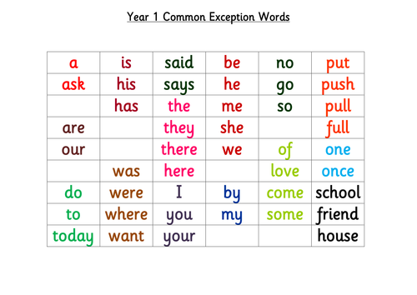
Memory Spelling Challenge
Look at these words for 30 seconds then your challenge is to write down as many as you can!
Good luck!

Please send in your scores!

