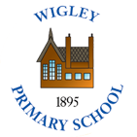  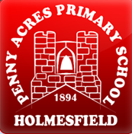 | Policy No: C11 | Revision No: | 6
 |  | Date Issued: | April 2012
 |  | Committee: | Curriculum
 | History Policy | Author: | Headteacher
 |  | Date Adopted: | June 2022
 |  | Minute No:
 |  | Review Date: | June 2024

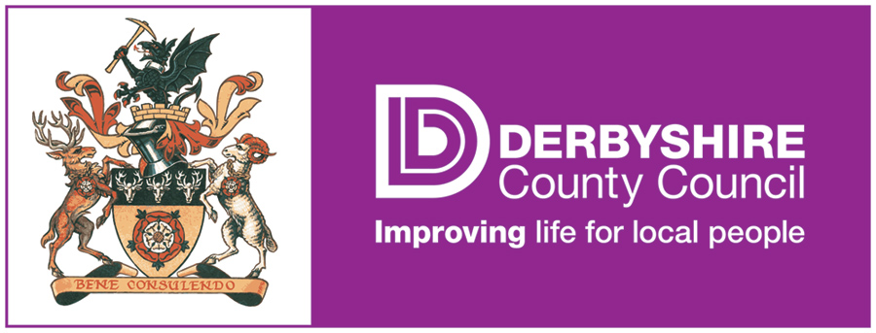

FEDERATION OF PENNY ACRES AND WIGLEY PRIMARY SCHOOL

HISTORY POLICY

History Policy

The shared History Policy of the Penny Acres and Wigley Foundation reflects both school’s commitment to a broad, balanced and exciting topic based curriculum.

Aims and objectives
The aim of history teaching is to stimulate the children’s interest and understanding about the life of people who lived in the past.
The aims of history are:
- to foster in children an interest in the past and to develop an understanding that enables them to enjoy all that history has to offer;
- to enable children to know about significant events in British history and to appreciate how things have changed over time;
- to develop a sense of chronology;
- to know and understand how the British system of democratic government has developed and in so doing, contribute to pupil understanding of British Values;
- to have some knowledge and understanding of historical development in the wider world;

Planning
At both schools pupils are taught in mixed-aged, mixed ability classes and the teaching of history reflects this. History is taught through topic work and is carefully planned to ensure all pupils receive full curriculum coverage whether on a 3 year cycle (EYFS/KS1) or a 4 year cycle (KS2). EYFS/KS1 change topic half-termly, whilst KS2 change topic termly.

We follow the National Curriculum 2014 and ensure that topics consider the ‘Purpose of study’ and ‘Aims’.

Staff work together to produce long term, medium term and short term topic plans which include, when relevant to the topic, geographical subject content. Subject content is taken directly from the National Curriculum 2014.

Subject content - Key Stage 1
Pupils should develop an awareness of the past, using common word and phrases relating to the passing of time. They should know where the people and events they study fit within a chronological framework and identify similarities and differences between ways of life in different periods. They should use a wide vocabulary or everyday historical terms. They should ask and answer questions, choosing and using parts of stories and other sources to show that they know and understand key features or events. They should understand some of the ways in which we find out about the past and identify different ways in which it is represented.

In planning to ensure the progression described above through teaching about the people, events and changes outlined below, teachers are often introducing pupils to historical period that they will study more fully at key stages 2 and 3.

Pupils should be taught about:
- changes within living memory. Where appropriate, these should be used to reveal aspects of change in national life

- events beyond living memory that are significant nationally or globally (.e. the Great Fire of London, the first aeroplane flight or events commemorated through festivals or anniversaries)

- the lives of significant individuals in the past who have contributed to national and international achievements. Some should be use to compare aspects of life in different periods (e.g. Elizabeth I and Queen Victoria, Christopher Columbus and Neil Armstrong, William Caxton and Tim Berners-Lee, Pieter Bruegel the Elder and LS Lowry, Rosa Parks and Emily Davison, Mary Seacole and Edith Cavell)

- significant historical events, people and places in their own locality.

Subject content - Key Stage 2
Pupils should continue to develop a chronologically secure knowledge and understanind of British, local and world history, establishing clear narratives within and across the periods they study. They should note connections, contrasts and trends over time and develop the appropriate use of historical terms. They should regularly address and sometimes devise historically valid questions about change, cause, similarity and difference, and significance. They should construct informed responses that involve thoughtful selection and organisation of relevant historical information. They should understand how our knowledge of the past is constructed from a range of sources and that different versions of past events may exist, giving some reasons for this.

In planning to ensure the progression described above through teaching the British, local and world history outlined below, teachers should combine overview and depth studies to help pupils understand both the long arc of development and the complexity of specific aspects of the content.

Pupils should be taught about:
- changes in Britain from the Stone Age to the Iron Age

This could include:
- late Neolithic hunter-gatherers and early farmers, e.g. Skara Brae
- Bronze Age reliogion, technology and travel, e.g. Stonehenge
- Iron Age hill forts: tribal kingdoms, farming, art and culture

- the Roman Empire and its impact on Britain

This could include:
- Julius Caesar’s attempted invasion in 55-54 BC
- the Roman Empire by AD 42 and the power of its army
- successful invasion by Claudius and conquest, including Hadrian’s Wall
- British resistance, e.g. Boudica
- “Romanisation” of Britain: sites such as Caerwent and the impact of technology, culture and beliefs, including early Christianity

- Britain’s settlement by Anglo-Saxons and Scots

This could include:
  - Roman withdrawal from Britain in c. AD 410 and the fall of the western Roman Empire
  - Scots invasions from Ireland to north Britain (now Scotland)
  - Anglo-Saxon invasions, settlements and kingdoms: place names and village life
  - Anglo-Saxon art and culture
  - Christian conversion – Canterbury, Iona and Lindisfarne

Subject content - Early Years Foundation Stage
We teach geography in the EYFS as an integral part of the topic work covered during the year. We also relate the geographical aspects of the children’s work to the objectives set out in the Early Learning Goals. One of the Specific Areas f Learning, ‘Knowledge and Understanding of the World’ (ELG 14) states “children know about similarities and differences in relation to places, objects, materials and living things. They talk about the features of their own immediate environment and how environments might vary from one another”.

Assessment, Monitoring and Reporting
Both schools use Target Tracker (a commercial education software package supporting entry, analysis and sharing of pupil progress and attainment data through Early Years and Key Stages 1 and 2. It includes complete support for the National Curriculum). Target Tracker enables staff to track curriculum coverage and attainment by highlighting statements.

A member of staff has subject responsibility for Geography and is responsible for monitoring the subject by e.g. work scrutinies. The subject leader is also responsible for keeping colleagues informed about current developments in the subject and for providing a strategic lead and direction across the federation.
Parents’ Consultations are held twice yearly with annual reports sent home in the summer term.

Educational visits
History is taught within topic work across the federation, with the same topics being taught at the same time termly or half-termly across both schools.

To stimulate, enhance and inspire topic work, educational visits are booked for each topic. These may be local or further afield (including abroad). We believe that educational visits promote learning and understanding and prompt pupils to investigate and ask questions. Further, it develops knowledge of places and environments. We believe geographical education of this type enriches pupils’ lives.

