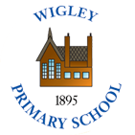 | Policy No: S36 | Revision No: | 5
 |  | Date Issued: | January 2016
 |  | Committee: | Full Governors
 | Dinner Money Policy | Author: | DCC
 |  | Date Adopted: | October 2022
 |  | Minute No: | 4.10.22, min no 19.15
 |  | Review Date: | October 2024

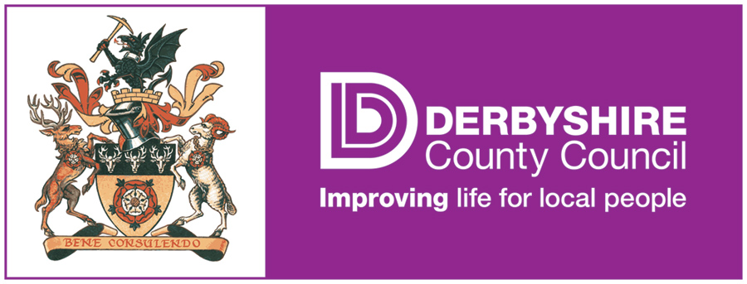

FEDERATION OF PENNY ACRES AND WIGLEY PRIMARY SCHOOL

DINNER MONEY
POLICY

Dinner Money Policy
Background
The Federation of Penny Acres and Wigley Primary School Dinner Money Policy has been adopted to ensure a consistent and fair approach to debt, incurred by parents/carers, whose children take school dinners. As the Local Education Authority is no longer accountable for the administration of dinner money debt, the responsibility now falls on the school to pursue instances of non-payment. As a result the school budget will have to directly fund any outstanding debts that cannot be recovered, thereby directly affecting the amount of money that is available to provide education to all pupils.

Provision of School Meals

The Schools Meals Service is no different to any other business in that meals have to be paid for by someone. Free School Meals are available for parents who meet certain criteria including the receipt of state benefits. Anyone who may qualify for Free School Meals should contact the school office for further information. Free School Meals are a statutory right and it is important that all parents/carers who qualify take up their child’s entitlement so that they can receive a School meal each day.

Information on the entitlement to free school meals and an application form can be found on the Derbyshire County Council’s website:
http://www.derbyshire.gov.uk/education/schools/your_child_at_school/meals/school_meals/default.asp?VD=freeschoolmeals
If a child’s entitlement to free school meals expires or the parents/ carers personal circumstances change the parent/carer must provide a packed lunch or send payment in advance for a school dinner.
Cost of School Meals
School meals are available to children at a cost of £2.30 per day or at no cost to those in receipt of Free School Meals entitlement. School meals must be paid for in advance. Any revision to the school meal prices will be notified to parents/carers the term prior to the new charge taking effect.
Payment for School Meals
Please send payment either in cash or cheque format (made payable to Derbyshire County Council) on a Monday morning in a sealed envelope clearly marked with your child’s name and class number, and amount enclosed. This payment should be handed by your child to their class teacher at registration time. Alternatively, payment can be made online on the ParentMail system. The School must ensure that all dinner money collected is banked in a timely manner in accordance with the School’s Financial Regulations which are periodically inspected by audit. The limit for money held in school is £1,000.
Management of School Meal Debts
To ensure that the School’s budget is not adversely affected by the cost of School meal debt the Governors consider the fairest system to all families is to pursue a ‘Zero Tolerance’ approach. Although, this may seem harsh to some parents, it is important that the school budget is spent for the benefit of all our pupils and not a small number.

If a child arrives at school without a packed lunch or payment, or if a child’s entitlement to free school dinners has ceased, the School will telephone/text the parent/carer in the first instance to establish if alternative arrangements have been made.
When a child has failed to produce dinner money, the school may allow a meal to be provided where it is felt that this is a temporary situation. e.g. lost or forgotten dinner money, temporary hardship etc. However, details should be recorded in writing and a record maintained and monitored.
If a child takes a school meal which has not been paid for, a letter/text/email detailing how much is owed will be sent to the parent/carer requesting payment directly to the school within 7 days. The same process will be used if a cheque is not honoured by the bank. Prompt action will be taken to address any debt issue at an early stage in order to prevent arrears amassing.
Where a child continues to require meals, the School must establish if the child is entitled to free school meals, or if the parent/carer is experiencing hardship which affects their ability to pay. Under these circumstances the parent/carer should be invited to apply for free school meals or speak confidentially to the Headteacher.
When the debt exceeds £10 for a child or family a formal letter must be sent to the parent/carer informing them to provide their child/children with a packed lunch to prevent further arrears. If the child/children is/are not provided with the requested packed lunch and the parent/carer cannot be contacted, the School will provide a sandwich and a drink of water only (Example letter 1).
If the debt exceeds £30 for a family and/or action proves unsuccessful in securing dinner money arrears, the School should inform the local Safeguarding Team and formally write to the parent/carer, explaining that the School is not obliged to provide a school dinner where advance payment is not forthcoming or where authorisation for free school dinners has not been received (Example letter 2).
Monitoring and Recovery of School Meal Debts

At each meeting of the Governing Body/Finance Committee, the Headteacher will provide Governors with details of any outstanding dinner money debt and the current position with regard to such debt. The aim of the School’s dinner money policy is to minimise the opportunity for debt balances to build up and incurring costly referral to the School’s solicitors. The School does however, reserve the right to begin legal proceedings to recover outstanding school meal debts and inform the local authority that a child is not being provided with a suitable meal at lunch time.

All Write-offs of outstanding debt must be approved by the Governing Body/Finance Committee following submission of details of the debt by the Headteacher together with reasons for no further action being taken.

Example – Letter 1

Parent or carer of (Pupil Name)
(Address Line 1)
(Address Line 2)
(Address Line 3)
(Post Code)
Date: XX/XX/XX

Dear xxx
School Meals provided to (Pupil Name)

According to the School’s financial records you have not paid dinner money for your child (pupil name) in Class: xx. As at xx/xx/xx your account is showing a debt of £xx.

In order that the school’s budget is not used to clear your child’s debt please make arrangements for the outstanding dinner money debt to be paid immediately. Once you have cleared the current debt I should be grateful if you could ensure that you keep your account in credit. The current cost of a school meal is £x per day or £x per week.

If you think you may qualify for Free School Meals, please contact the school office for further information. Remember that Free School Meals are a statutory right and it is important that you use it if you qualify, your child will then receive a School meal each day. Additional information and an application form can be found on the Derbyshire County Council’s website or in the school office if you do not have access to the Internet:
http://www.derbyshire.gov.uk/education/schools/your_child_at_school/meals/school_meals/default.asp?VD=freeschoolmeals
If this debt is not cleared the school will not provide a school meal and you should send your child with a packed lunch. If a packed lunch is not provided, the school will provide a sandwich and a drink of water only.

If you have any queries regarding these arrears or wish to discuss the matter further please do not hesitate to contact the school office.

Yours sincerely

Headteacher

Example – Letter 2

Parent or carer of (Pupil Name)
(Address Line 1)
(Address Line 2)
(Address Line 3)
(Post Code)
Date: XX/XX/XX
Dear xxx
School Meals provided to (Pupil Name)

I am writing regarding the current level of outstanding school meal debt that is showing on your account. Despite previous correspondences and messages the debt for your child xx in Class xx is still outstanding. The School’s records show that as at xx/xx/xx your account is £x in debt. The current cost of a school meal is £x per day or £x per week.

I would ask that you please make arrangements to clear this debt immediately and take steps to ensure your account is kept in credit in the future.

If you think you may qualify for Free School Meals, please contact the school office for further information. Remember that Free School Meals are a statutory right and it is important that you use it if you qualify, your child will then receive a School meal each day. Additional information and an application form can be found on the Derbyshire County Council’s website or in the school office if you do not have access to the Internet:
http://www.derbyshire.gov.uk/education/schools/your_child_at_school/meals/school_meals/default.asp?VD=freeschoolmeals

Since the School has to fund all school meal debts from its budget it is essential that all payments are up to date so that the quality of the service provided to all pupils is maintained. Unfortunately, if the debt is not cleared by xxxxx a school meal will no longer be provided to your child and you must make your own arrangements for your child’s lunch. The School reserves the right to begin legal proceedings to recover the outstanding debt and to inform the local authority that your child is not being provided with a suitable meal at lunch time.

If you have any queries regarding these arrears, please contact the school office immediately so that this matter can be resolved.

Yours sincerely

Headteacher

