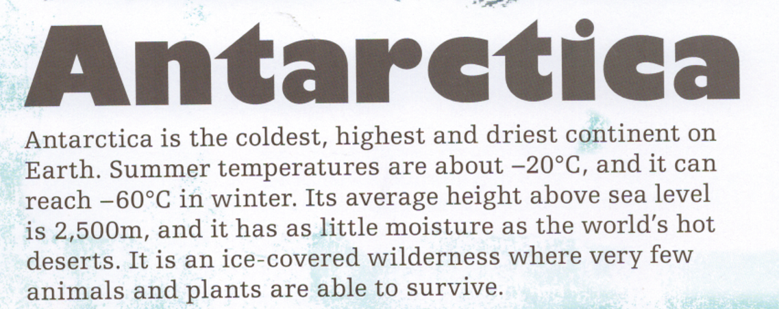
- Which is colder, summer or winter temperatures?
Winter temperatures are -60, which is 40 decrees colder than the summer temperatures.
- What is its average height above sea level?
The average height above sea level is 2,500metres.
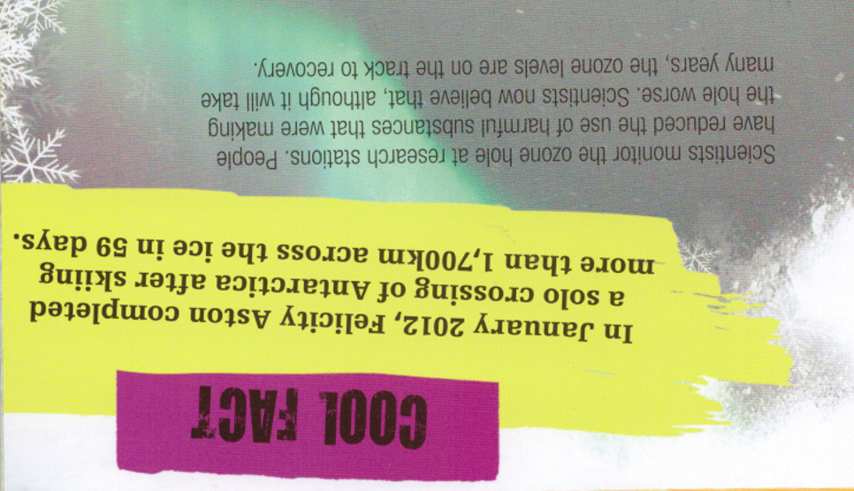
- Who crossed the Antarctica by skiing?
Felicity Aston skied across Antarctica.
- When did she do this?
She completed this in January 2012.
- How long did it take?
This took 59 days.

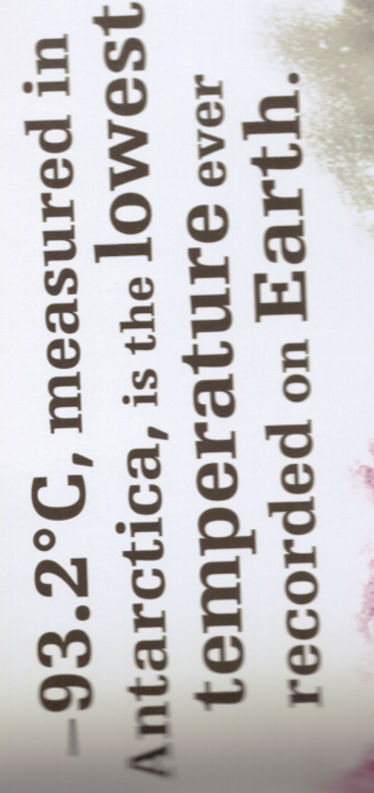
- What is special about the temperature -93.2°C?
This is the lowest recorded temperature on Earth.
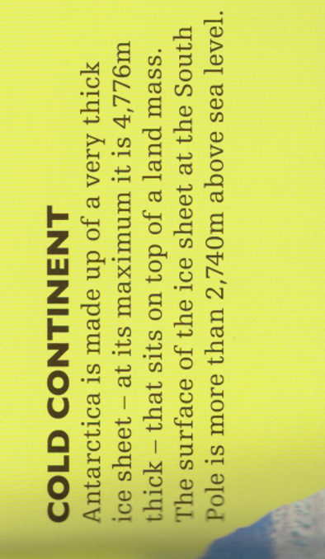
- Is there land underneath the ice? Yes or no?
Yes because it says it sits upon a land mass.
- How high is the ice above sea level?
The ice is 2,740 metres above sea level.
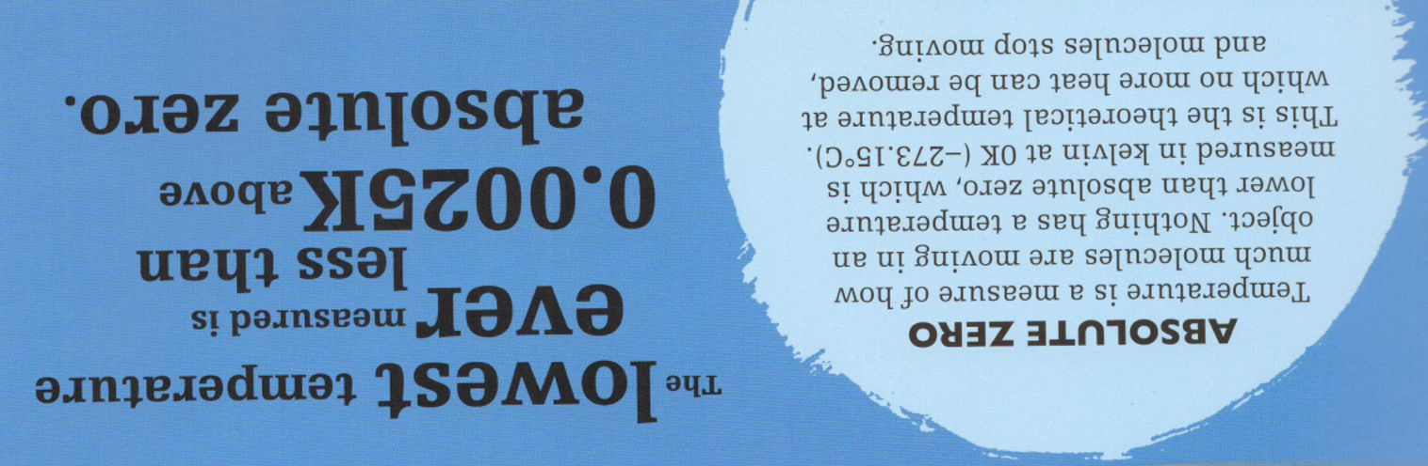
- What temperature is absolute zero?
Absolute zero is -273.15°C.
- What is lower than absolute zero?
There has never been a temperature recorded lower than this

