Working from home in science – Mrs Eyre
Thursday 16th July
I can hardly believe it’s the 12th week of working at home! Very well done if you have kept up with the science work; I look forward to seeing it all when possible. (Thank you again to those of you who have been emailing work for me to see)
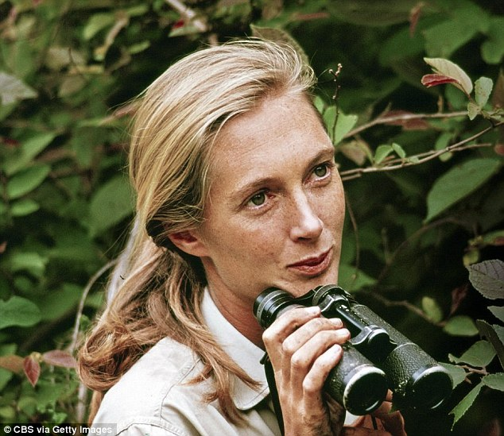
This week we are looking at endangered animals, and our scientist of the week is Jane Goodall.

Y3/4 Why are chimps endangered?
Watch this video to find out why chimps are endangered.
https://www.youtube.com/watch?v=5PwcY_axJwA
Find out more about how human impact and environmental change are affecting the chimps’ habitat
https://www.worldwildlife.org/species/chimpanzee
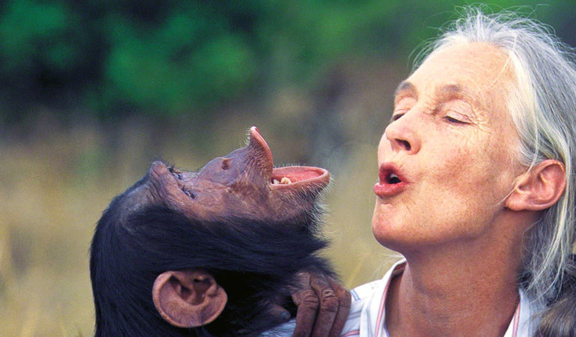
Design a ‘save the chimps’ poster to raise awareness about the need to save the chimps from extinction. Use clear lettering and include pictures. What can you do to help?

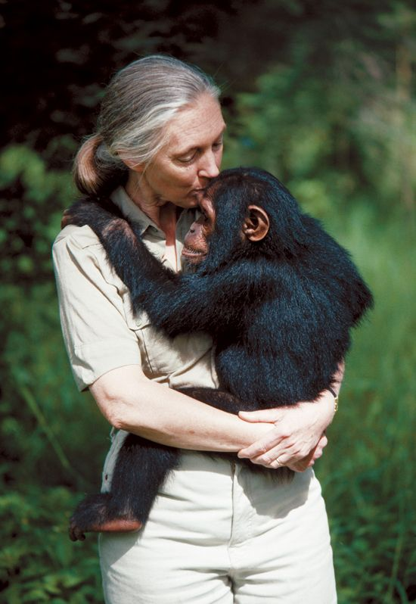
Y5/6 What is an ethologist?
Watch this video to find out more and research Jane Goodall’s life.
https://www.youtube.com/watch?v=72iF67x75Ng
www.janegoodall.org.uk

Draw a detailed time-line of Jane’s life from birth to old age. Include pictures, interesting facts and her main achievements.

