
History Detectives

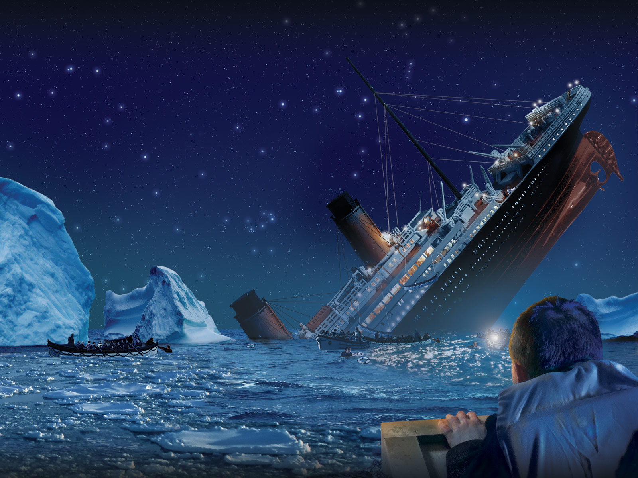

Investigating the Titanic Disaster

Dear History Detective,
We would like you to find out who was really responsible for the Titanic sinking. Why did it happen and how can we stop this from ever happening again?
Your group has been given an envelope containing a number of sources. There are two types of sources:
- Primary sources – these are pieces of information from the time, from people who were there. A photograph of the Titanic is a primary source, because it was taken in 1912, by someone who was there.
- Secondary sources – these are pieces of information written after the event by people who were not there. A painting of the ship sinking is a secondary source, because nobody on the lifeboats was painting at the time it happened!
We can tell whether sources are primary or secondary by looking at the provenance – the bit of writing underneath. This tells us what the source is, when it is from and sometimes who it is by.
You have a number of challenges to complete.
- Use the sources to answer the following questions in your booklet.
- Read the statements to decide who you think was responsible for the sinking.
- Write an argument, persuading me why your chosen crew member was responsible for the loss of life in the disaster.
- Imagine that you were on board the Titanic. Write your own diary entries describing the ship hitting the iceberg, the struggle for the lifeboats and finally, the sinking.

Good luck, detectives!

Question | Answer
How long and wide was Titanic?
What facilities (things to do) were there for first class passengers on the Titanic?

What might people have had for lunch on Titanic’s last day?
How many people were on the Titanic altogether?
Why did the lookout not see the iceberg coming?
How many life boats were there?
How many people were reported to have died the next day by the New York Times?
How many people actually died?

Now study the five statements from crew involved in the disaster. What role did each person play in the sinking?

Bruce Ismay

Captain Smith

Officer Murdoch

Captain Lord

Frederick Fleet

