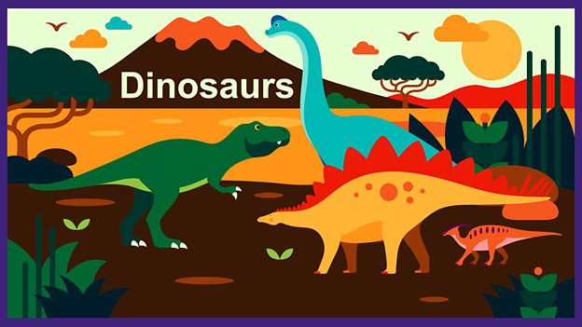
Topic Activities
(Key subject area in bold)
General
Take a look at the cbeebies website – Topics – dinosaurs.
Watch episodes of Andy’s Dinosaur Adventures on cbeebies iplayer.
P.E – BBC Dance KS1- Time to Move – this is a series of 3 dance sessions linked to our dinosaur topic.
P.E – Cosmic Kids yoga – www.cosmickids.com or You Tube.
Science/History/Geography
What did dinosaurs eat? See attached ppt and activity sheet.
How are fossils made? Go to ‘BBC Bitesize How are fossils made?’

Watch ‘BBC Teach Geography KS1: Fossil hunting along the Jurassic Coast’

Where were dinosaurs found? Put the dinosaurs onto the world map. See attached sheets.

We have learned about Mary Anning – the famous palaeontologist. Children can use ‘BBC Bitesize Mary Anning Fossil Hunter.’

