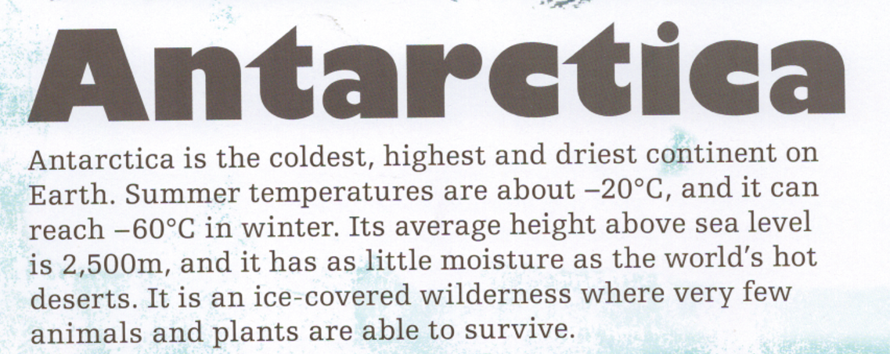
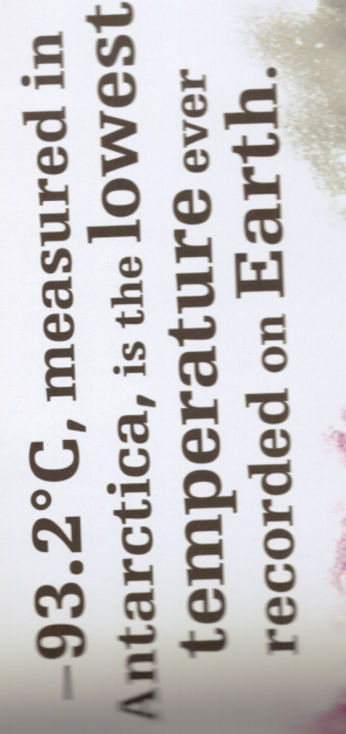
- What was special about Felicity Aston? Give at least 2 facts. She skied across the Antarctica. She did it on her own.
- Why do you think Antarctica measured the lowest temperature on Earth? Explain by using facts from the text above. It is the coldest, highest and driest continent.
- What country would you compare Antarctica to being similar to? Explain your reasoning. Choose a dry county, e.g. Ethiopia; a country with high mountains, e.g. Austria; a cold country e.g. Greenland.

- It is described as a ‘wilderness’. Why do you think this? Wilderness has the world wild in it. It is a wild landscape – there is not a lot to see there and not much grows.

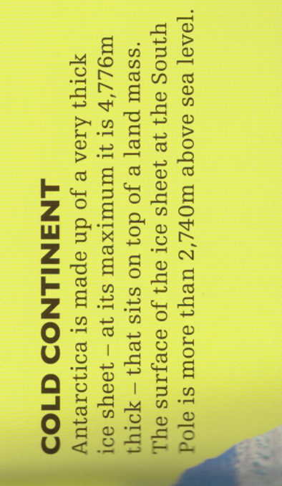
- A Kelvin is a base unit for measuring temperature. Why is Absolute Zero described as ‘theoretical’?
It is theoretical because this is where it has been found no more heat can be removed. It will be called absolute zero until proved otherwise.
- Do you think Antarctica can be explained as land or ice? Explain your opinion.
Either: Antarctica has a land mass below it so because it is there, it can be defined as land.
Or. Because the ice sits so deep on top of the land, the land cannot actually be reached so ic ould be explained as ice.
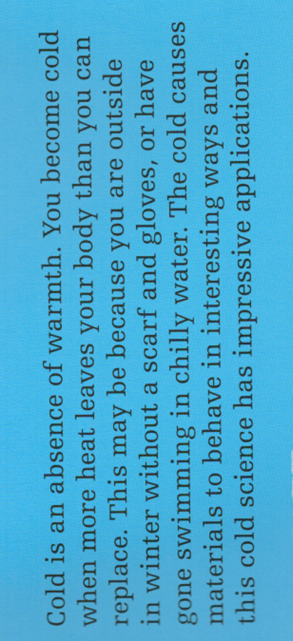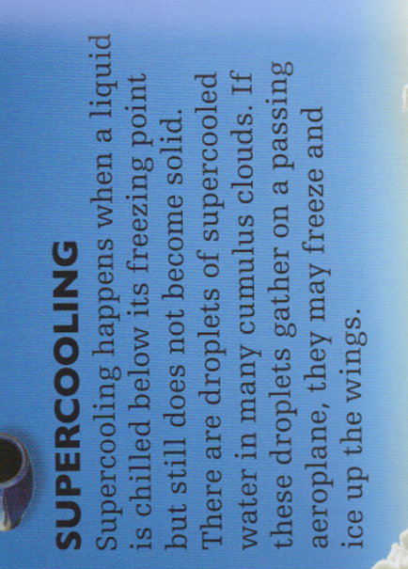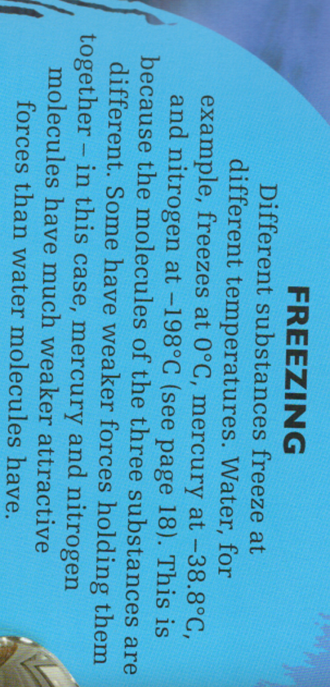
- Using the text, what can you do to help keep you warm?
Stay inside; put gloves and a scarf on if you go outside; swim in a warm pool, not outside.
- Where can you find evidence of supercooling? In cumulus clouds.
- Which has the strongest molecules, water or nitrogen? Water because ’mercury and nitrogen have much weaker attractive forces than water molecules’.

