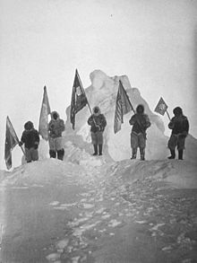
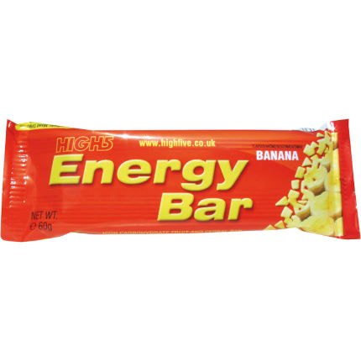
Explorers Project.
Over the next few weeks we will be adding information on the website all about explorers; especially those who have travelled to the North/South Pole.

Challenge 1.

Think about why it is important for explorers to eat properly and why they might need lots of high energy foods. Research the kinds of foods that give people lots of energy.

Challenge 2.

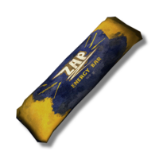
You have been asked to design an energy bar for the next up and coming exploration that will be taking place. Your bar, must be relatively healthy and have ingredients in it that will give the explorers energy. Your bar should still taste good. Draw what your bar would look like and label/list the ingredients and why you have chosen them. You could even make your bar and get your family to taste it - see what they think.

Challenge 3.
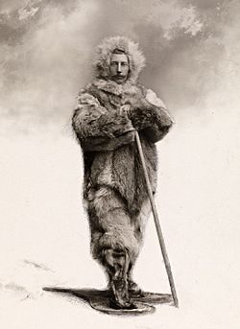
Give your bar an eye-catching wrapper and a name that will get people wanting to buy it. Think about the previous work we have done on advertising when we created chocolate bars. Who is your target audience? What will appeal to them?

Challenge 4.
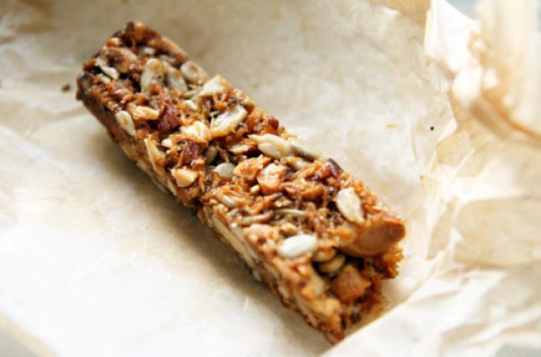
Find a way to advertise your bar. Again think of the things we did in our Chocolate Topic. You could film an advert, make a poster or record a radio advertisement. Anything that will capture the attention of your target audience and get them wanting to buy it. Think back to the adverts we studied. What was important? What features were included? What made them successful?

