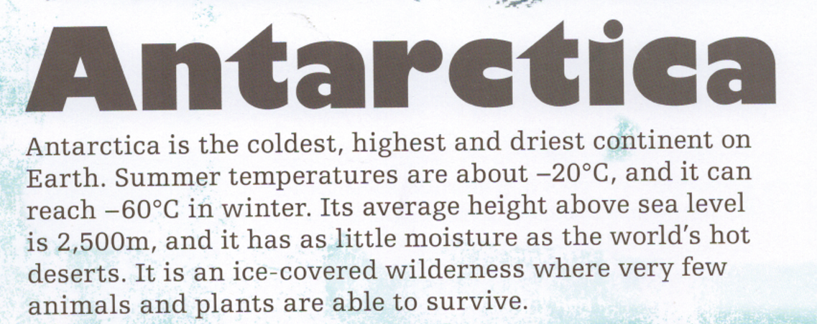
- Which is colder, summer or winter temperatures?
- What is its average height above sea level?
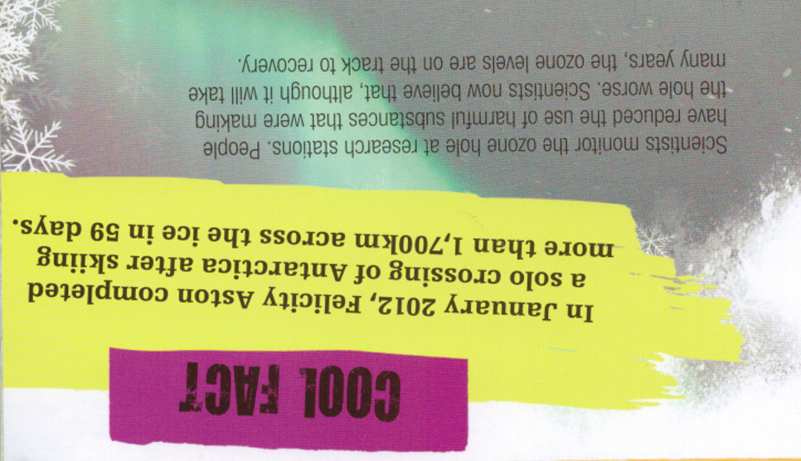
- Who crossed the Antarctica by skiing?
- When did she do this?
- How long did it take?

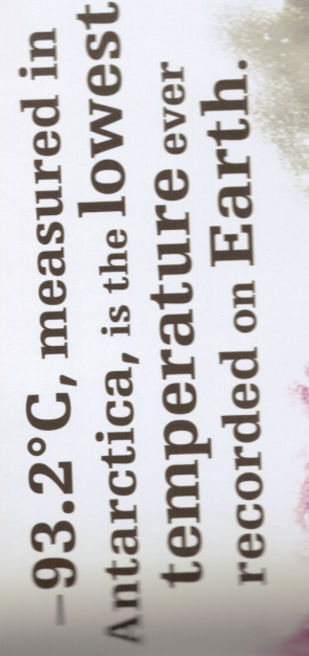
- What is special about the temperature -93.2°C?
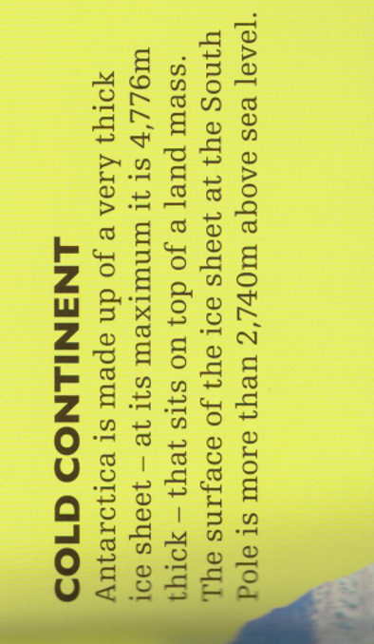
- Is there land underneath the ice? Yes or no?
- How high is the ice above sea level?
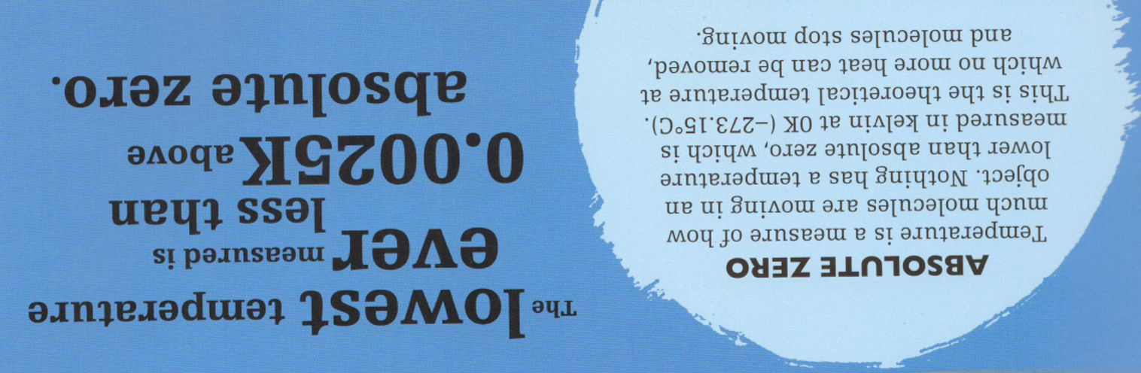
- What temperature is absolute zero?
- What is lower than absolute zero?

