Les adjectifs
Elle aime la banane jaune…
Ou la goyave sucrée et verte?
Ou l’orange ronde?
Ou la mangue rouge
Ou l’ananas jaune et vert?…
L’avocat vert et crémeux?
Ou le fruit de la passion violet?
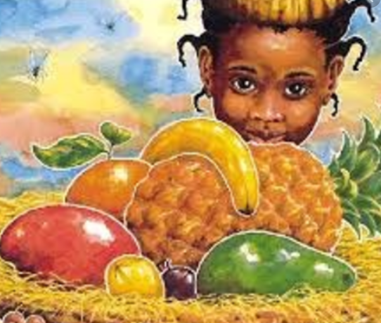
Adjectives in English describes and modifies a noun. Underline the names of the fruit (the nouns) that you looked at last week.
With a different colour, can you underline the adjectives?
Extension:
Can you translate the passage just using the vocabulary you have already learnt this year and your understanding of English to guess the meanings of other words?
Why is vert also spelt as verte?

