L.O. I can identify all the countries in the Arctic Circle
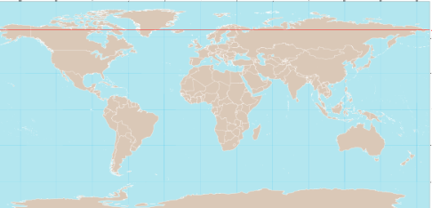
Can you use a map to locate all the countries in the Arctic circle? What is the capital city for these countries?
Name of country | Capital City

Which country has the largest land mass in the Arctic Circle?

