L.O. I can write a description of the scene

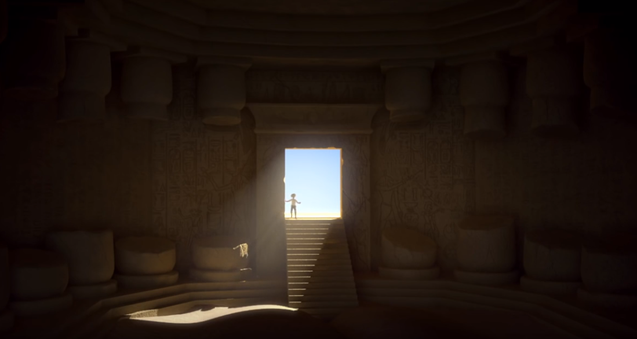

When Howard Carter opened the tomb of Tutankhamun, he was asked, “What do you see?”

He replied, “Yes, wonderful things.”

What do you think the explorer found when he first entered the tomb?

Use the vocabulary list below to help you.

