L.O. I understand the difference between a biography and an autobiography (Y5 and 6)
- Match the writing with the picture and the name.
- Decide whether they are an autobiography or biography, Highlight the key text which tells you this.
Jessica Ennis-Hill | 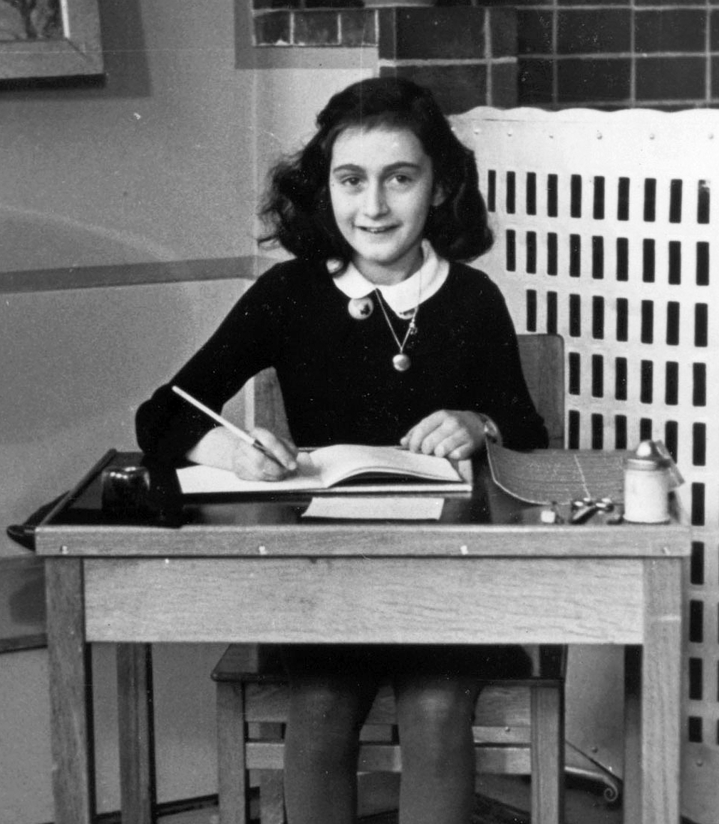 | 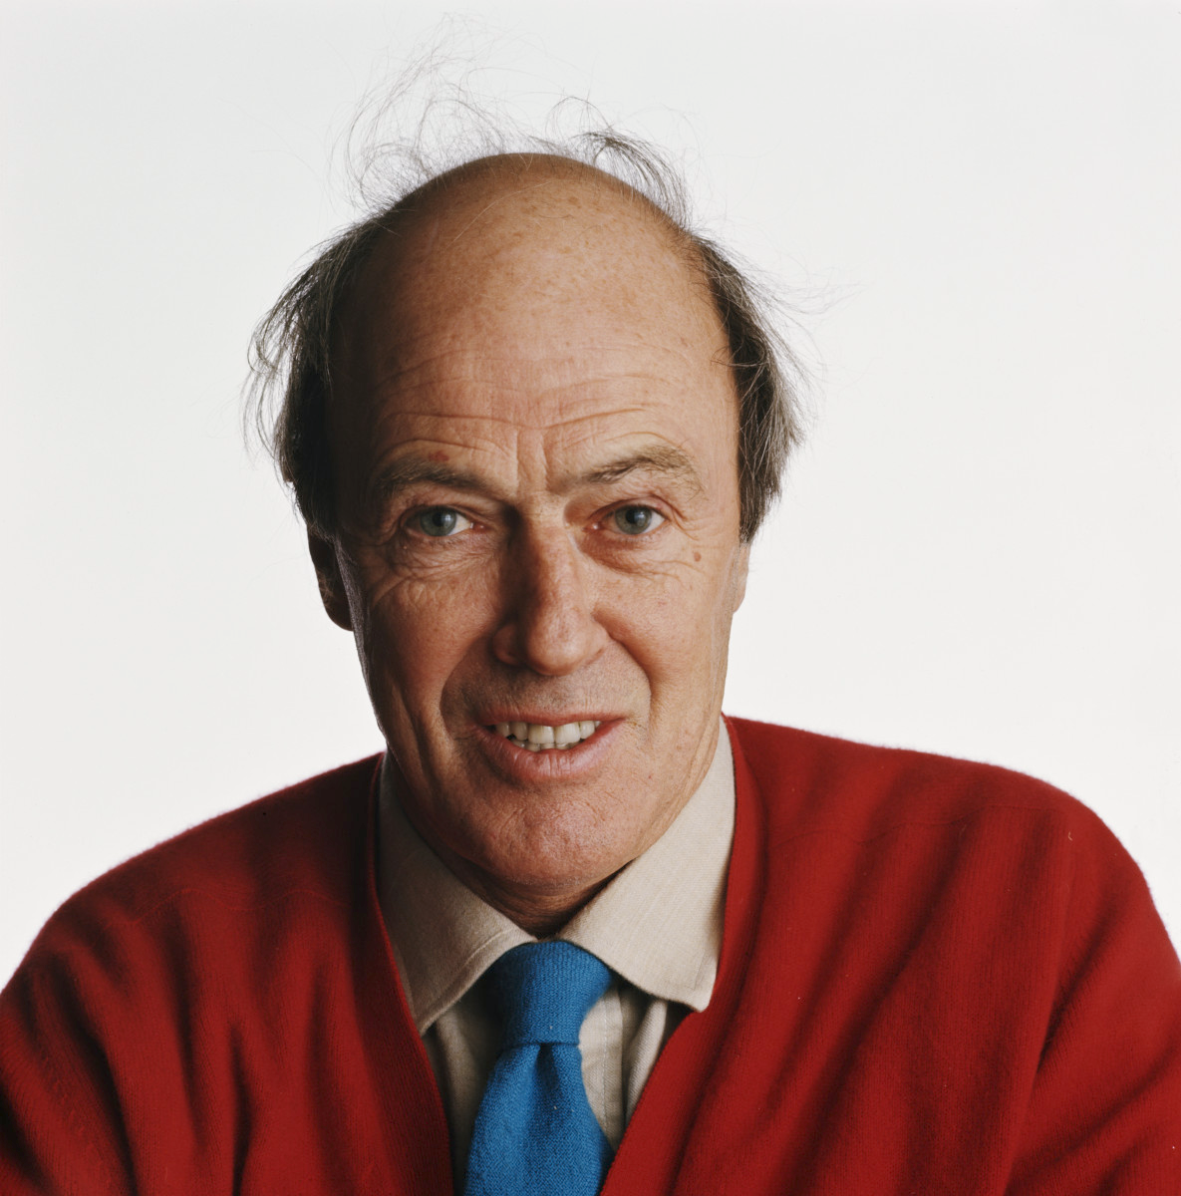 | Roald Dahl
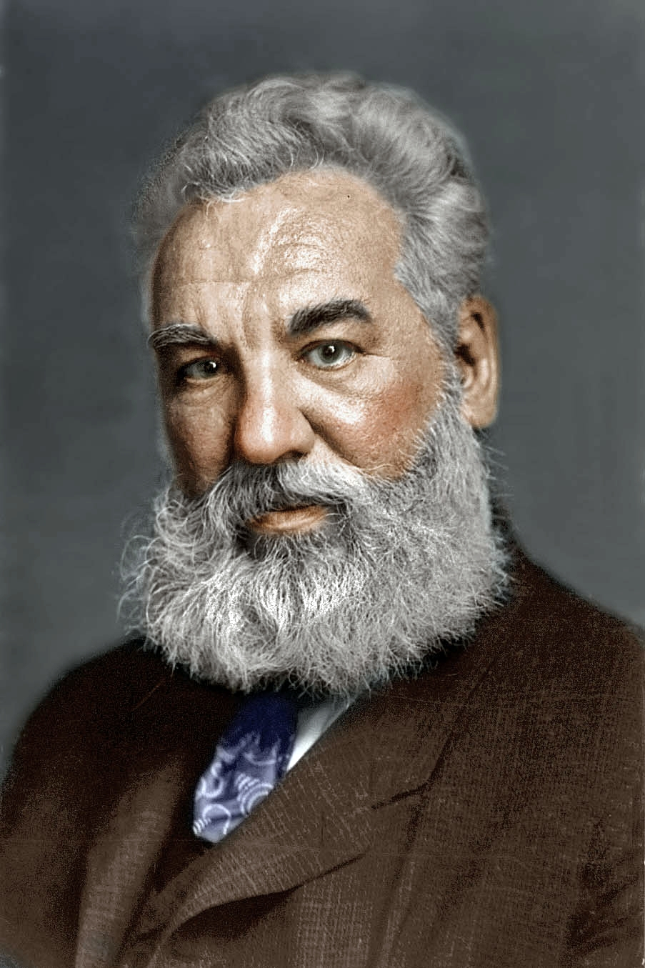 | Alexander Graham Bell | Anne Frank | 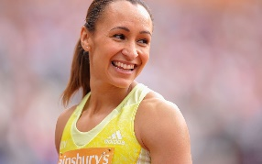
He had many inventions, some of these included the metal detector, the audiometer (a device used to detect hearing problems), he invented techniques which helped in teaching speech to the deaf and also made a device to help locate icebergs! | I don’t think I shall ever really feel at home in this house, but that does not mean that I loathe it here, it is more like being on vacation in a very peculiar boarding house… The Secret Annexe is an ideal hiding place. Although it leans to one side and is damp, you'd never find such a comfortable hiding place anywhere in Amsterdam, not even in the whole of Holland. Our little room perhaps looked bare at first with nothing on the walls; but thanks to Daddy who had brought my film star collection and postcards beforehand and with aid of paste, pot and brush, I have transformed the walls into one gigantic picture. | I am crying. I am a Sheffield schoolgirl writing in her diary about the bullies awaiting me tomorrow. They stand menacingly by the gates and lurk unseen in my head, mocking my size and status. They make a small girl shrink, and I feel insecure and frightened.  I pour the feelings out into words on the page, as if exposing them in some way will help, but nobody sees my diary. It is kept in my room as a hidden tale of hurt. Fast forward two decades and I am crying again. I am standing in a cavernous arena in London. Suddenly, the pain and suffering and frustration give way to a flood of overwhelming emotion. | He was born in Wales on 13th September 1916. His father died when he was 3 years old and he was brought up by his mother.  He was quite unhappy at boarding school which gave him inspiration for some of his stories.

