|  |  |
| --- | --- |
| **Using the book you’ve just read try to complete these tasks:** | |
| Can you describe the character? Kind, mean- how do you know? What are the clues? |  |
| Can you find three interesting words you can use in your writing- adjectives? |  |
| Can you find two contractions- e.g. don’t, haven’t. |  |
| Can you find three words to describe a setting? e.g. gloomy, dark, tranquil etc. |  |
| Can you find two verbs to show what a character is doing? |  |
| Look for an adverb to show how a character is ‘doing’ the verb e.g. running **quickly.** |  |

Literacy Scavenger Hunt

Other activities:

*Can you do bouncy blending?*

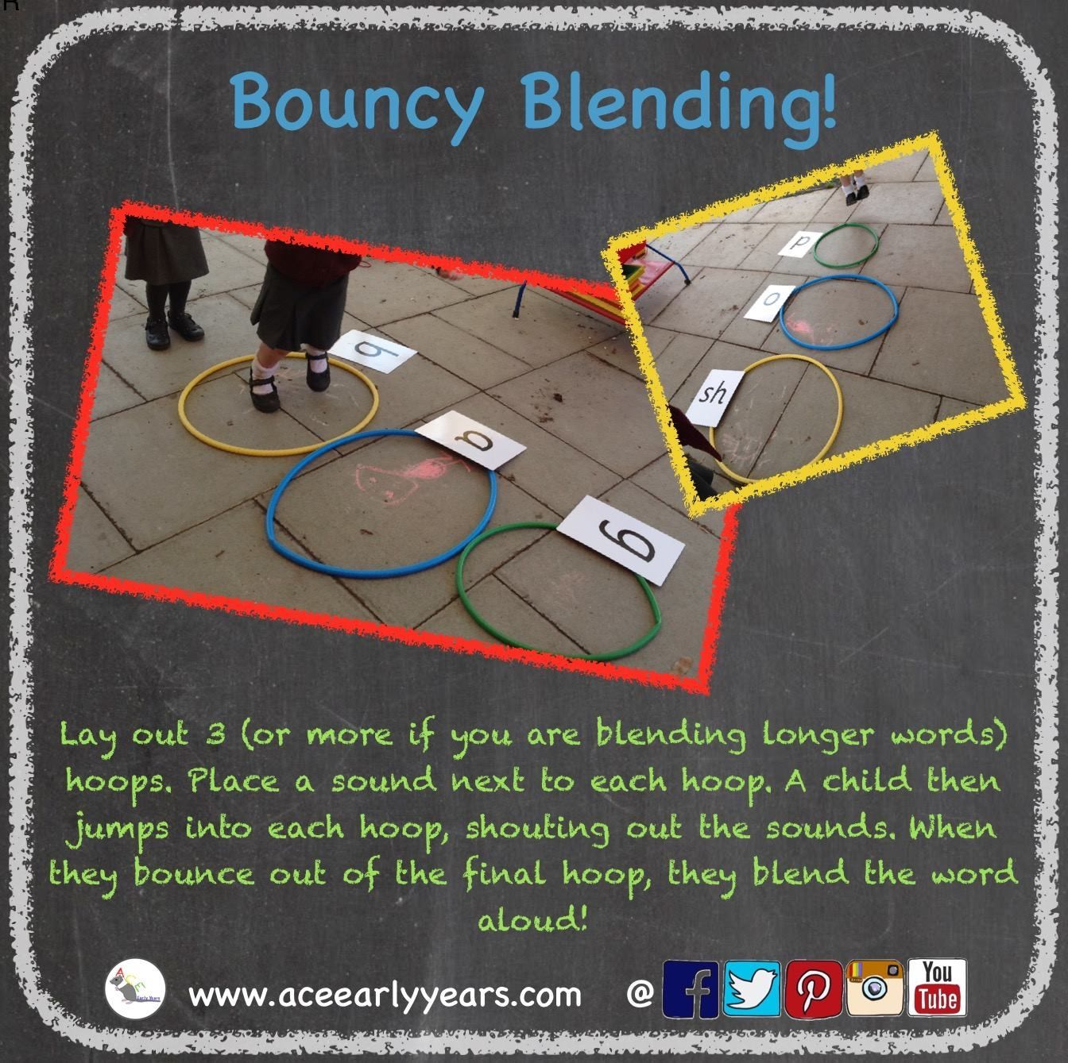

|  |
| --- |
| Write a rhyming poem in the style of Brown Brown Bear. What do you see? |
| Find something that has two syllables (tablecloth) |
| Find something that has three syllables (basketball) |
| Find an object and describe it using an adjective (use alliteration) e.g. tall tree |
| Label 10 objects in your house with post-it notes e.g. bathroom, mirror, fridge (Think carefully about your sounds). |